­­­Sqoop Learning: -

Sqoop is mainly used for transferring data from relational database to Hadoop eco-system.

Transferring an entire table: -

You have a table in a relational database, and you need to transfer the table’s contents into Hadoop Distributed File System (HDFS).

sqoop import --connect jdbc:mysql://192.168.1.8:3306/classicmodels --username hadoop --password Amma@3539 --table student --m 1

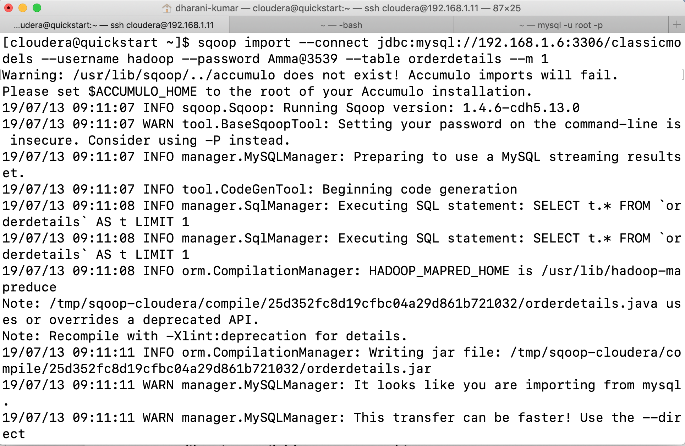

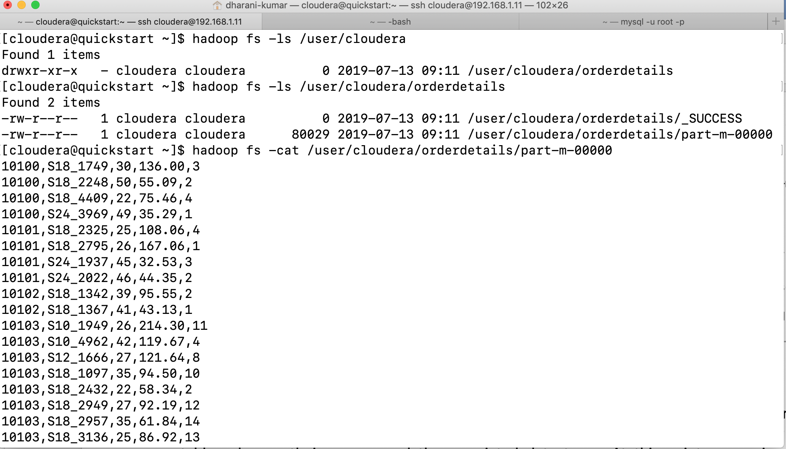

The result of this command will be a comma-separated CSV file (Flat file) where each row is stored in a single line. First sqoop will connect to the database to fetch table metadata: the number of table columns, their names, and the associated data types. At this point, sqoop is not transferring any data between the database and your machine. Based on the retrieved metadata, sqoop will generate a java class and compile it using the JDK and the Hadoop libraries available on your machine.

Next sqoop will connect to your Hadoop cluster and submit a map reduce job. Each mapper of the job will then transfer a slice of your table’s data. As MapReduce executes multiple mappers at the same time, sqoop will be transferring data in parallel to achieve the best possible performance by utilizing the potential of your database server. Each mapper transfers the table’s data directly between the database and the Hadoop cluster. To avoid becoming a transfer bottleneck, the sqoop client acts as the overseer rather than as an active participant while transferring the data.

Specifying a target directory: -

Sqoop offers a --target-dir parameter to specify the directory where sqoop should import your data.

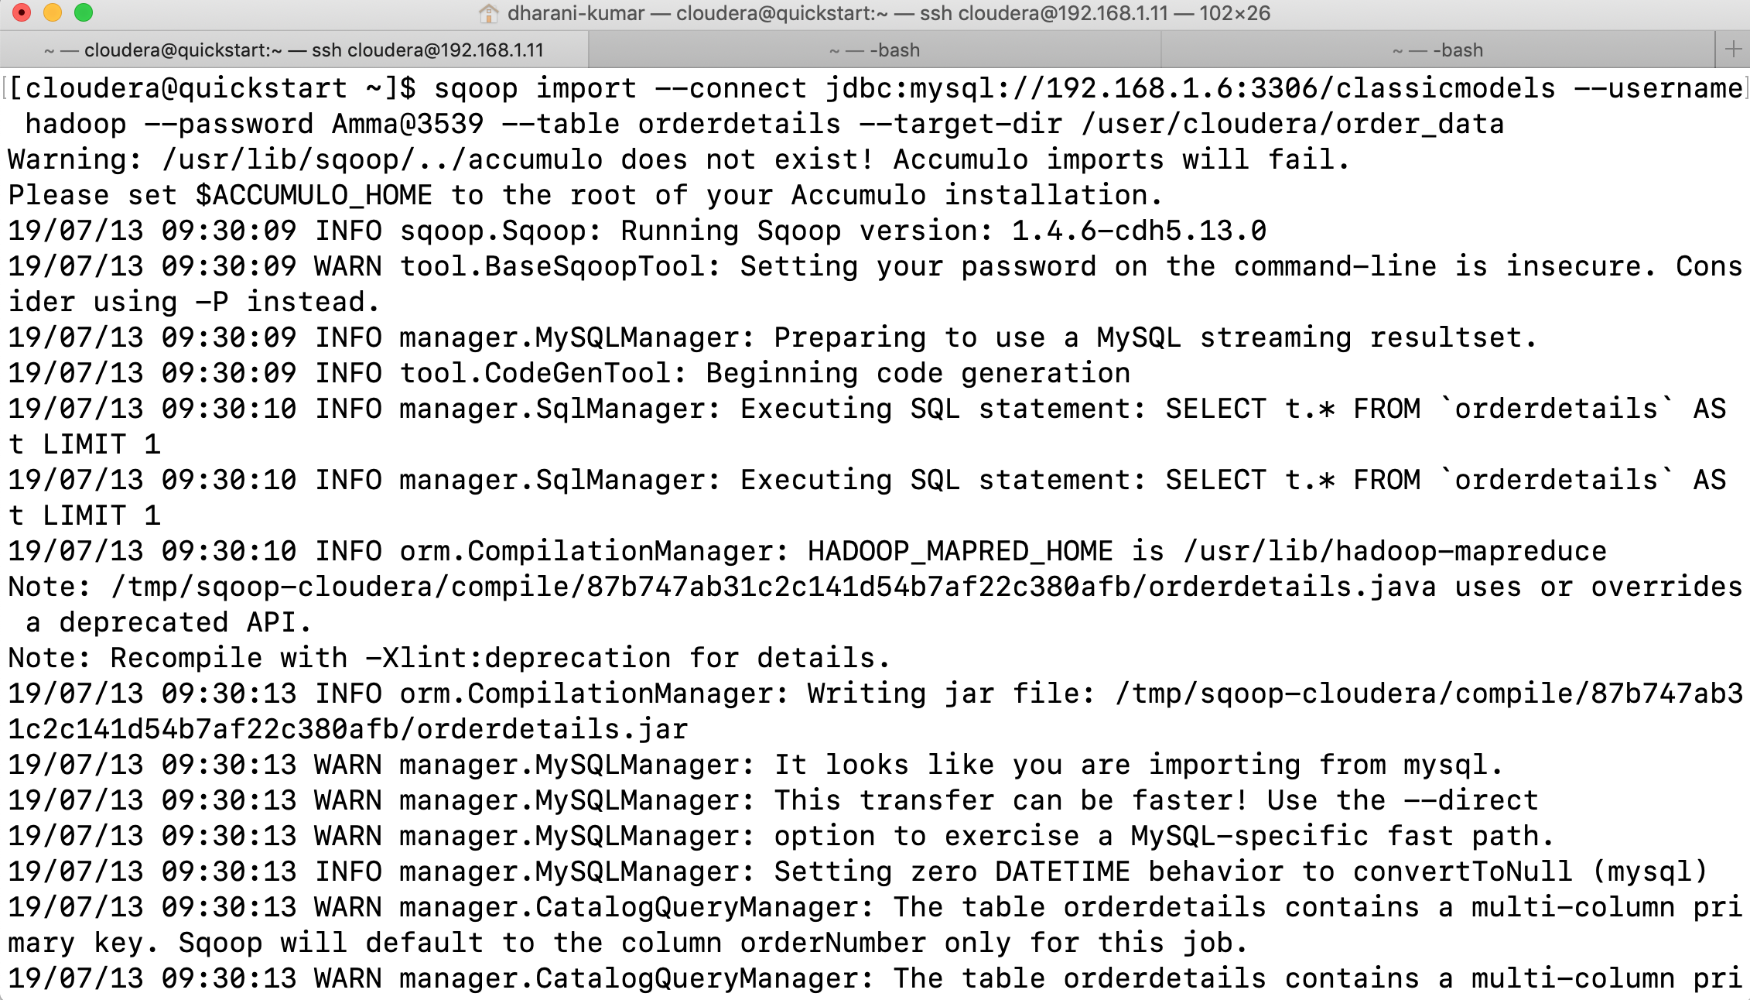

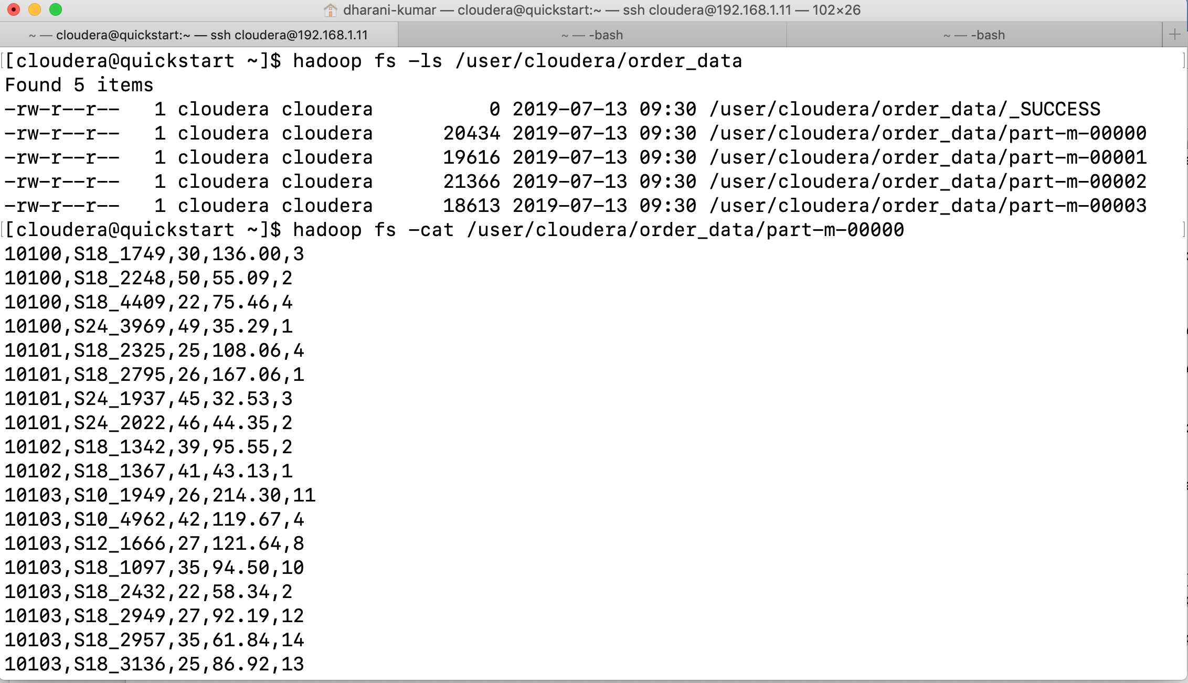

sqoop import --connect jdbc:mysql://192.168.1.8:3306/classicmodels --username hadoop --password Amma@3539 --table student --m 1 --target-dir /user/cloudera/Student_Data

To specify parent directory for all your sqoop jobs, instead use the --warehouse-dir parameter.

sqoop import --connect jdbc:mysql://192.168.1.8:3306/classicmodels --username hadoop --password Amma@3539 --table customers --m 1 --warehouse-dir /user/cloudera/My_Sqoop_Jobs

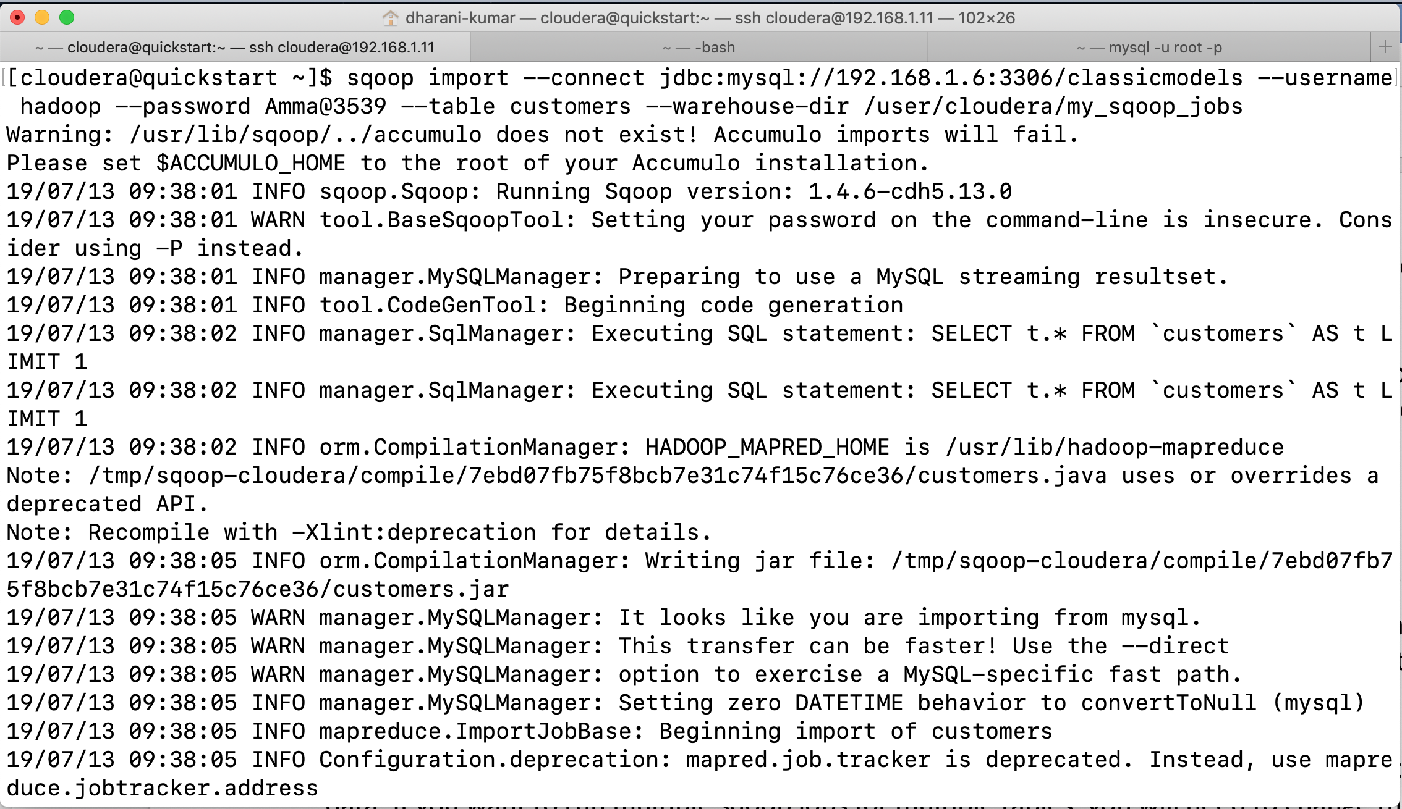

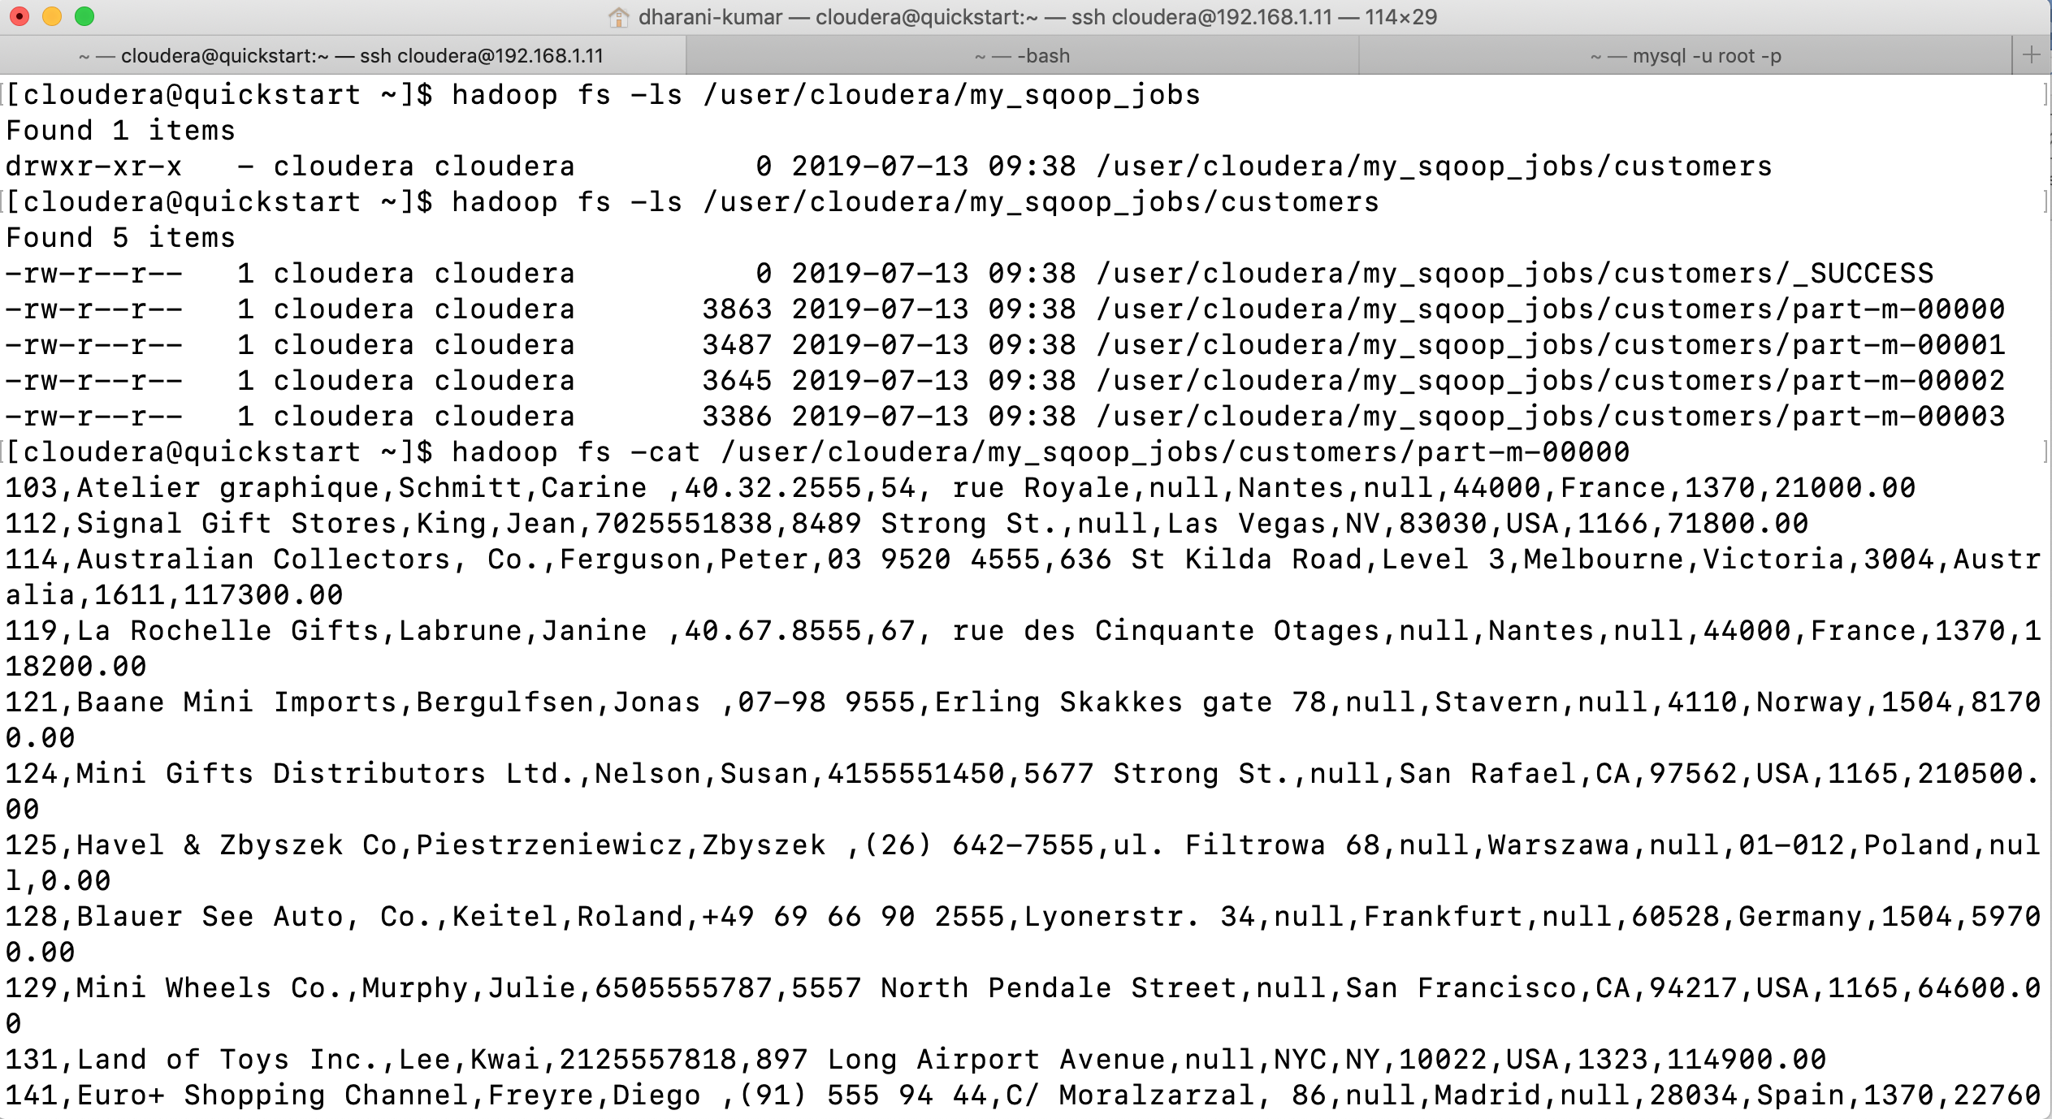



By default, sqoop will create a directory with the same name as the imported table inside your home directory on HDFS and import all data there. This directory can be changed to any arbitrary directory on your HDFS using the --target-dir parameter. The only requirement is that this directory must not exist prior to running the sqoop command.

Sqoop will reject importing into an existing directory to prevent accidental overwriting of the data. If you want to run multiple sqoop jobs for multiple tables, you will need to change the --target-dir parameter with every invocation. As an alternative sqoop offers another parameter by which to select the output directory. Instead directly specifying the final directory, the parameter --warehouse-dir allows you to specify only the parent directory. Rather than writing data into the warehouse directory, sqoop will create a directory with the same name as the table name inside the warehouse directory and import the data there. This is similar to the default case where sqoop imports data to your home directory on HDFS. Note that this parameter does not need to change with every table import unless you are importing tables with the same name.

Sqoop will reject importing data when the final output directory already exists.

Importing only a subset of the data: -

Instead of importing an entire table, you need to transfer only a subset of rows based on various conditions that you can express in the form of a SQL statement with a WHERE clause.

Use the command line interpreter --where to specify a SQL condition that the imported data should meet. Sqoop will propagate the content of the --where parameter as is to all generated queries that fetch data. Any special functions, conversions or even user-defined functions can be used. When using the --where parameter, keep in mind the parallel nature of sqoop transfers. Data will be transferred in several concurrent tasks. Any expensive function call will put a significant performance burden on your database server. Advanced functions could lock certain tables, preventing sqoop from transferring data in parallel. For efficient advanced filtering query on your database prior to import, save its output to a temporary table and run Sqoop to import the temporary table to Hadoop without any --where parameter.

sqoop import --connect jdbc:mysql://192.168.1.8:3306/classicmodels --username hadoop --password Amma@3539 --table customers --m 1 --where "contactlastname = 'Smith'" --target-dir /user/cloudera/where

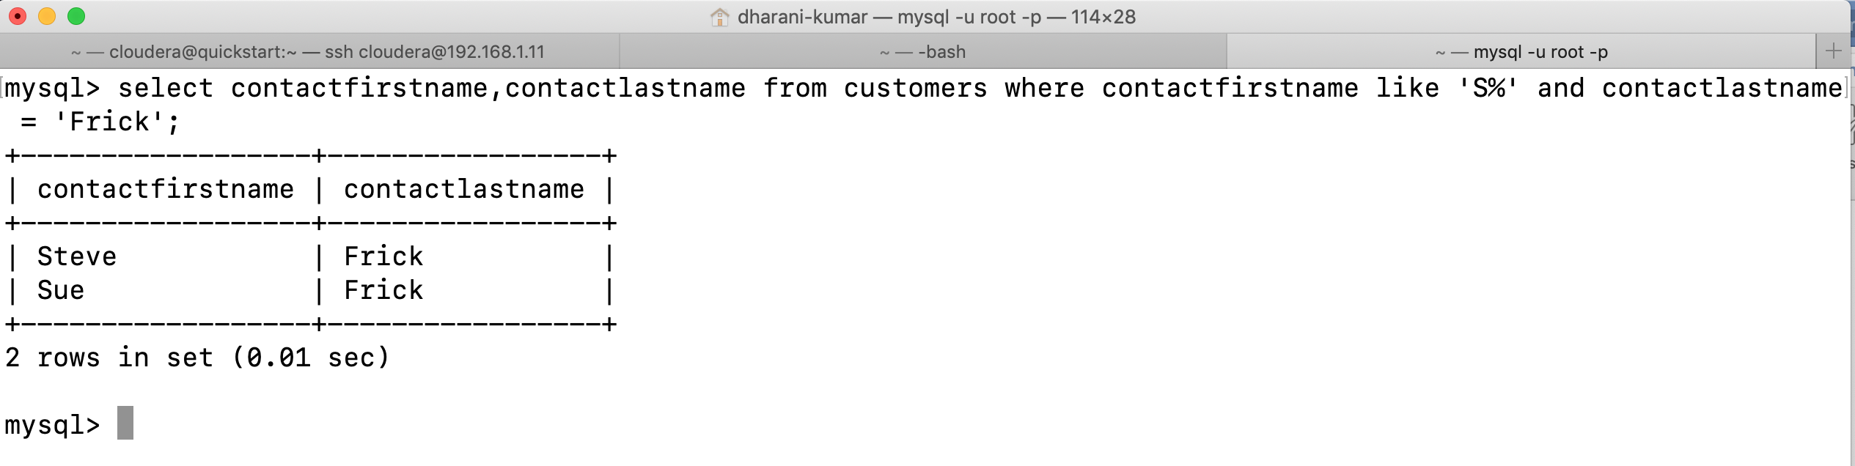

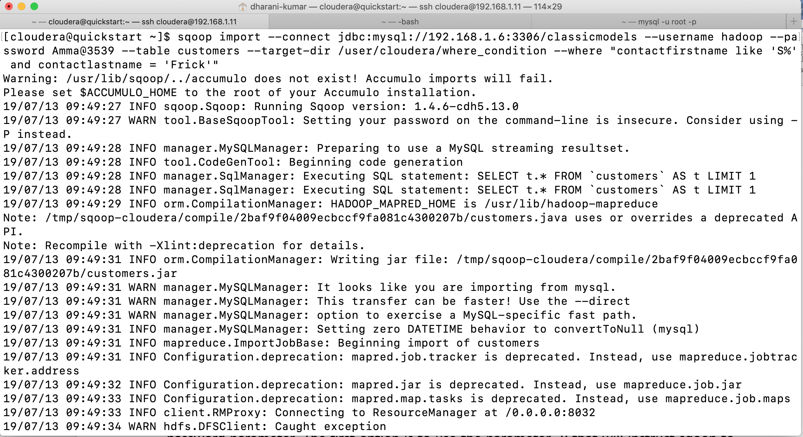

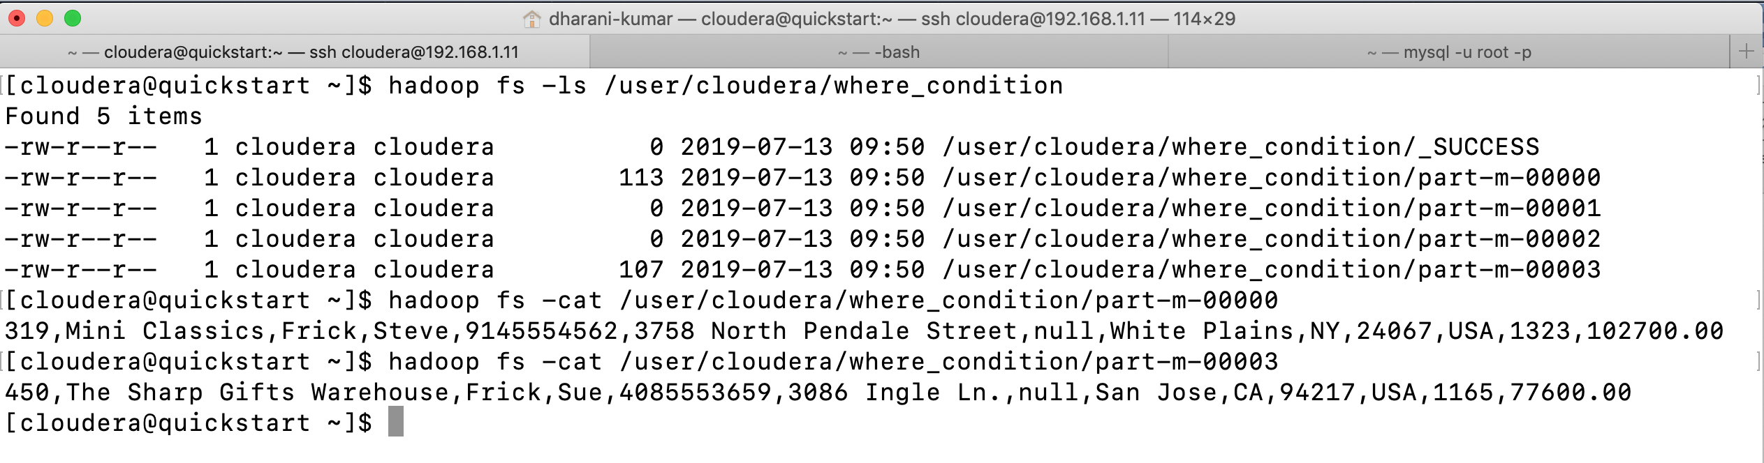

Protecting your password: -

Typing your password into the command line interface is insecure.

You have two options besides specifying the password on the command line with the --password parameter. The first option is to use the parameter -P that will instruct sqoop to read the password from standard input. Alternatively, you can save your password in a file and specify the path to this file with the parameter --password-file.

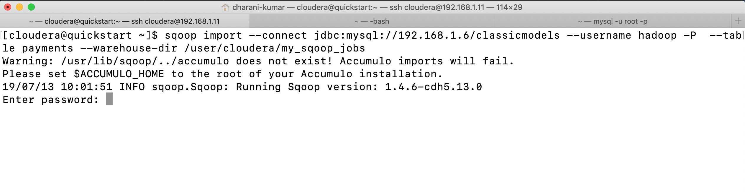

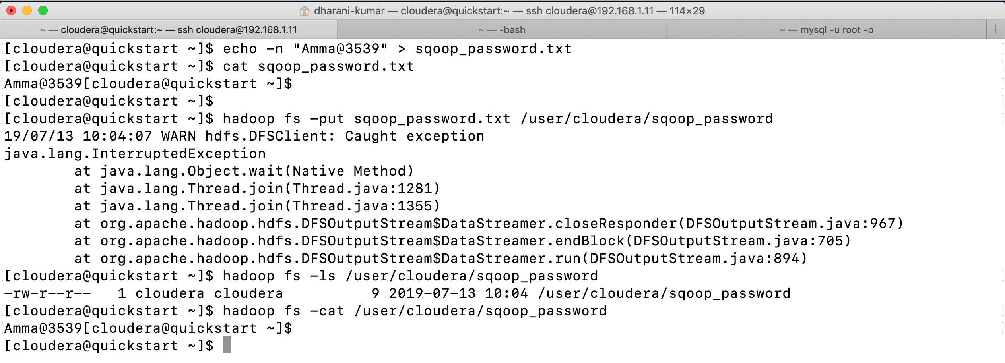

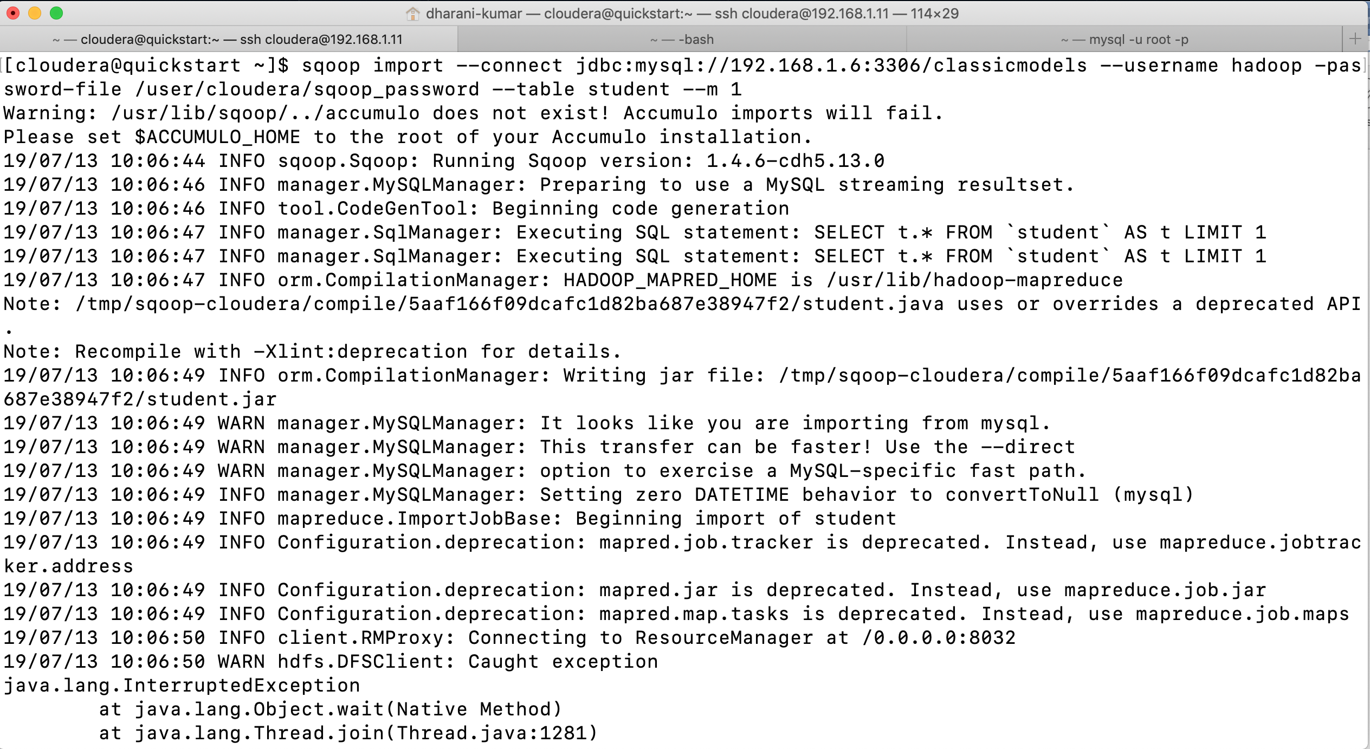

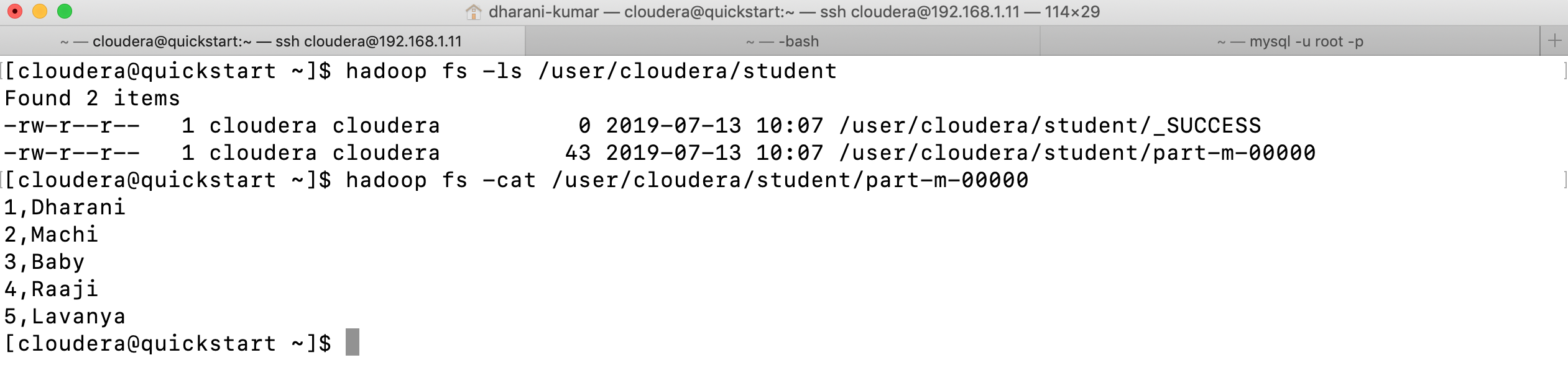

The --password-file method is recommended.

Using a File format other than CSV: -

The tab-separated CSV file that sqoop uses by default does not suite your use case. You prefer a binary format over plain text.

Sqoop supports three different types of file formats; one of these is text, and the other two are binary. The binary formats are Avro and Hadoop’s sequence file. You can enable import into SequenceFile using the --as-sequencefile parameter.

sqoop import --connect jdbc:mysql://192.168.1.2:3306/classicmodels --username hadoop -P --table employees --warehouse-dir /user/cloudera/sqoop_jobs --as-sequencefile

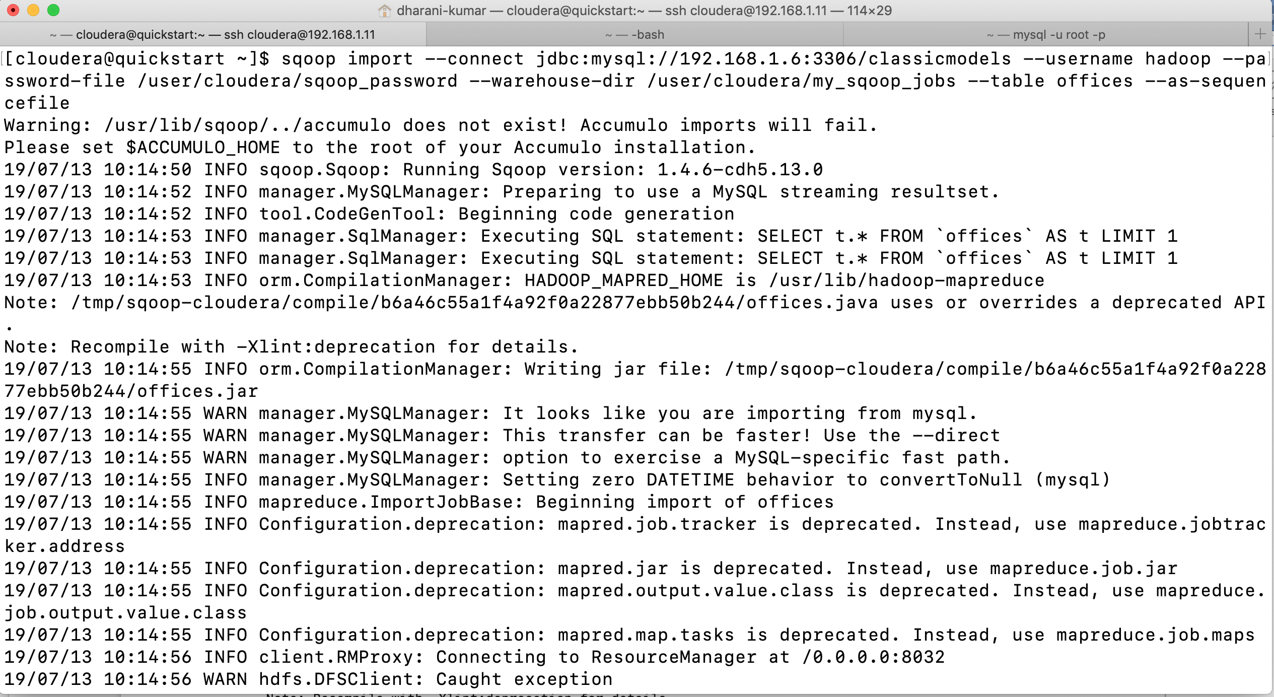

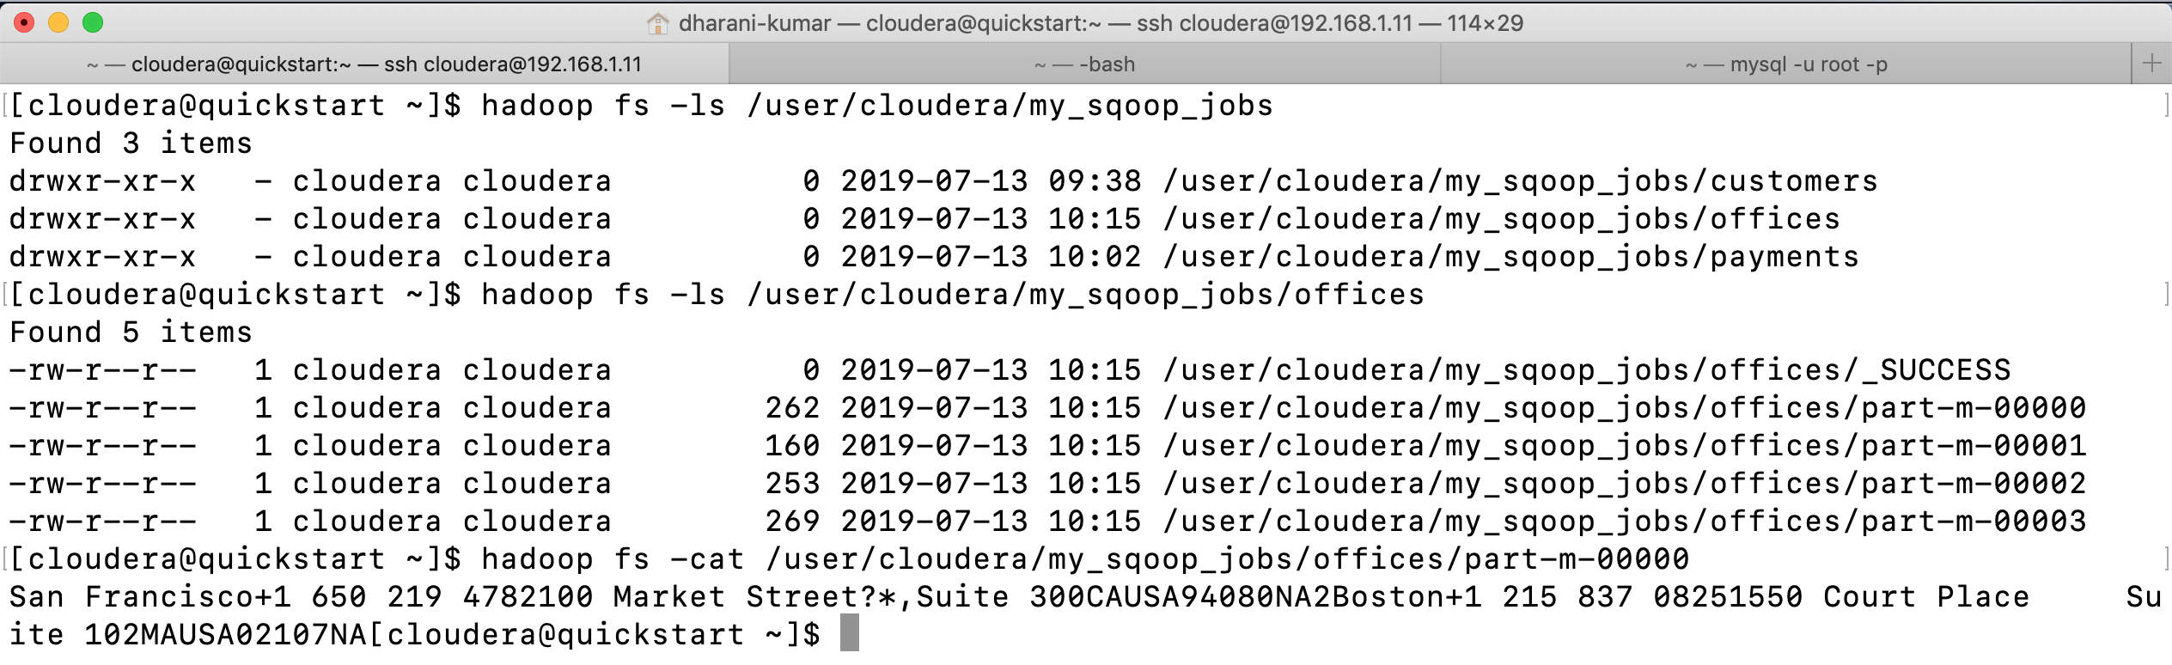

If we don’t give any mappers in our command and if the table has a primary key, then automatically 4 mappers will be generated by the sqoop. If the table does not have a primary key, then an error is thrown.

Binary formats have a few benefits over that of text files. First, binary formats are a natural fit for storing binary values like images or pdf documents. Along with benefits there is one downside: in order to access the binary data, you need to implement extra functionality or load special libraries in your application.

The SequenceFile is a special hadoop file format that is used for storing objects and implements the writable interface. This format was customized for MapReduce, and thus it expects each record will consist of two parts: key and value. Sqoop does not have the concept of key-value pairs and thus uses an empty object called NullWritable in place of the value. For the key, sqoop uses the generated class. For convenience, this generated class is copied to the directory where sqoop is executed. You will need to integrate this generated class to your application if you need to read a sqoop generated SequenceFile.

Apache Avro is a generic data serialization system. Specifying the --as-avrodatafile parameter instructs sqoop to use its compact and fast binary encoding format. Avro is a very generic system that can store any arbitrary data structures. It uses a concept called schema to describe what data structures are stored within the file. The schema is usually encoded as a JSON string so that it’s decipherable by the human eye. Sqoop will generate the schema automatically based on metadata information retrieved from the database server and will retain the schema in each generated file. Your application will need to depend on Avro libraries in order to open and process data stored as Avro. You don’t need to import any special class, such as in the SequenceFile case, as all required metadata is embedded in the imported files themselves.

sqoop import --connect jdbc:mysql://192.168.1.2:3306/classicmodels --username hadoop --password Amma@3539 --table orders --as-avrodatafile

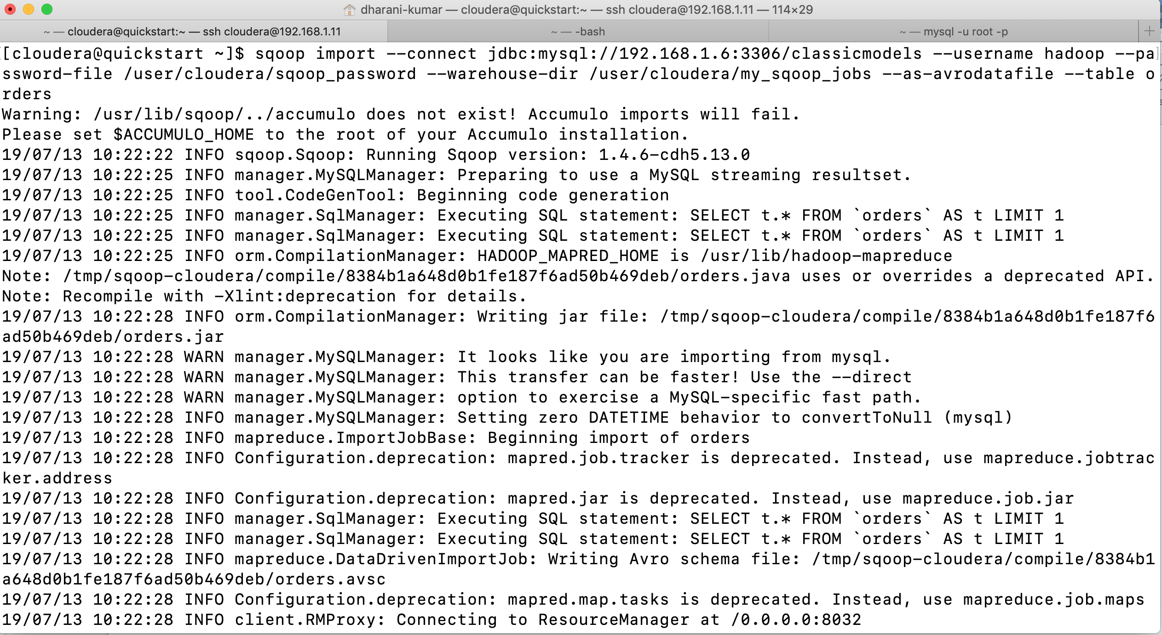

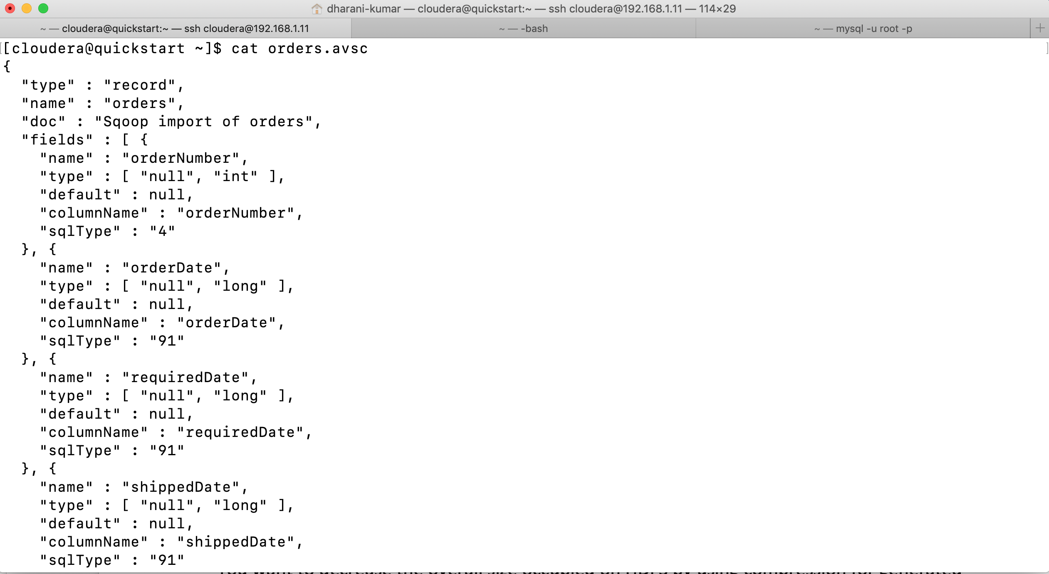

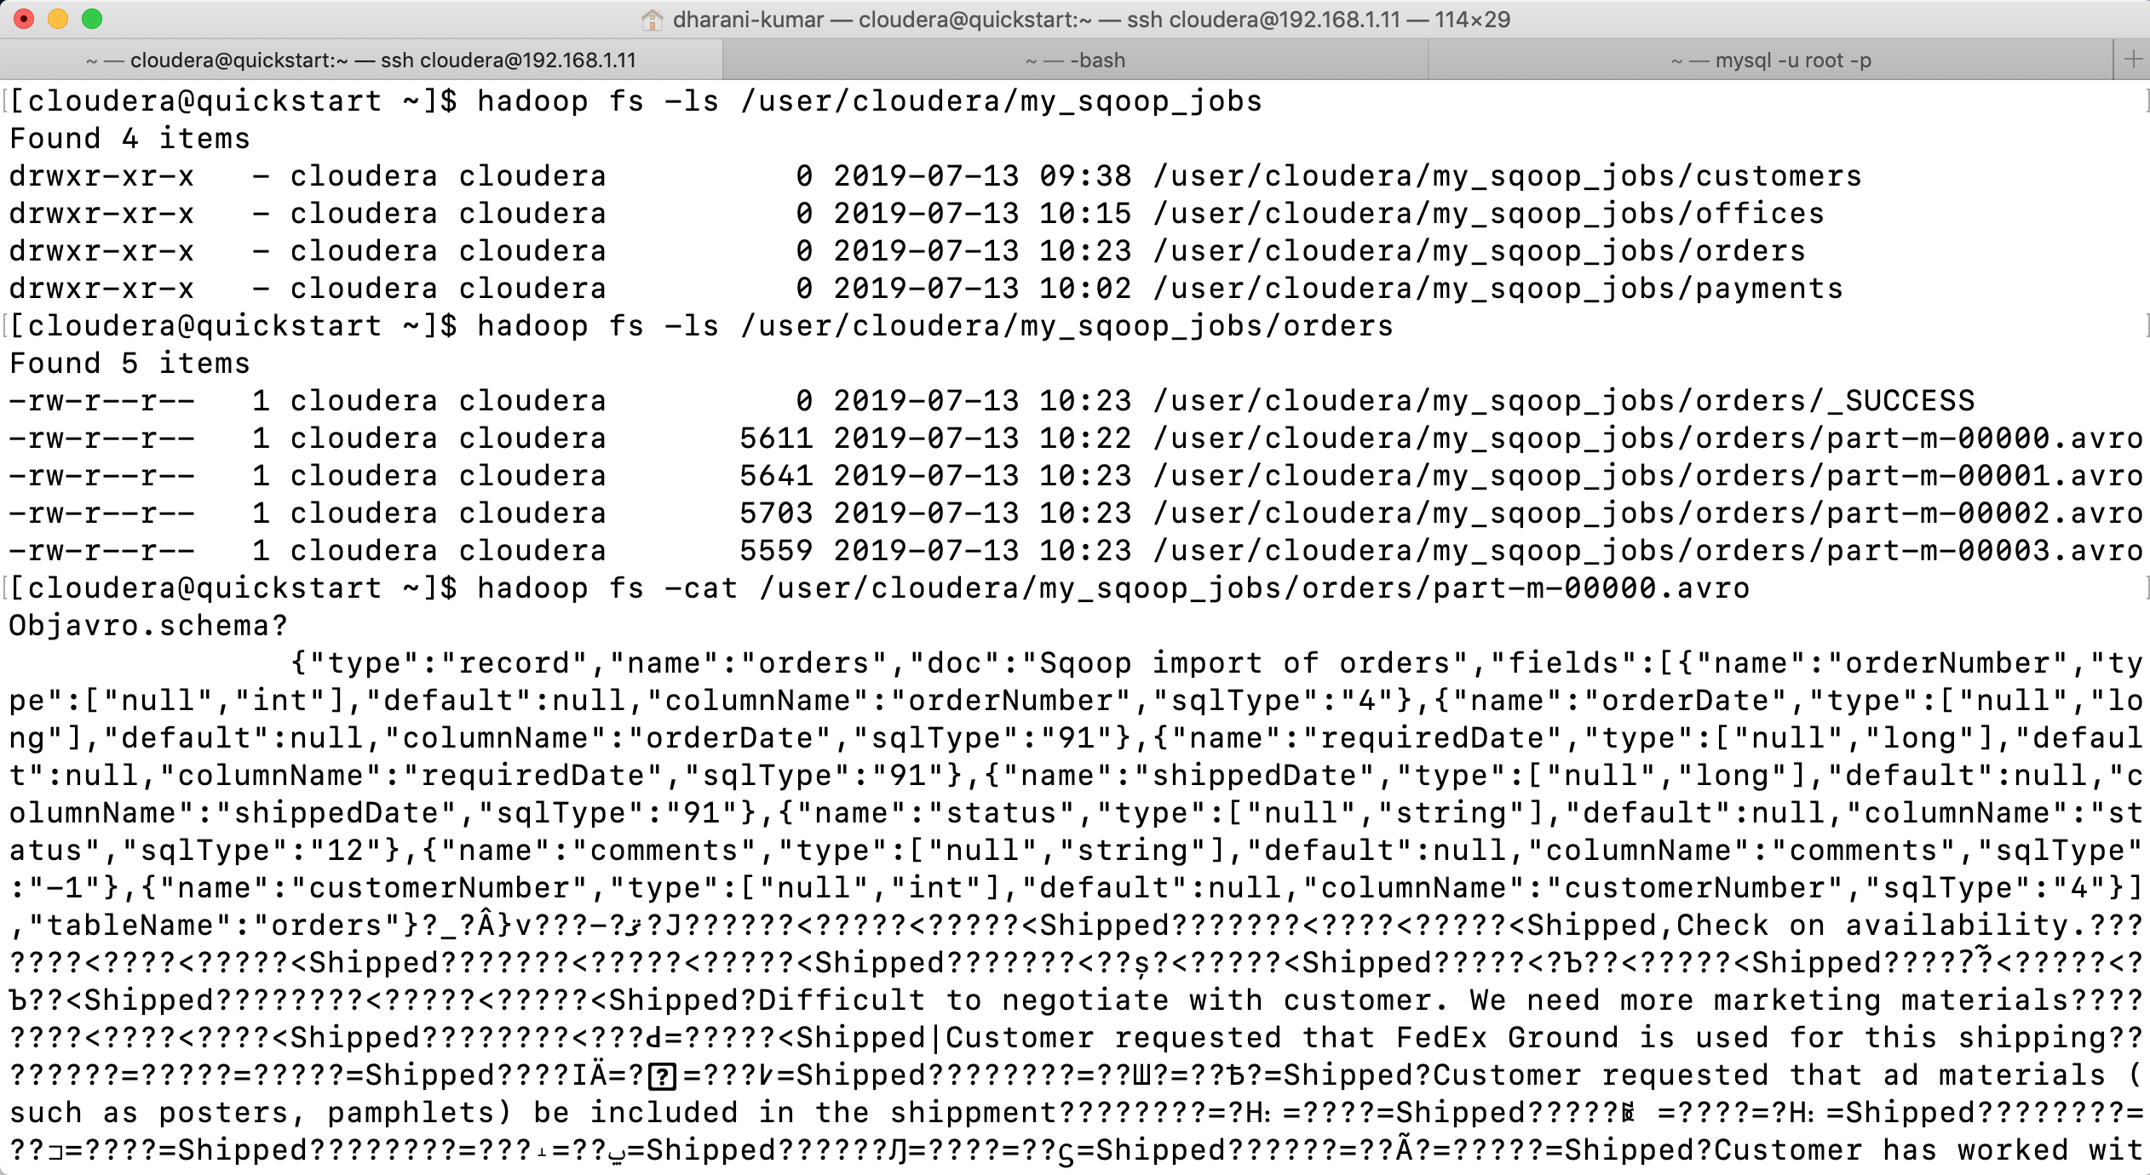

Parquet file: -

We can create the parquet file using the --as-parquet file parameter.

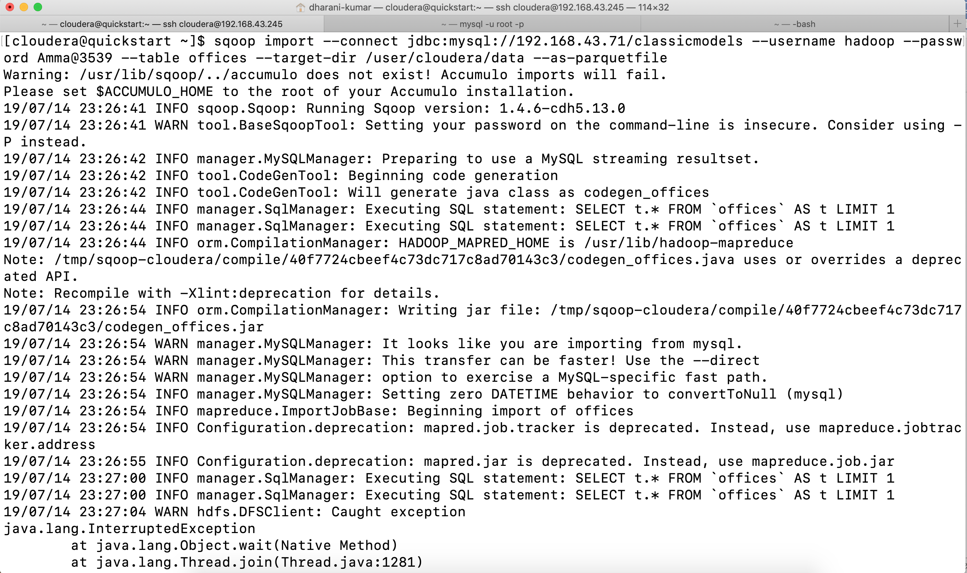

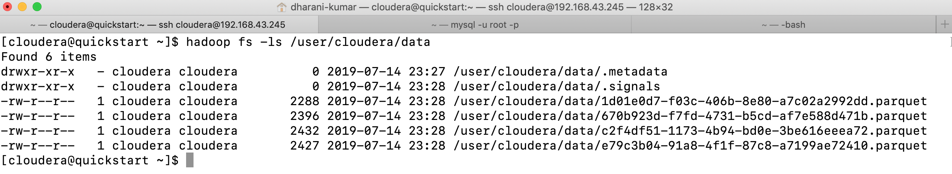

Compressing imported data: -

You want to decrease the overall size occupied on HDFS by using compression for generated files. Use the parameter --compress to enable compression.

sqoop import --connect jdbc:mysql://192.168.1.2/classicmodels --username hadoop --password Amma@3539 --table orders --warehouse-dir /user/cloudera/sqoop_jobs --append --compress

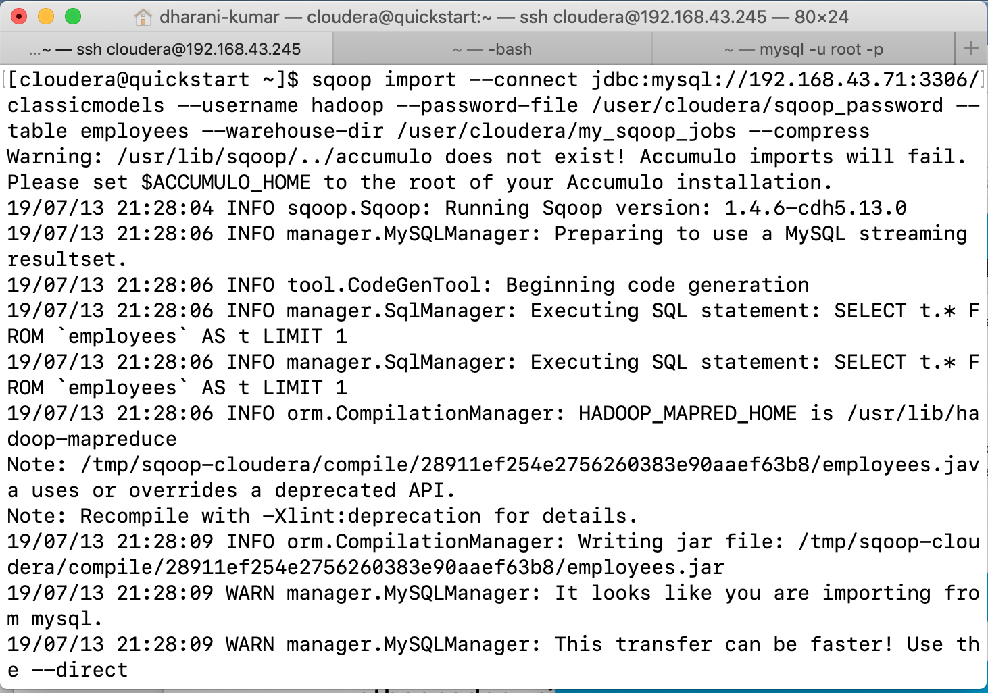

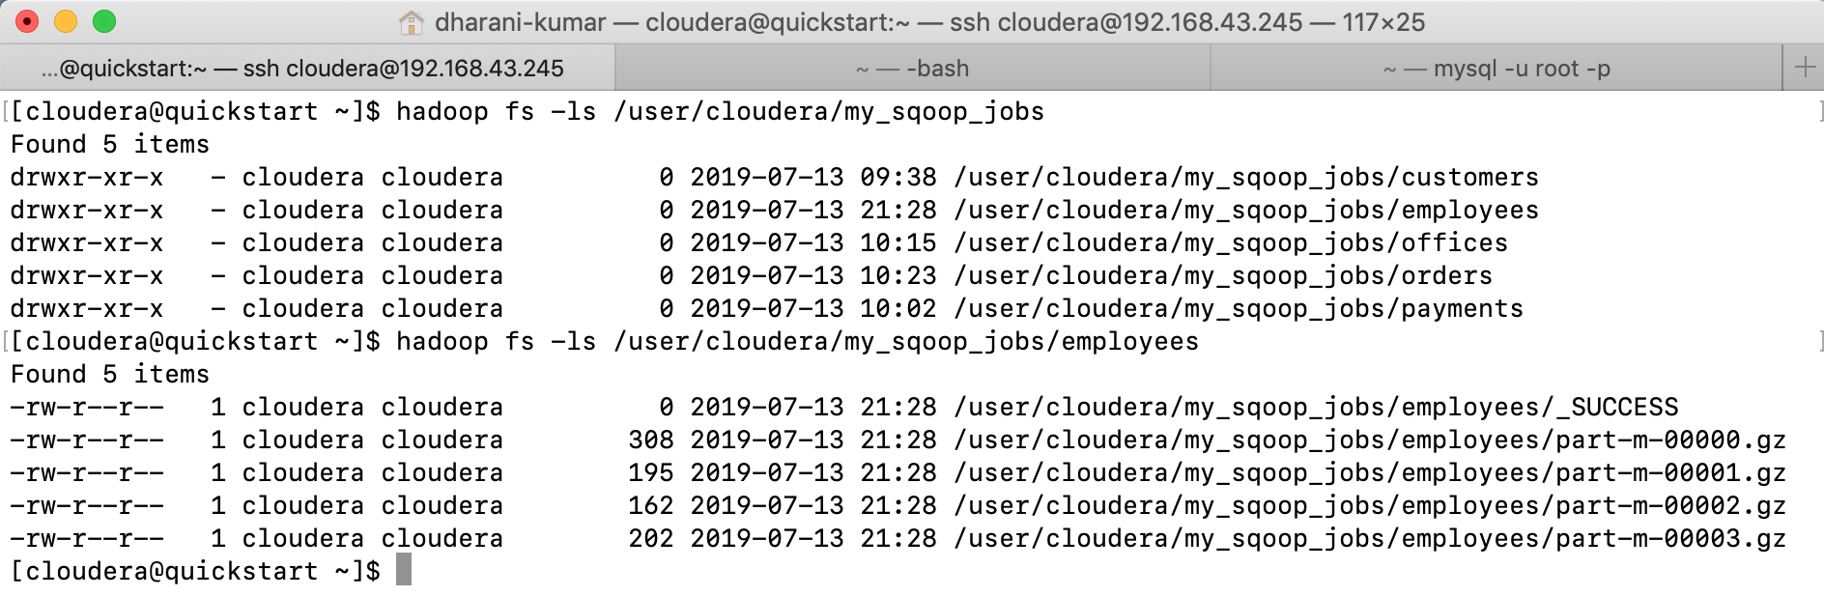

Sqoop takes advantage of the inherent parallelism of Hadoop by leveraging Hadoop’s execution engine, MapReduce to perform data transfers. As MapReduce already has excellent support for compression, sqoop simply reuses its powerful abilities to provide compression options. By default, when using the --compress parameter, output files will be compressed using the GZip codec, and all the files will end up with a .gz extension. You can choose any other codec using the --compression-codec parameter. The following example uses the BZip2 codec instead of GZip (files on HDFS will end up having the .bz2 extension).

Sqoop can’t use any compression algorithm not known to hadoop.

sqoop import --connect jdbc:mysql://192.168.1.2/classicmodels --username hadoop --password Amma@3539 --table orders --warehouse-dir /user/cloudera/sqoop_jobs --append --compression-codec org.apache.hadoop.io.compress.BZip2Codec

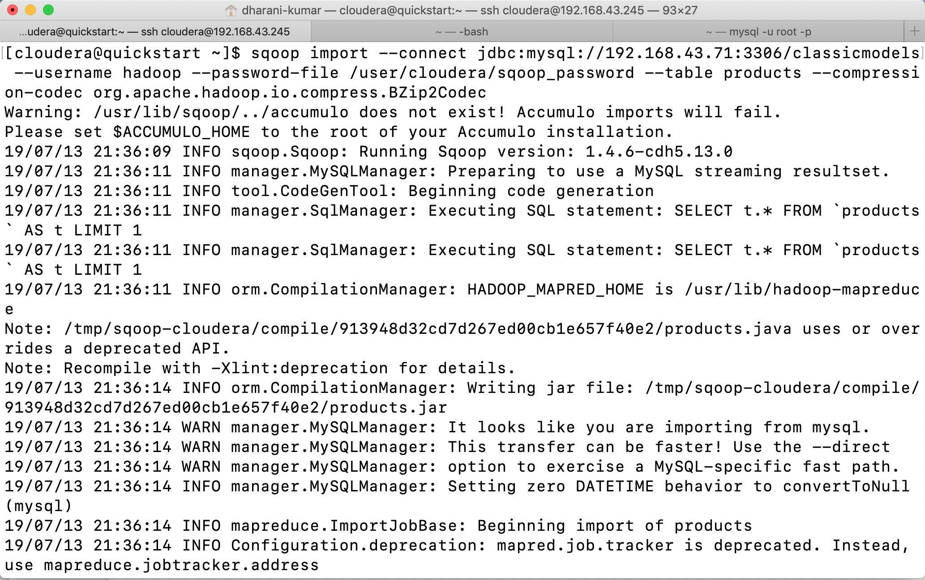

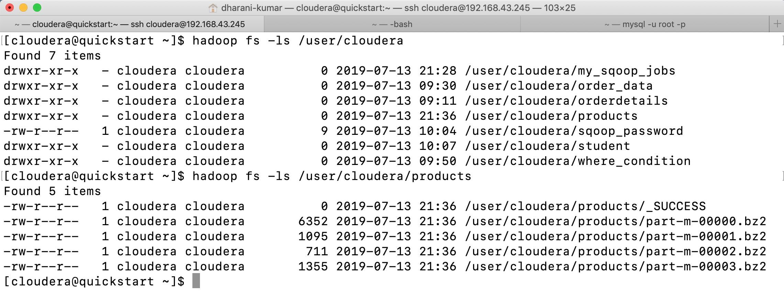

As sqoop delegates compression to the MapReduce engine, you need to make sure the compressed map output is allowed in your configuration. For example, if in the mapred-site.xml file, the property mapred.output.compress is set to false with the final flag, then sqoop won’t be able to compress the output files even when you call it with --compress parameter.

The selected compression codec might have a significant impact on subsequent processing.

Some codecs do not support seeking to the middle of the compressed file without reading all previous content, effectively preventing Hadoop from processing the input files in a parallel manner. You should use a splittable codec for data that you’re planning to use in subsequent processing.

Splittable codecs -- BZip2, LZ0

Not Splittable -- GZip, Snappy

Speeding up transfers: -

Sqoop is a great tool, and it’s processing bulk transfers very well. For some databases you can take the advantage of the direct mode by using the --direct parameter.

Rather than using the JDBC interface for transferring data, the direct mode delegates the job of transferring data to the native utilities provided by the database vendor. In case of mysql the mysqldump and mysqlimport will be used for retrieving data from the database server and moving data back. Using native utilities will greatly improve performance, as they are optimized to provide the best possible transfer speed while putting less burden on the database server. There are several limitations that come with this faster import. For one, not all databases have available native utilities. This mode is not available for every supported database. Sqoop has direct support only for MySQL and PostgreSQL.

Because all data transfer operations are performed inside generated MapReduce jobs and because the data transfer is being deferred to native utilities in direct mode, you will need to make sure that those native utilities are available on all of your Hadoop TaskTracker nodes. For example, in the case of MySQL, each node hosting a TaskTracker service needs to have both mysqldump and mysqlimport utilities installed. Another limitation of the direct mode is that not all parameters are supported. As the native utilities usually produce text output, binary formats like SequenceFile or Avro won’t work. Also, parameters that customize the escape characters, type mapping, column and row delimiters, or the NULL substitution string might not be supported in all cases.

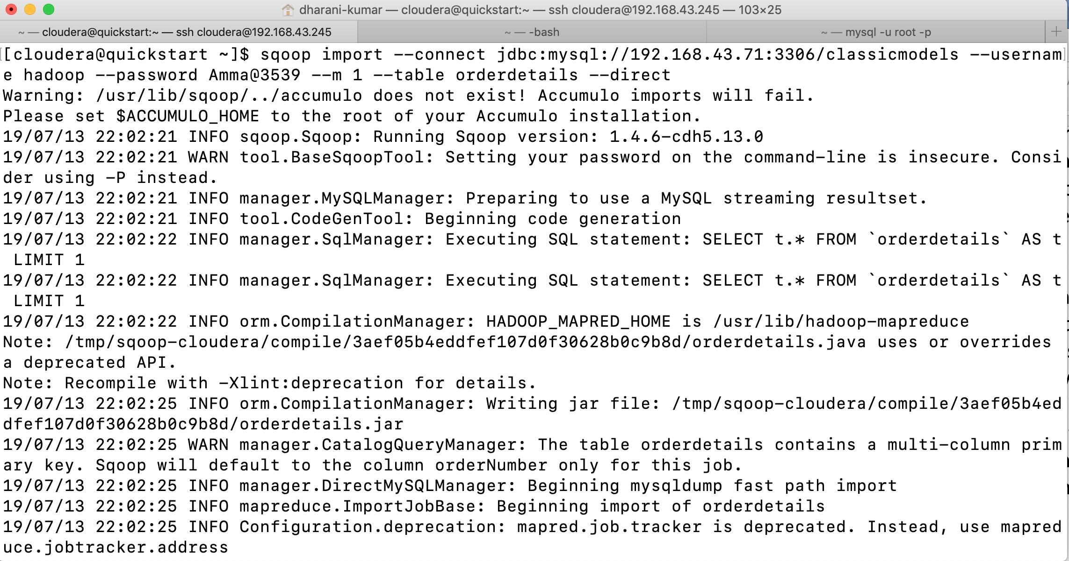

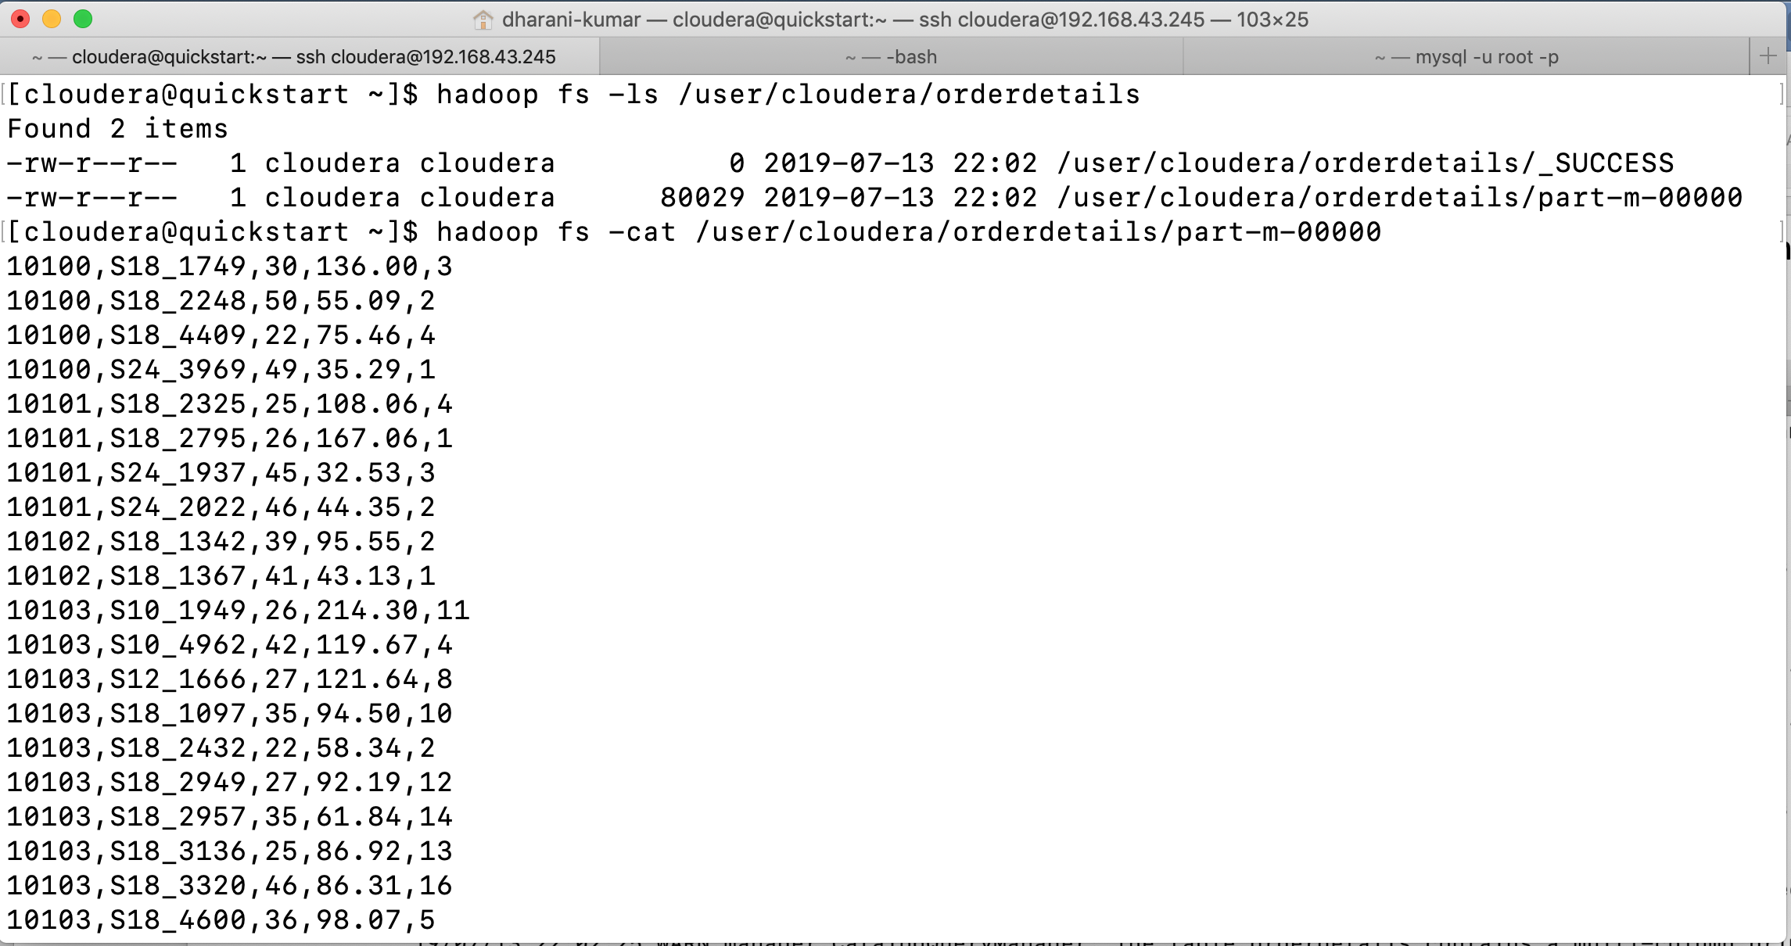

Overriding Type Mapping: -

The default type mapping that sqoop provides between relational databases and Hadoop usually works well. Use Sqoop’s ability to override default type mapping using the parameter --map-column-java.

The parameter --map-column-java accepts a comma separated list where each item is a key-value pair separated by an equal sign. The exact column name is used as the key, and the target Java type is specified as the value. For example, if you need to change mapping in three columns c1, c2 and c3 to float, string and string, respectively, then your sqoop command line would contain the following fragment.

sqoop import --map-column-java c1=Float, c2=String, c3=String ...

An example of where this parameter is handy is when your MySQL table has a primary key column that is defined as unsigned int with values that are bigger than 2147483647. In this particular scenario, MySQL reports that the column has type integer, even though the real type is unsigned integer. The maximum value for an unsigned integer column in MySQL is 4294967295. Because the reported type is integer, Sqoop will use Java’s Integer object, which is not able to contain values larger than 2147483647. In this case, you have to manually provide hints to do more appropriate type mapping.

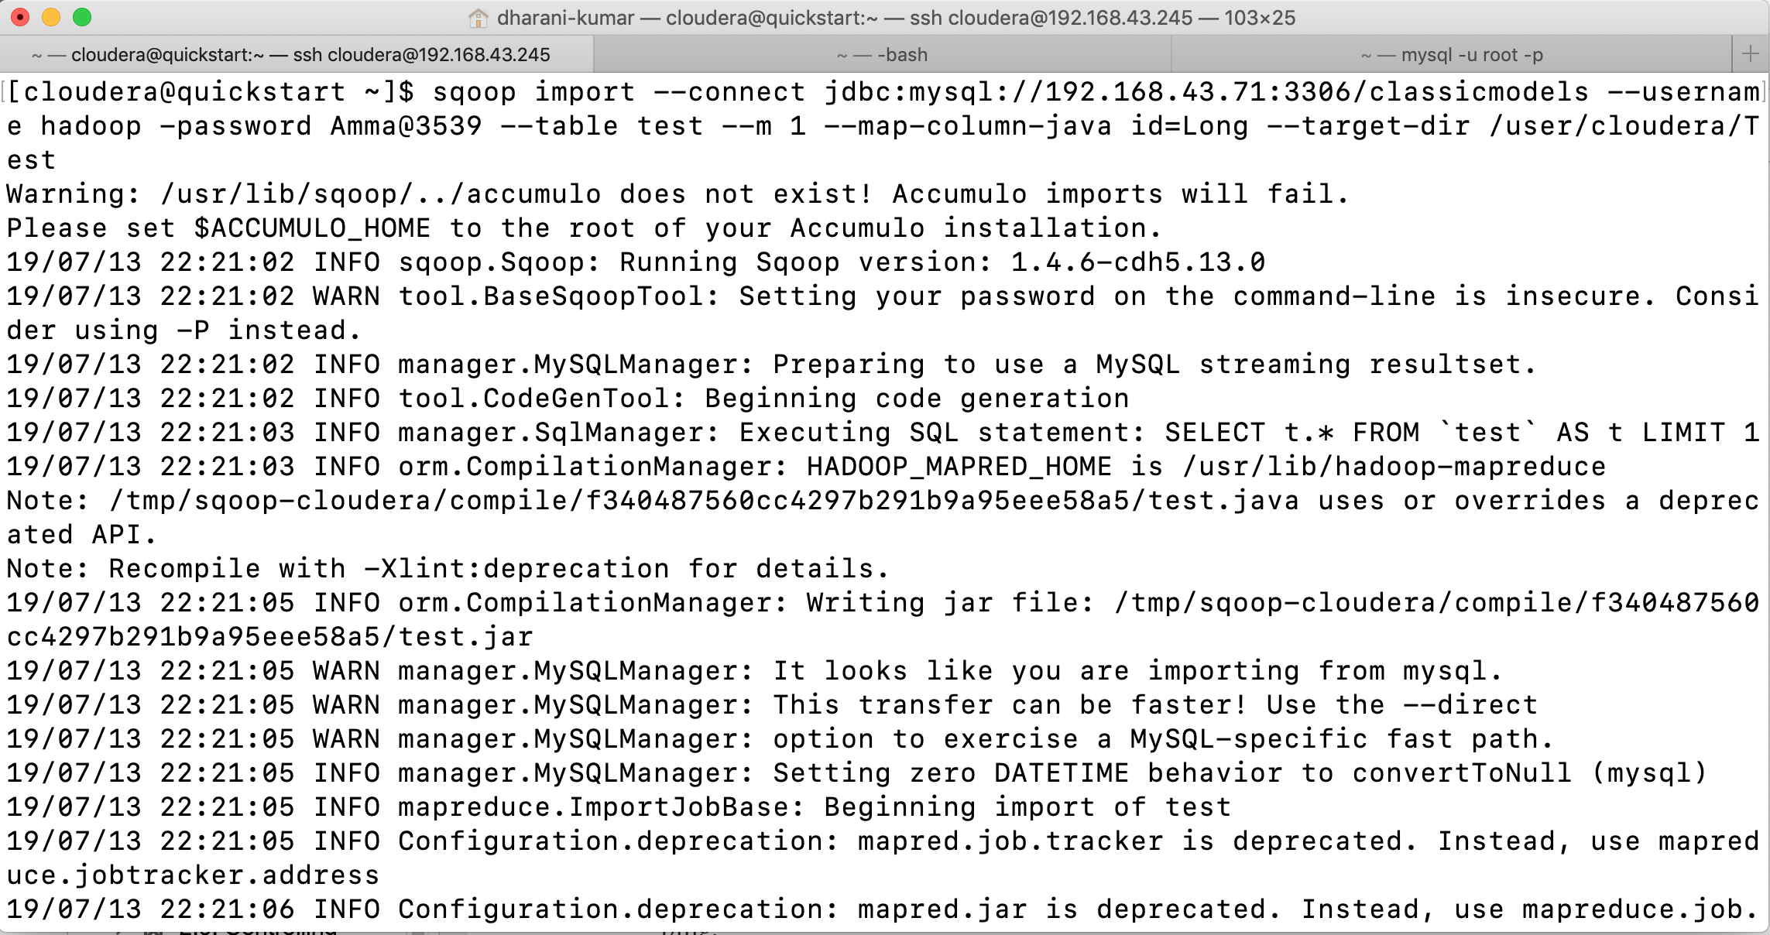

Use of this parameter is not limited to overcoming MySQL’s unsigned types problem. It is further applicable to many use cases where Sqoop’s default type mapping is not a good fit for your environment. Sqoop fetches all metadata from database structures without touching the stored data, so any extra knowledge about the data itself must be provided separately if you want to take advantage of it. For example, if you’re using BLOB or BINARY columns for storing textual data to avoid any encoding issues, you can use the --map-column-java parameter to override the default mapping and import your data as String.

Controlling Parallelism: -

Sqoop by default uses four concurrent map tasks to transfer data to Hadoop. Transferring

bigger tables with more concurrent tasks should decrease the time required to transfer all data. You want the flexibility to change the number of map tasks used on a per-job basis.

Use the parameter --num-mappers if you want Sqoop to use a different number of mappers.

The parameter --num-mappers serves as a hint. In most cases, you will get the specified number of mappers, but it’s not guaranteed. If your data set is very small, Sqoop might resort to using a smaller number of mappers. For example, if you’re transferring only 4 rows yet set --num-mappers to 10 mappers, only 4 mappers will be used, as the other 6 mappers would not have any data to transfer.

Controlling the amount of parallelism that Sqoop will use to transfer data is the main way to control the load on your database. Using more mappers will lead to a higher number of concurrent data transfer tasks, which can result in faster job completion. However, it will also increase the load on the database as Sqoop will execute more concurrent queries. Doing so might affect other queries running on your server, adversely affecting your production environment. Increasing the number of mappers won’t always lead to faster job completion. While increasing the number of mappers, there is a point at which you will fully saturate your database. Increasing the number of mappers beyond this point won’t lead to faster job completion; in fact, it will have the opposite effect as your database server spends more time doing context switching rather than serving data.

The optimal number of mappers depends on many variables: you need to take into account your database type, the hardware that is used for your database server, and the impact to other requests that your database needs to serve. There is no optimal number of mappers that works for all scenarios. Instead, you’re encouraged to experiment to find the optimal degree of parallelism for your environment and use case. It’s a good idea to start with a small number of mappers, slowly ramping up, rather than to start with a large number of mappers, working your way down.

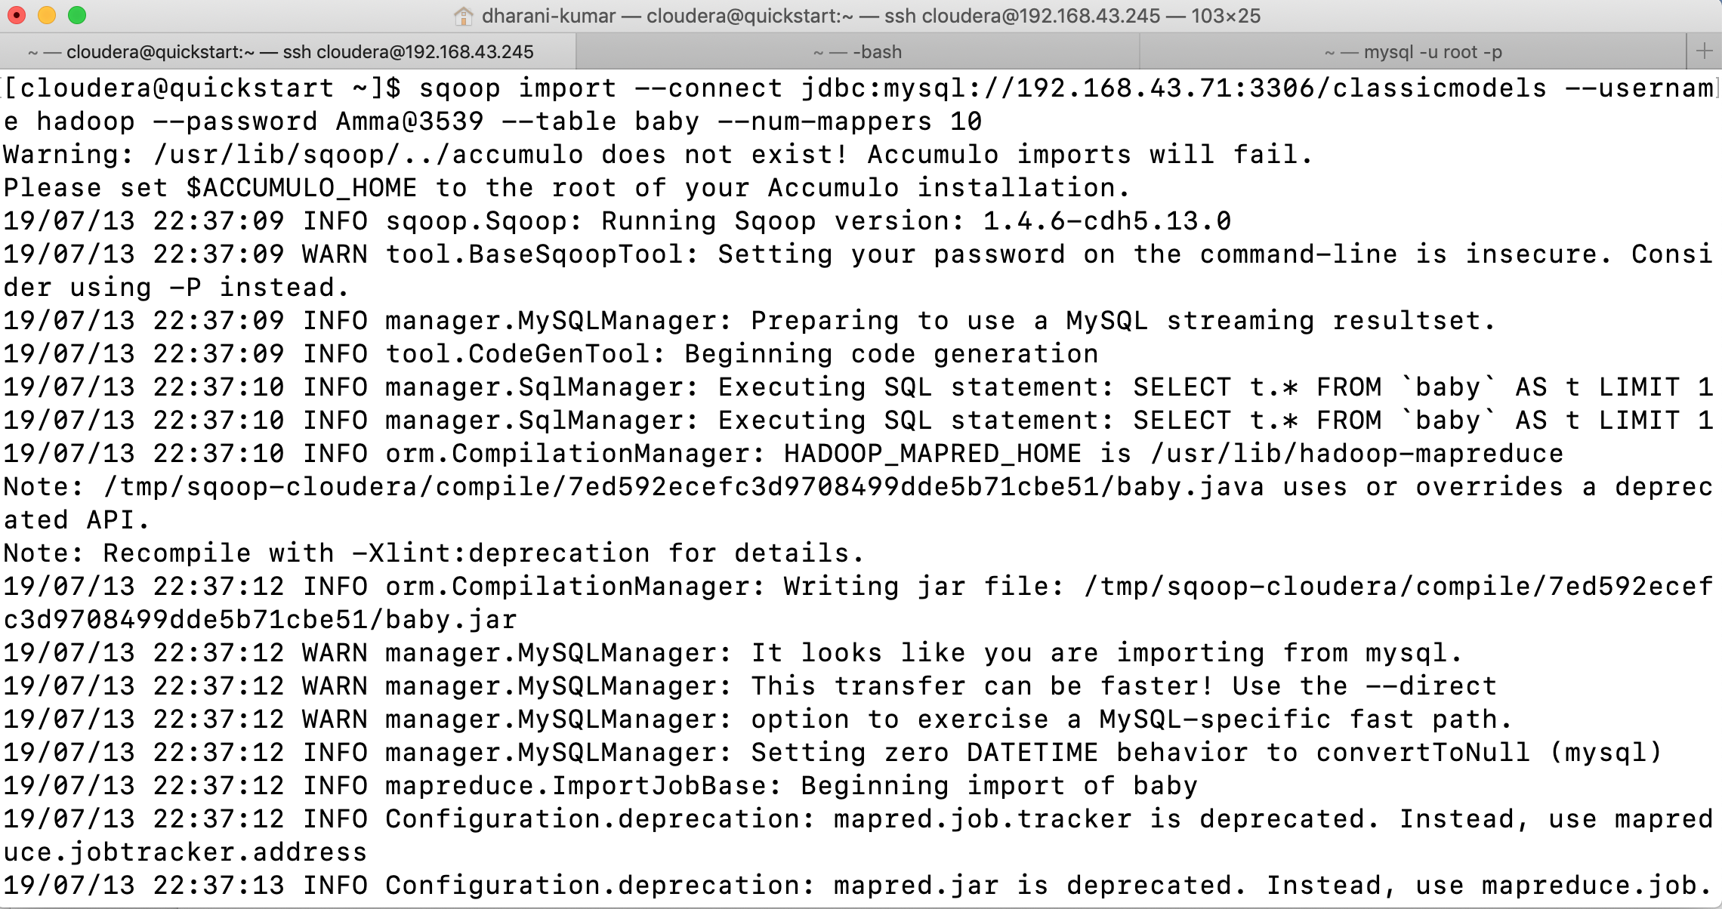

Encoding Null values: -

Sqoop encodes database NULL values using the null string constant. Your downstream processing (Hive Queries, custom MapReduce job, or Pig Script) uses a different constant for encoding missing values. You would like to override the default one.

You can override the NULL substitution string with the --null-string and --null-non-string parameters to any arbitrary value.

Almost all relational databases allow you to define columns as optional, allowing the columns to be associated with no value. This missing information is usually referred to as the NULL value. For example, a BOOL column generally contains only two distinct values: true and false. Additionally, the column can contain the value NULL if during table creation you’ve explicitly allowed that column to be optional. Databases usually store the NULL value as an extra bit in addition to the column’s usual data. With Sqoop supporting the import of data to formats that don’t natively support the NULL value (e.g. CSV file), there is a need to encode the missing value into the data itself. By default, Sqoop uses the string constant null (lowercased) for representing the missing value. This default constant might not suit your needs if your data can contain the same string constant as a regular value or if your downstream processing is expecting a different substitution string constant.

To allow easier integration with additional Hadoop ecosystem components, Sqoop distinguishes between two different cases when dealing with missing values. For text-based

columns that are defined with type VARCHAR, CHAR, NCHAR, TEXT, and a few others, you

can override the default substitution string using the parameter --null-string. For all other column types, you can override the substitution string with the --null-non-string parameter. Some of the connectors might not support different substitution strings for different column types and thus might require you to specify the same value in both parameters.

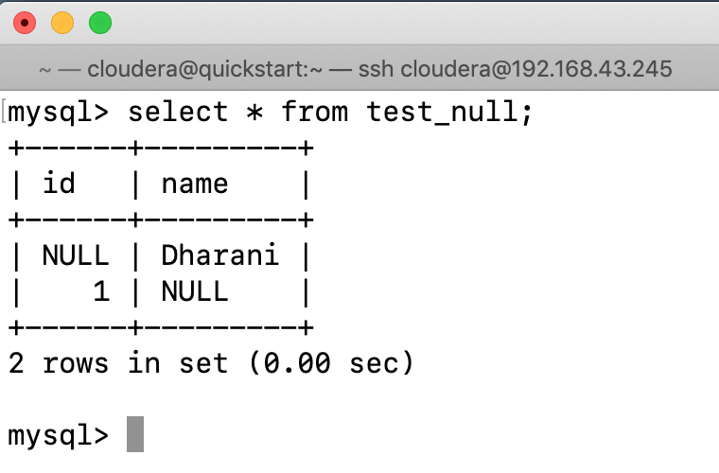

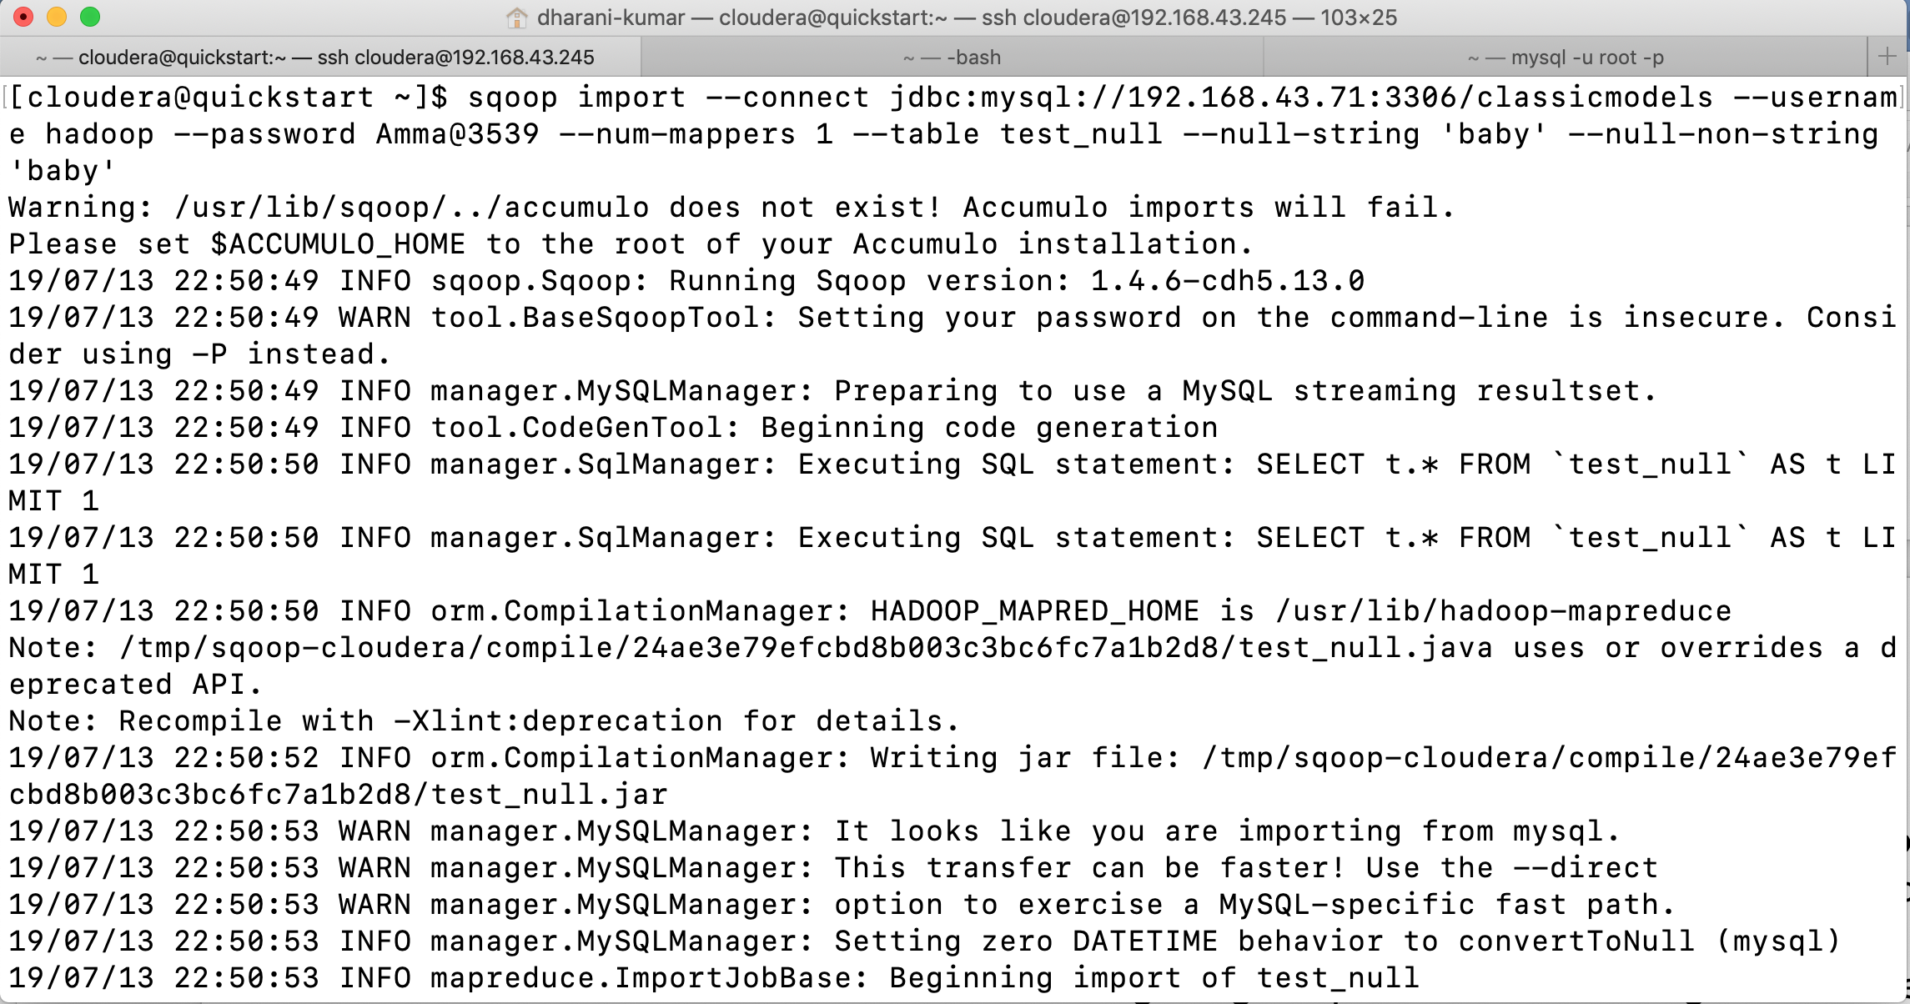

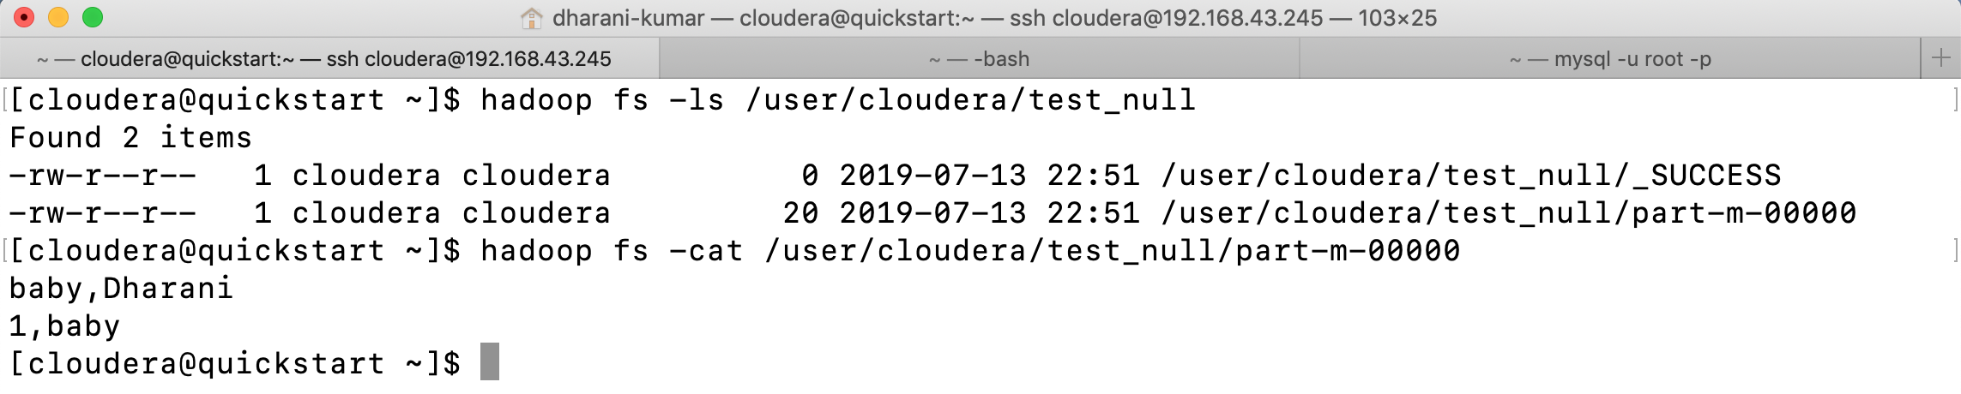

Importing All your tables: -

You would like to import all tables from your database at once using one command rather than importing the tables one by one.

Rather than using the import tool for one table, you can use the import-all-tables tool. For example, to import all tables from one database.

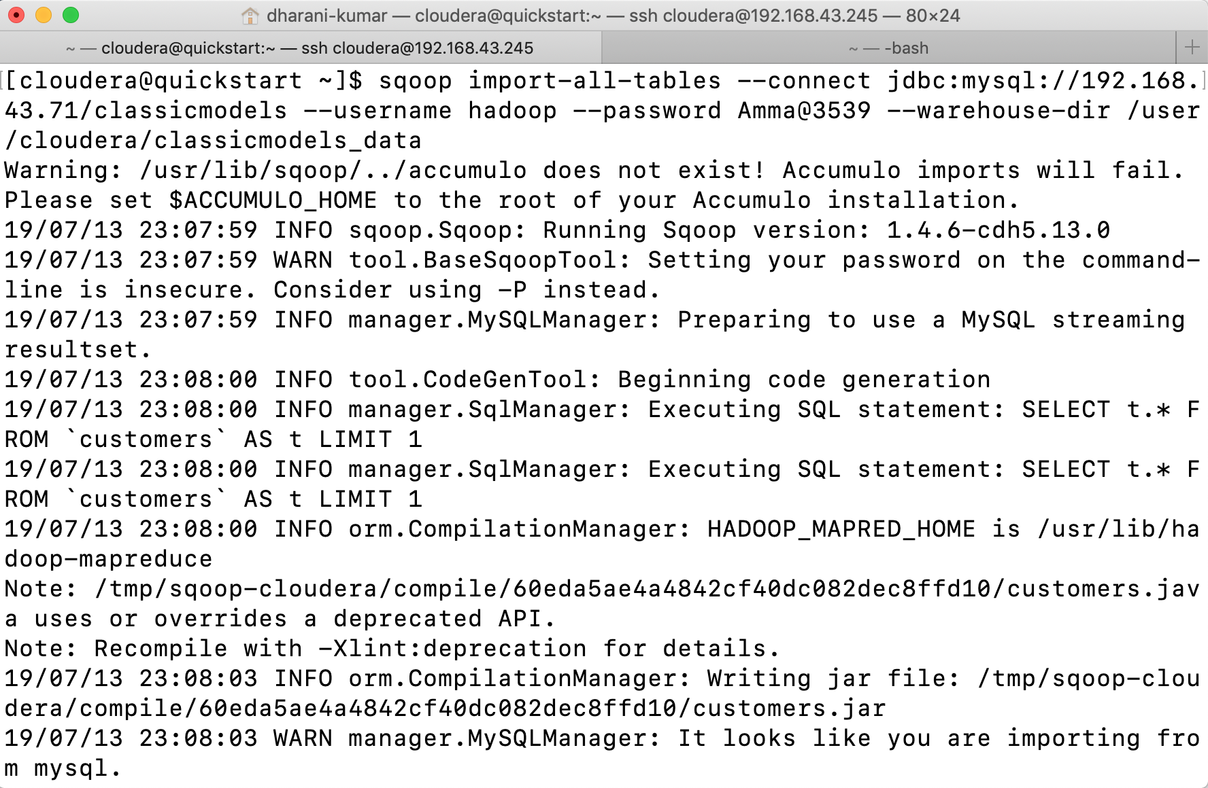

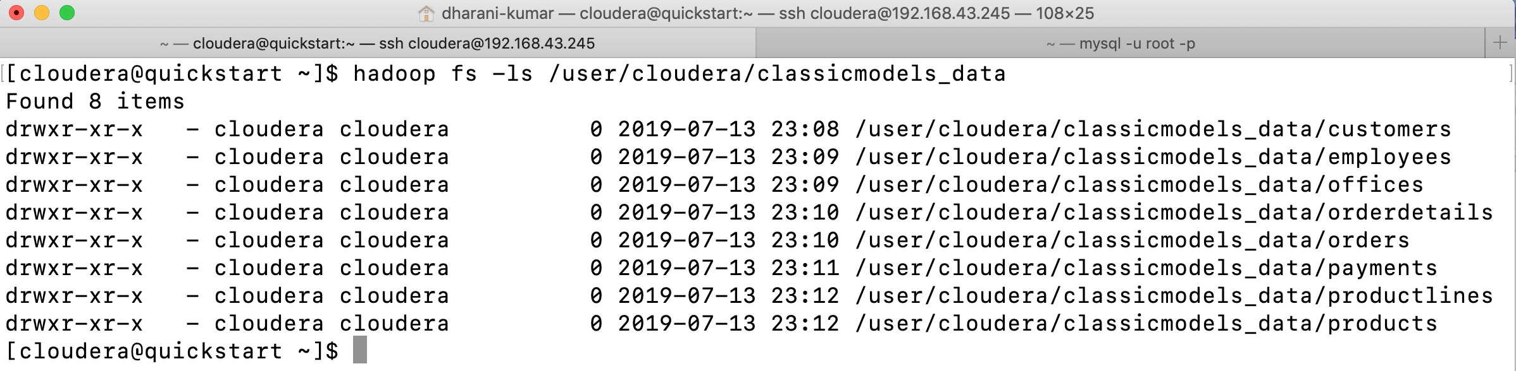

When using the import-all-tables tool, Sqoop will use catalog queries to retrieve a list of all tables in your database. Subsequently for each table, Sqoop will internally call the import tool to import your data to Hadoop. Tables will be imported in sequential order to avoid any unnecessary burden on the database server that would be created by importing several tables at the same time. With this one command, Sqoop will import the entire content of a given database to Hadoop.

If you need to import all but a few tables, you can use the parameter --exclude-tables that accepts a comma-separated list of table names that should be excluded from the bulk import.

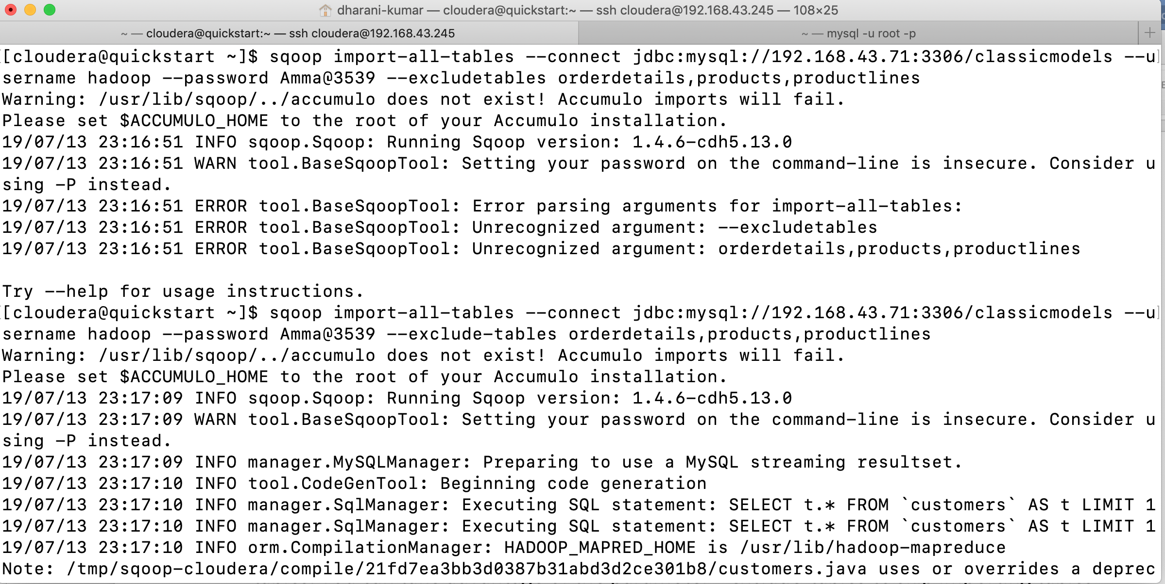 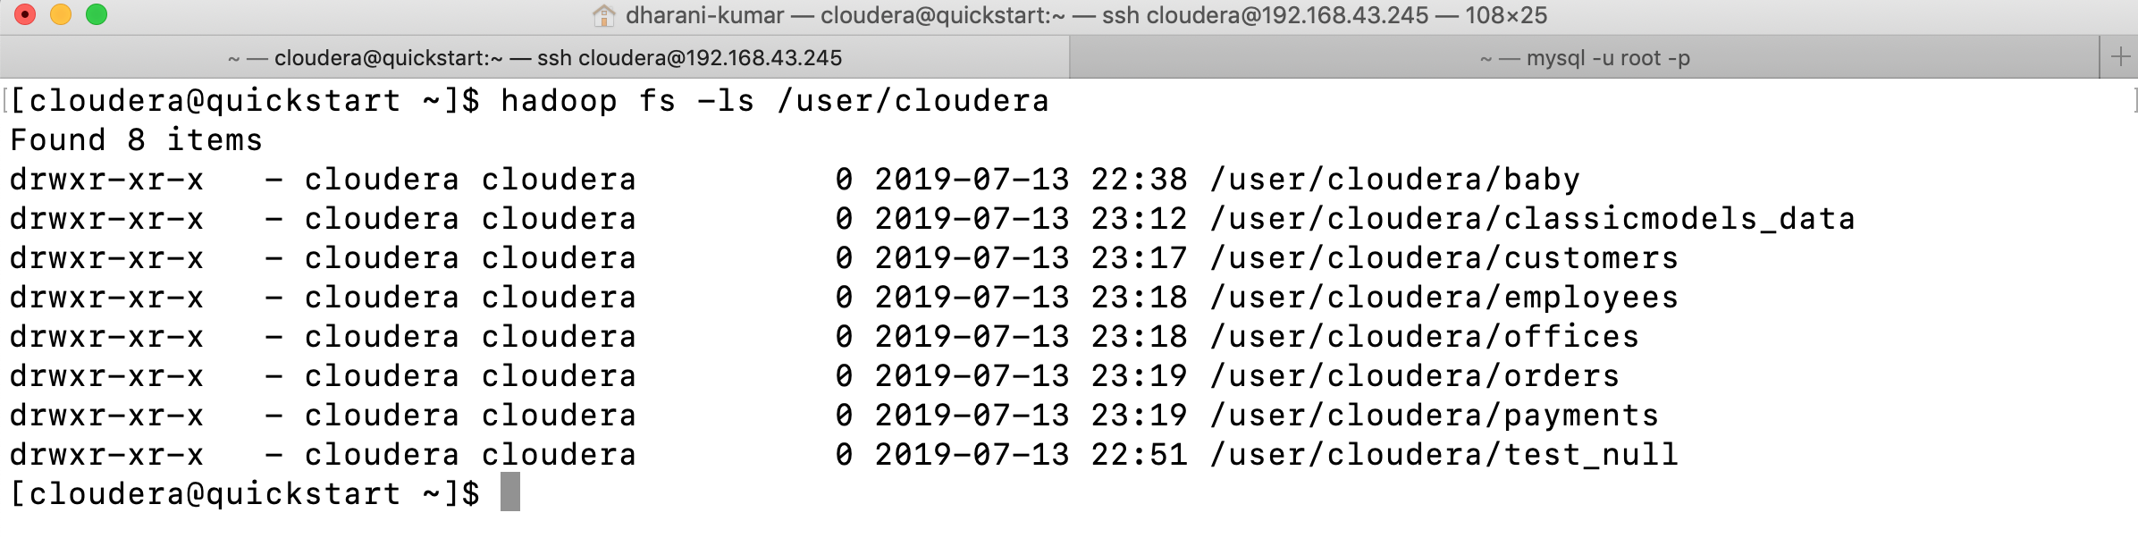

If we don’t give any directory then all the tables data will be stored in the home directory separately.

Importing all tables will internally call the usual import tool for transferring each table. You’ll find that many of the import parameters can’t be used in conjunction with the import-all-tables tool.

For example, you can’t use the parameter --target-dir, as that would instruct Sqoop to import all tables into the same directory, resulting in a total file mess on HDFS. Using the --warehouse-dir parameter is fine, as this parameter can be easily used for all imported tables. You can take advantage of the parameter --exclude-tables to skip importing tables that need special parameters; you can then import them separately using the import tool, which allows you to specify additional parameters.

Incremental Import: -

So far, we have covered use cases where you had to transfer entire table’s contents from the database into Hadoop as a one-time operation. What if you need to keep the imported data on Hadoop in sync with the source table on relational database side? While you could obtain a fresh copy every day by reimporting all the data, that would not be optimal. The amount of time needed to import the data would increase in proportion to the amount of additional data appended to the table daily. This would put an unnecessary burden on your database. Why reimport the data that has already been imported? For transferring deltas of data Sqoop offers ability to do incremental imports.

You have a database table with an INTEGER primary key. You are only appending new rows, and you need to periodically sync the table’s state to Hadoop for further processing.

Activate Sqoop’s incremental feature by specifying the --incremental parameter. The parameter’s value will be the type of incremental import. When your table is only getting new rows and the existing ones are not changed, use the append mode.

Incremental import also requires two additional parameters: --check-column indicates a column name that should be checked for newly appended data, and --last-value contains the last value that successfully imported into Hadoop.

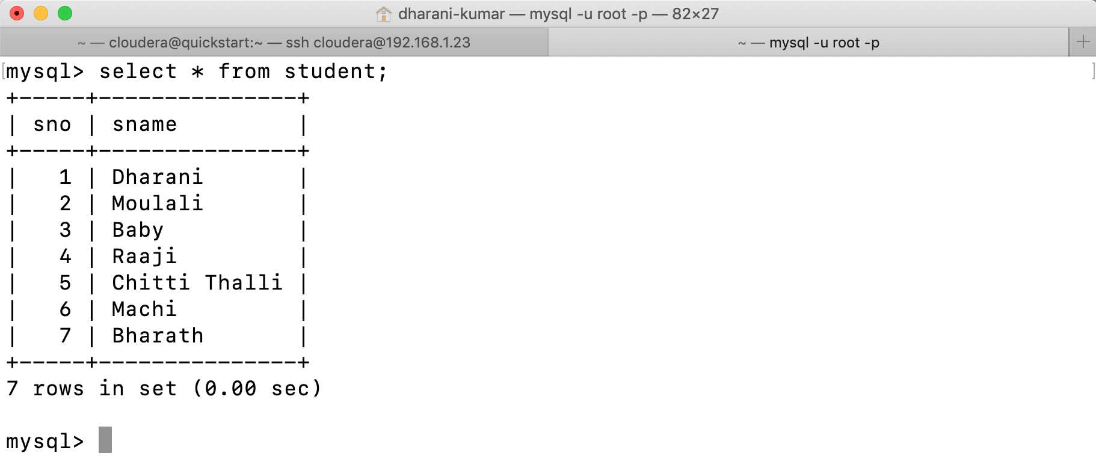

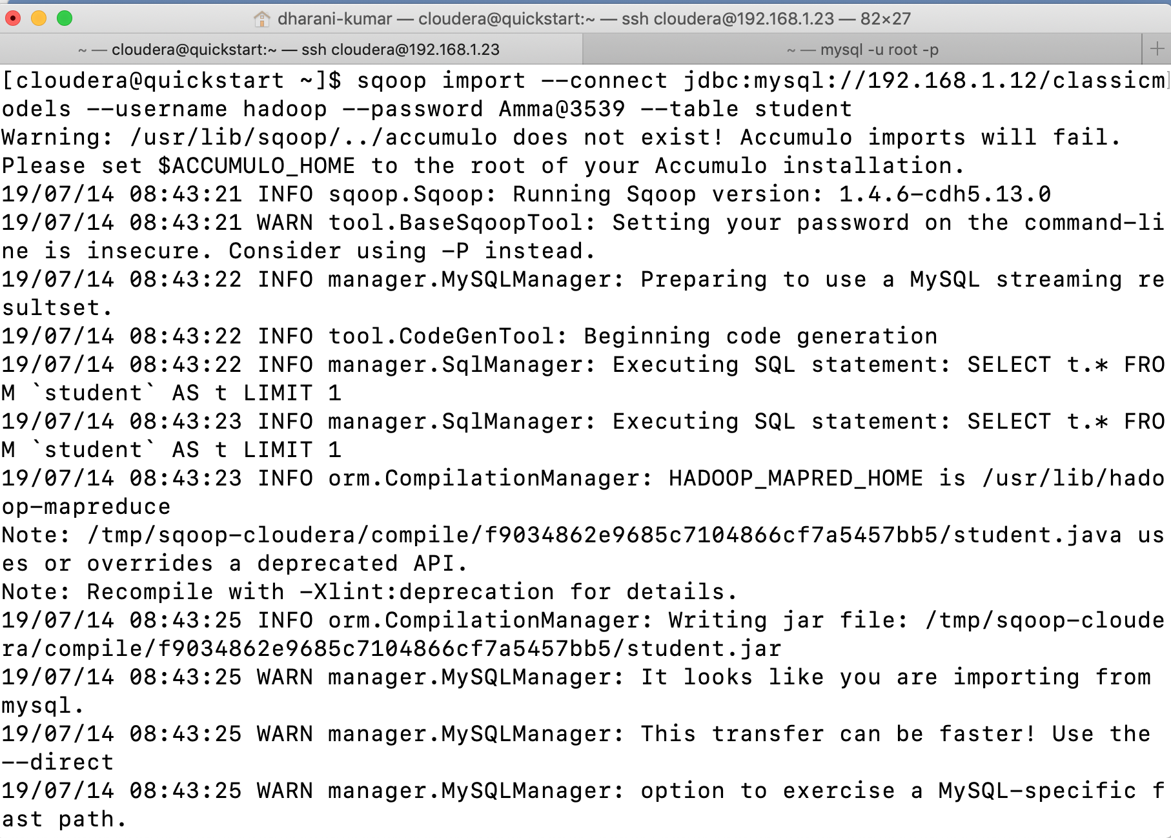

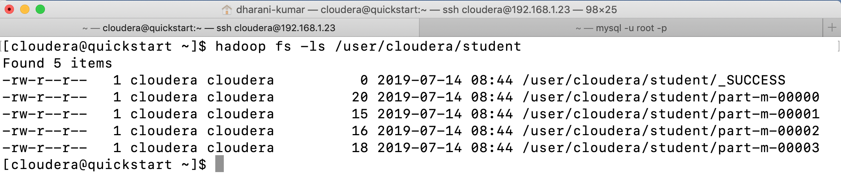

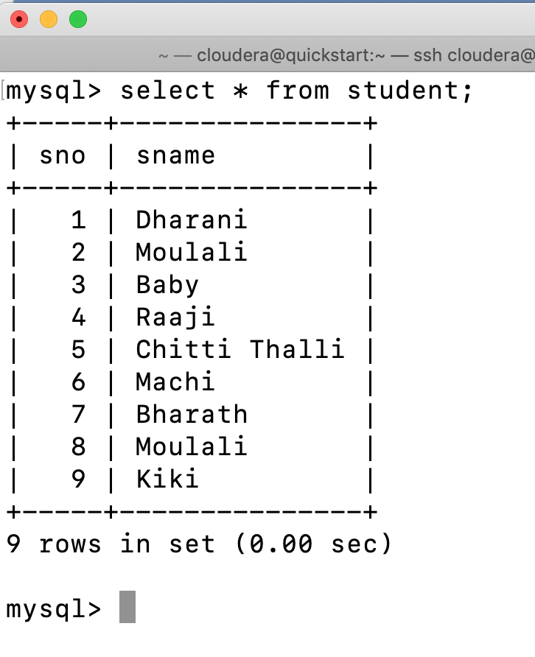

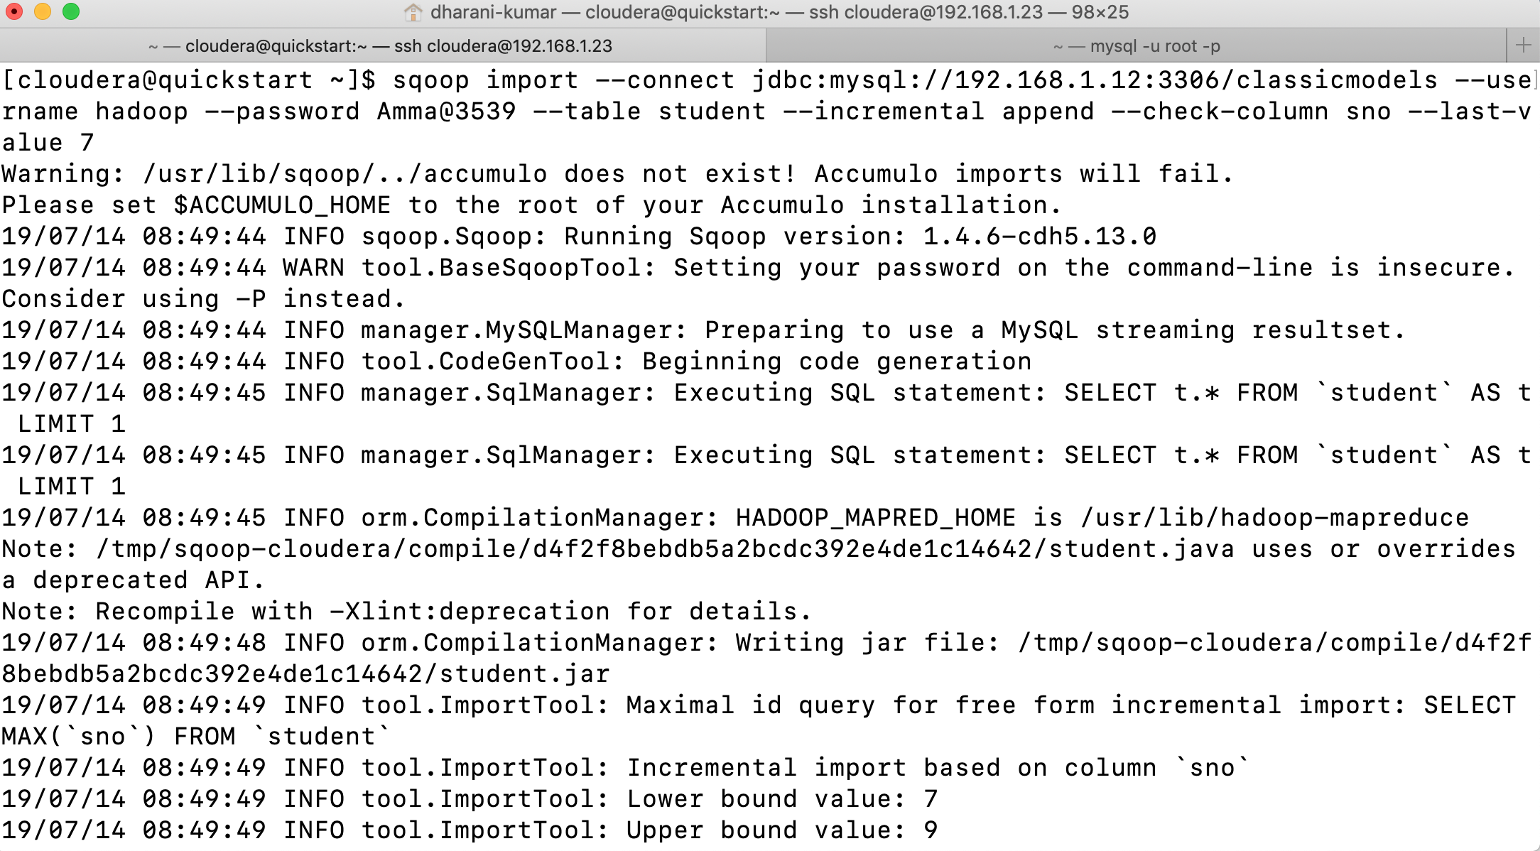

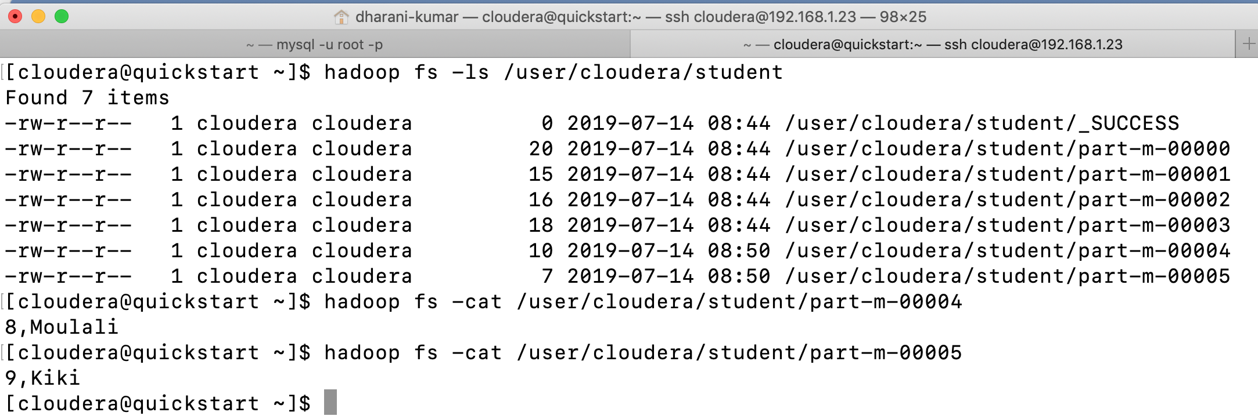

Incremental import in append mode will allow you to transfer only the newly created rows. This saves a considerable amount of resources compared with doing a full import every time you need the data to be in sync. One downside is the need to know the value of the last imported row so that next time Sqoop can start off where it ended. Sqoop when running in incremental mode always prints out the value of the last imported row. This allows you to easily pick up where you left off.

Any changed rows that were already imported from previous runs won’t be transmitted again. This method is meant for tables that are not updating rows.

Incrementally Importing Mutable data: -

While you would like to use the incremental import feature, the data in your table is also being updated, ruling out the use of the append mode.

Use the lastmodified mode instead of the append mode. The incremental mode lastmodified requires a column holding a date value (suitable types are date, time, datetime, and timestamp) containing information as to when each row was last updated. Sqoop will import only those rows that were updated after the last import. This column should be populated to the current time on every new row insertion or on a change to an existing row. This ensures that sqoop can pick up changed rows accurately. Sqoop only knows what you tell it. The onus is on your application to reliably update this column on every row change. Any row that does not have modified column, as specified in the --check-column parameter won’t be imported.

Internally the lastmodified incremental import consists of two standalone MapReduce jobs. The first job will import the delta of changed data similarly to normal import. This import job will save data in temporary directory on HDFS. The second job will take both the old and new data and will merge them together into final output, preserving only the last updated value for each row.

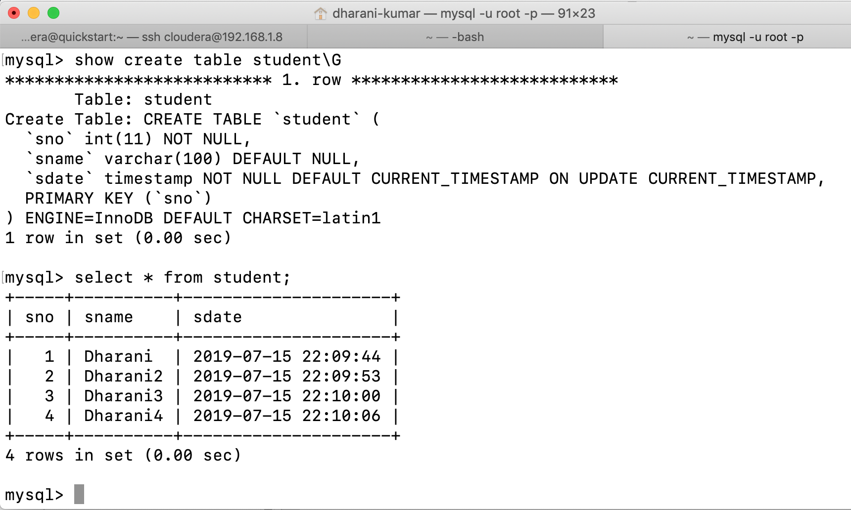

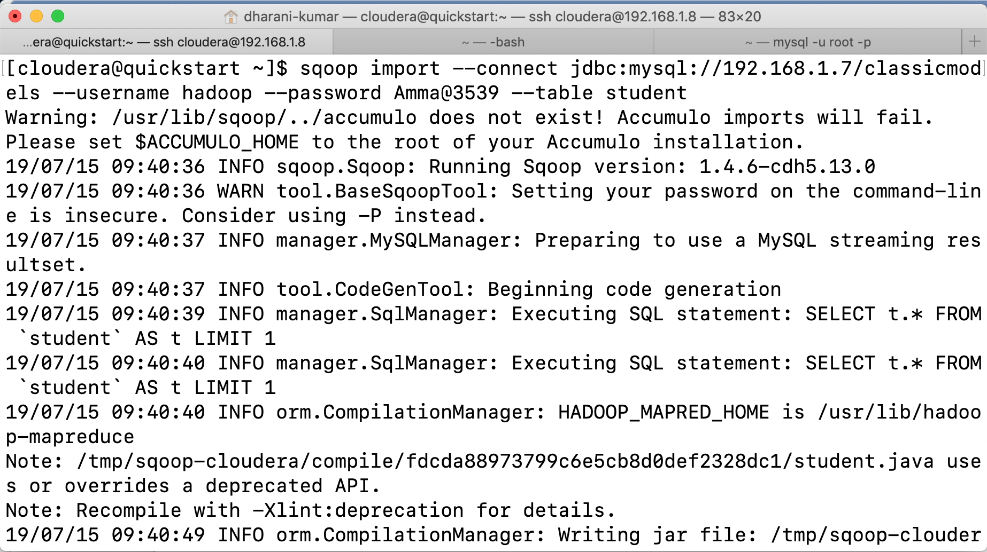

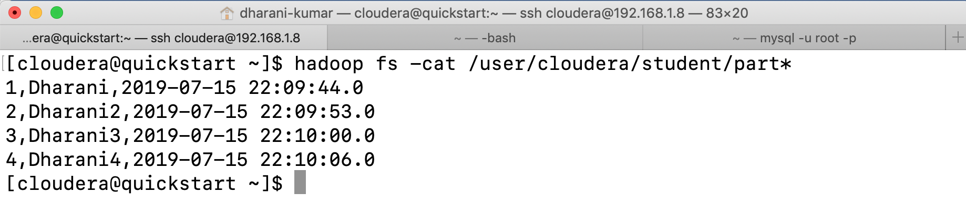

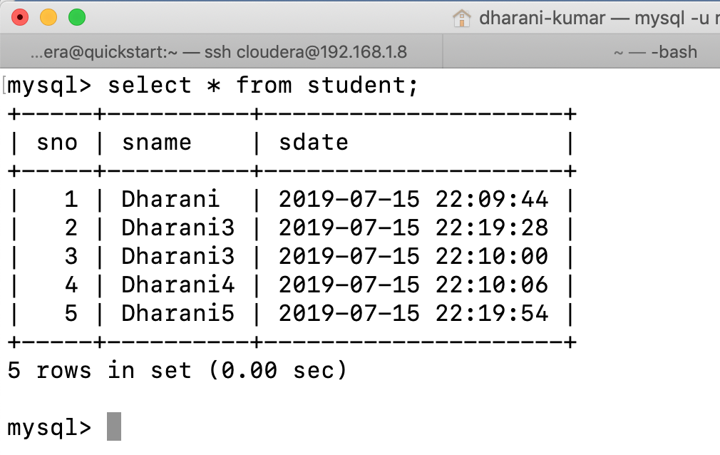

If we don’t use any merge key or append when we use lastmodified we will get an error.



The --last-value will be the current timestamp.

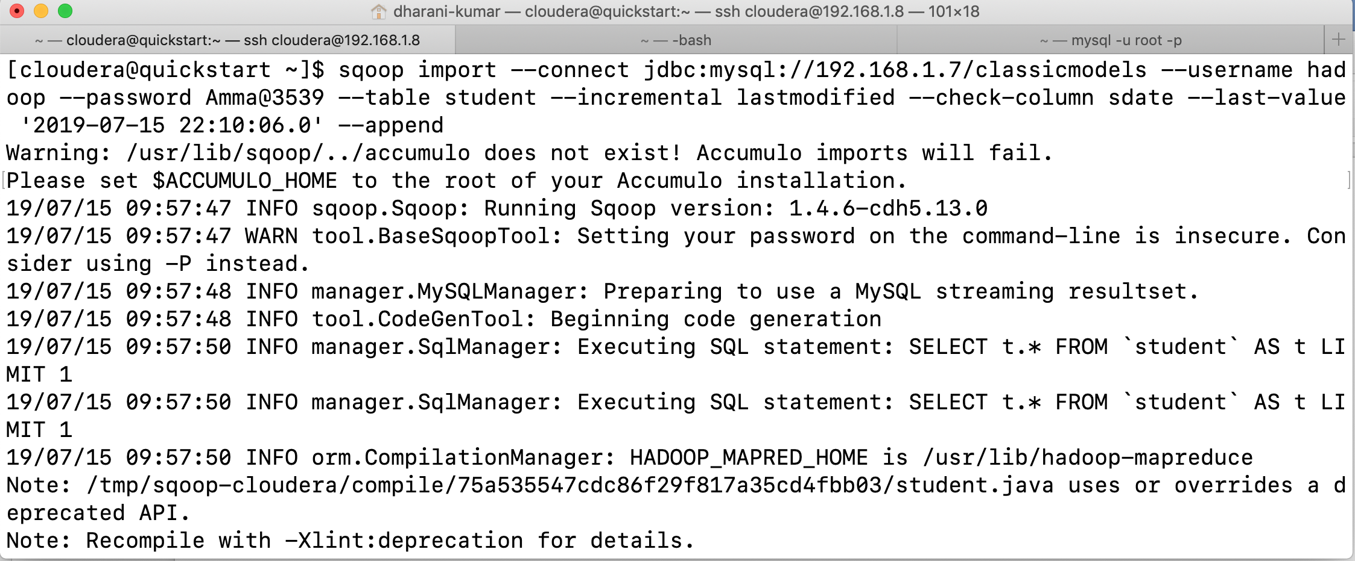



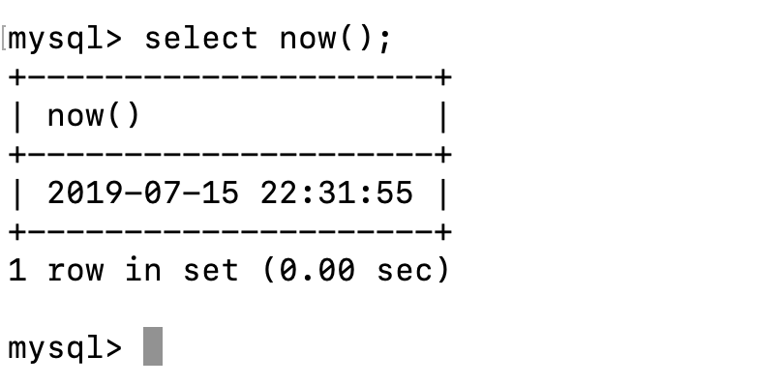

When we use append, new files are created and the modified and insert rows after the given timestamp will be inserted in it.

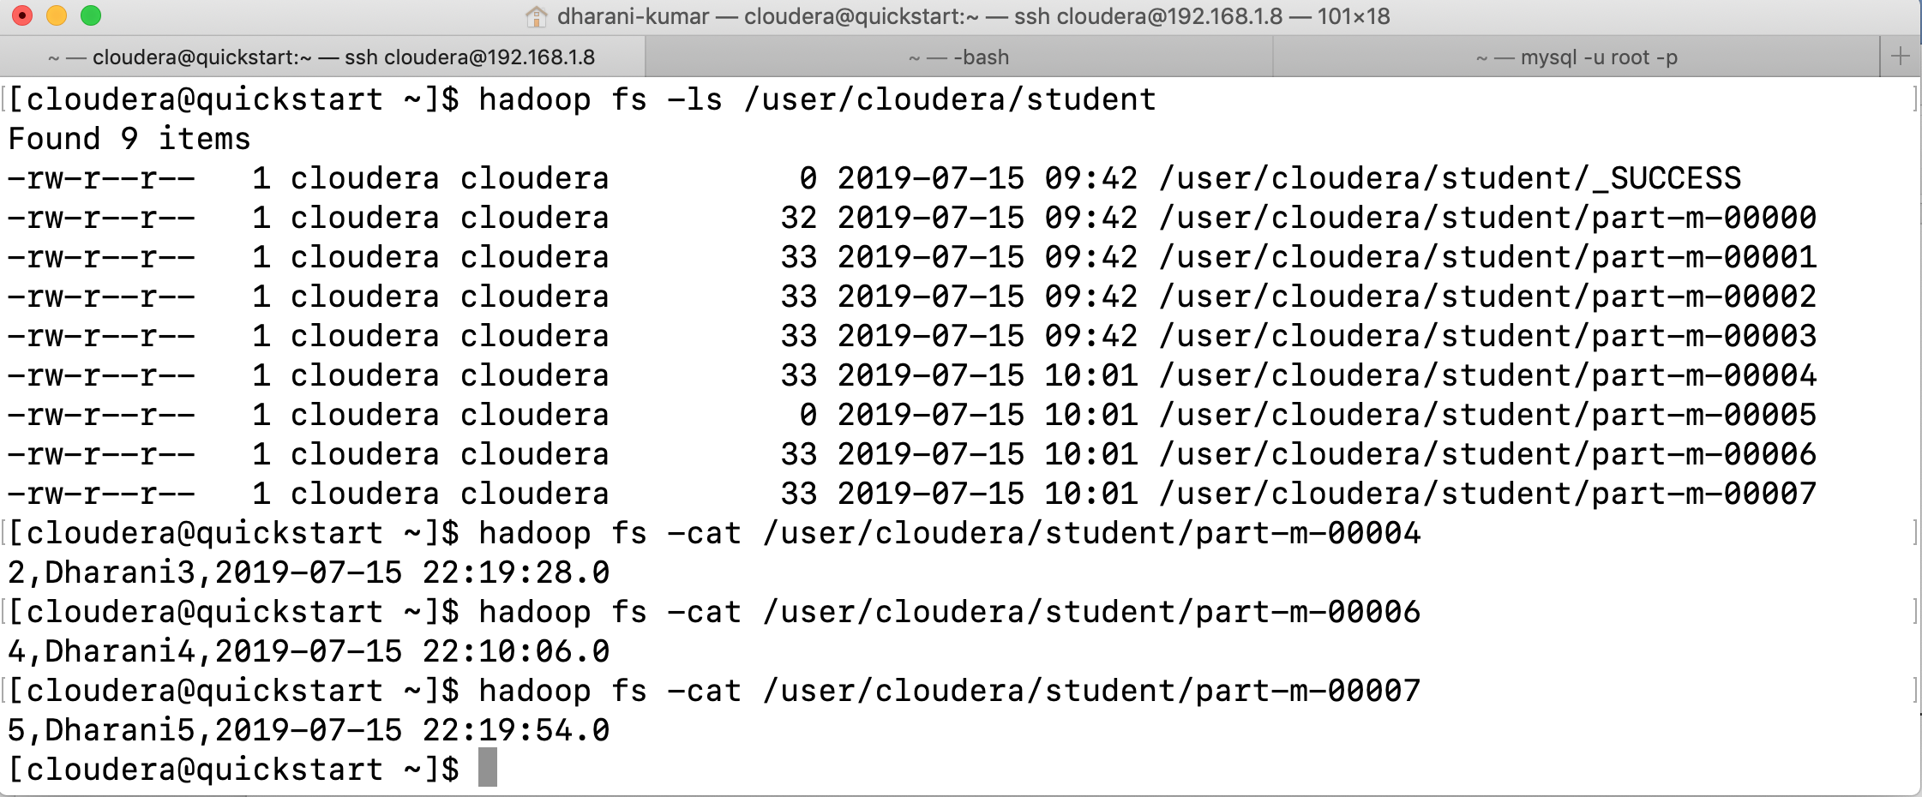

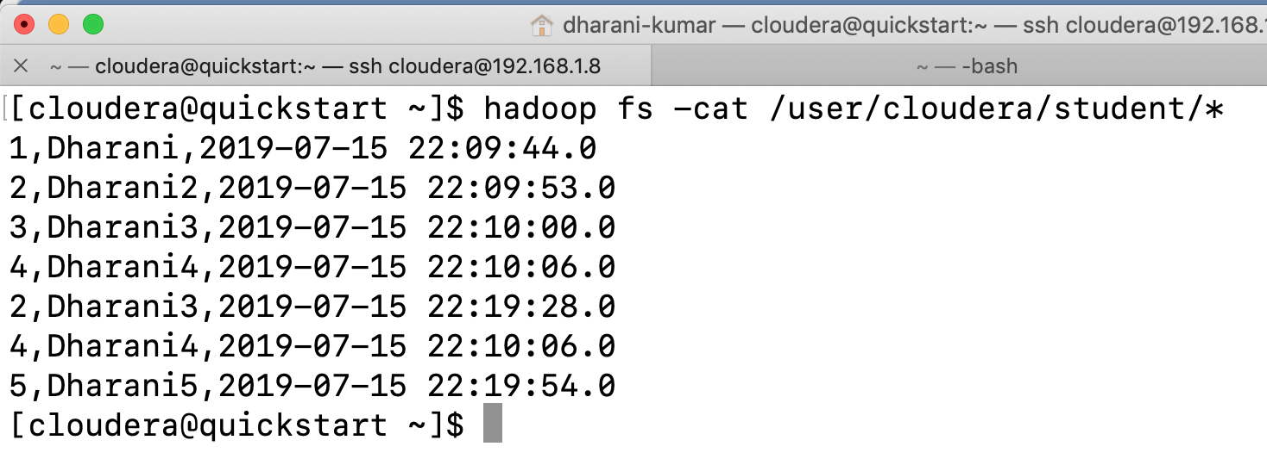

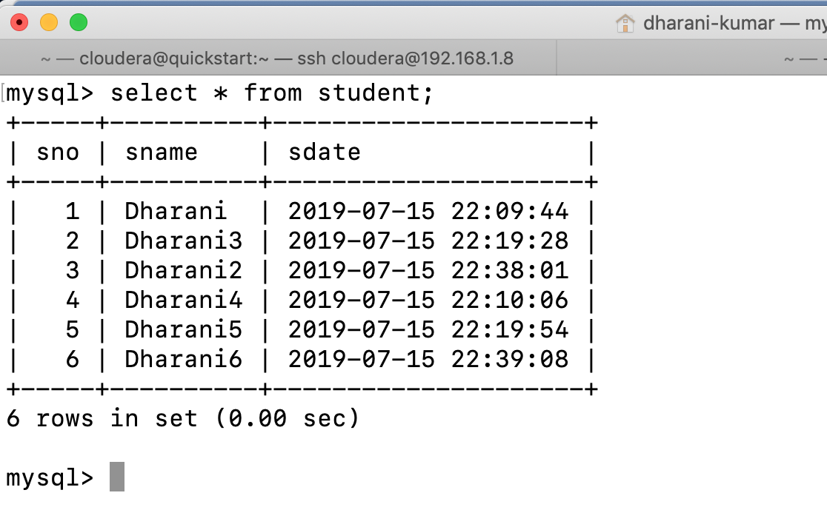

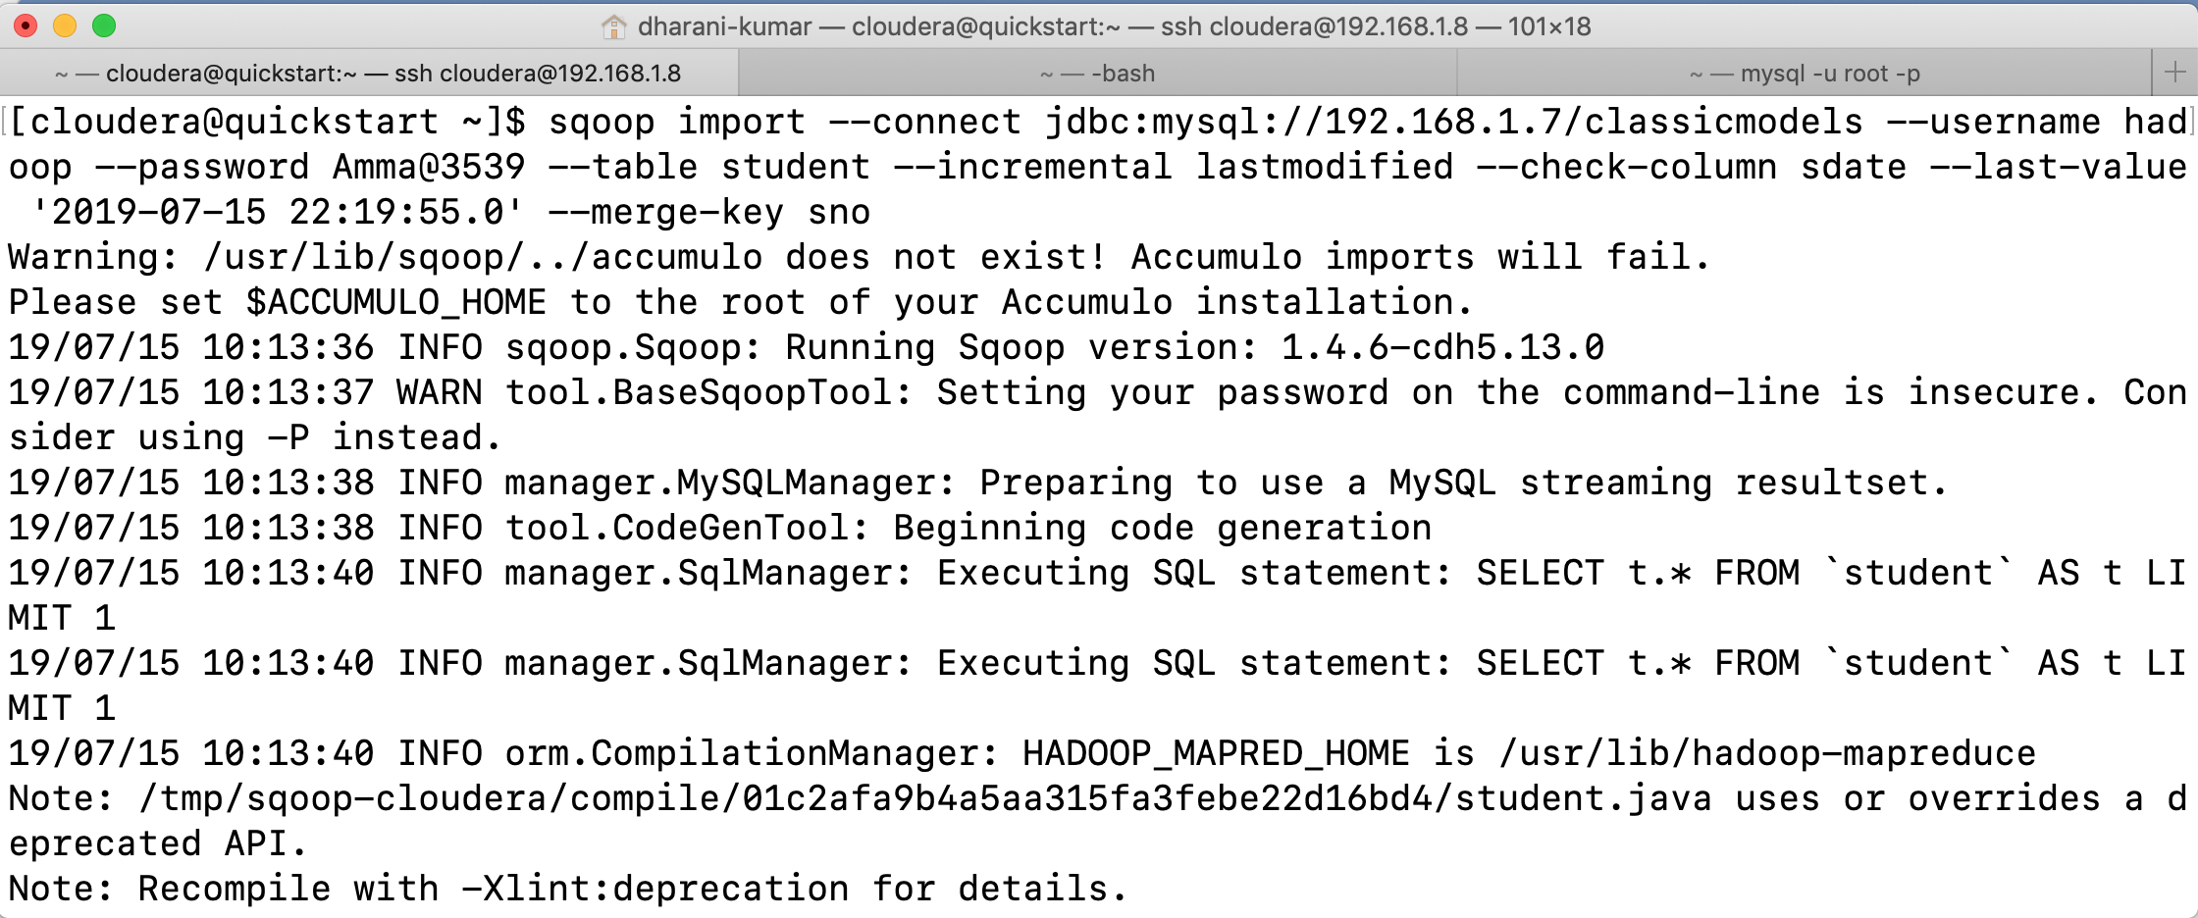



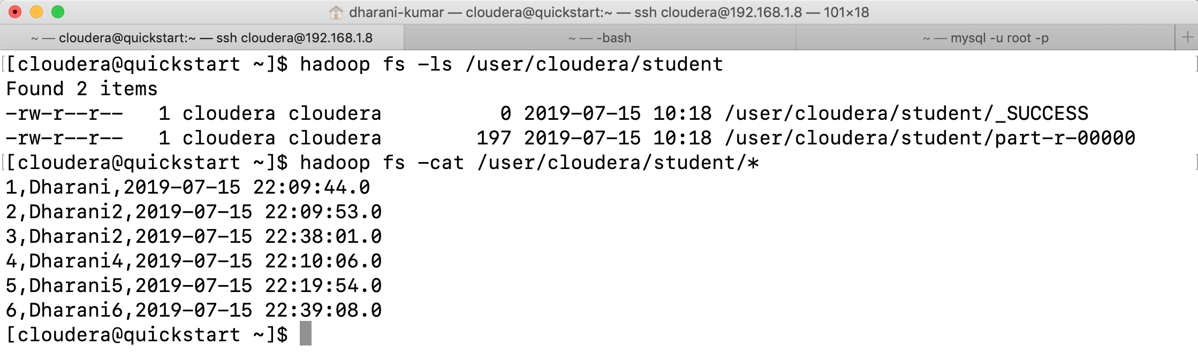

Preserving the Last imported value: -

Incremental import is a great feature that you are using a lot. Shouldering the responsibility for remembering the last imported value is getting to be hassle.

You can take the advantage of the built-in Sqoop metastore that allows you to save all parameters for later reuse. The sqoop metastore is a powerful part of sqoop that allows you to retain your job definitions and to easily run them anytime. Each saved job has a logical name that is used for referencing.

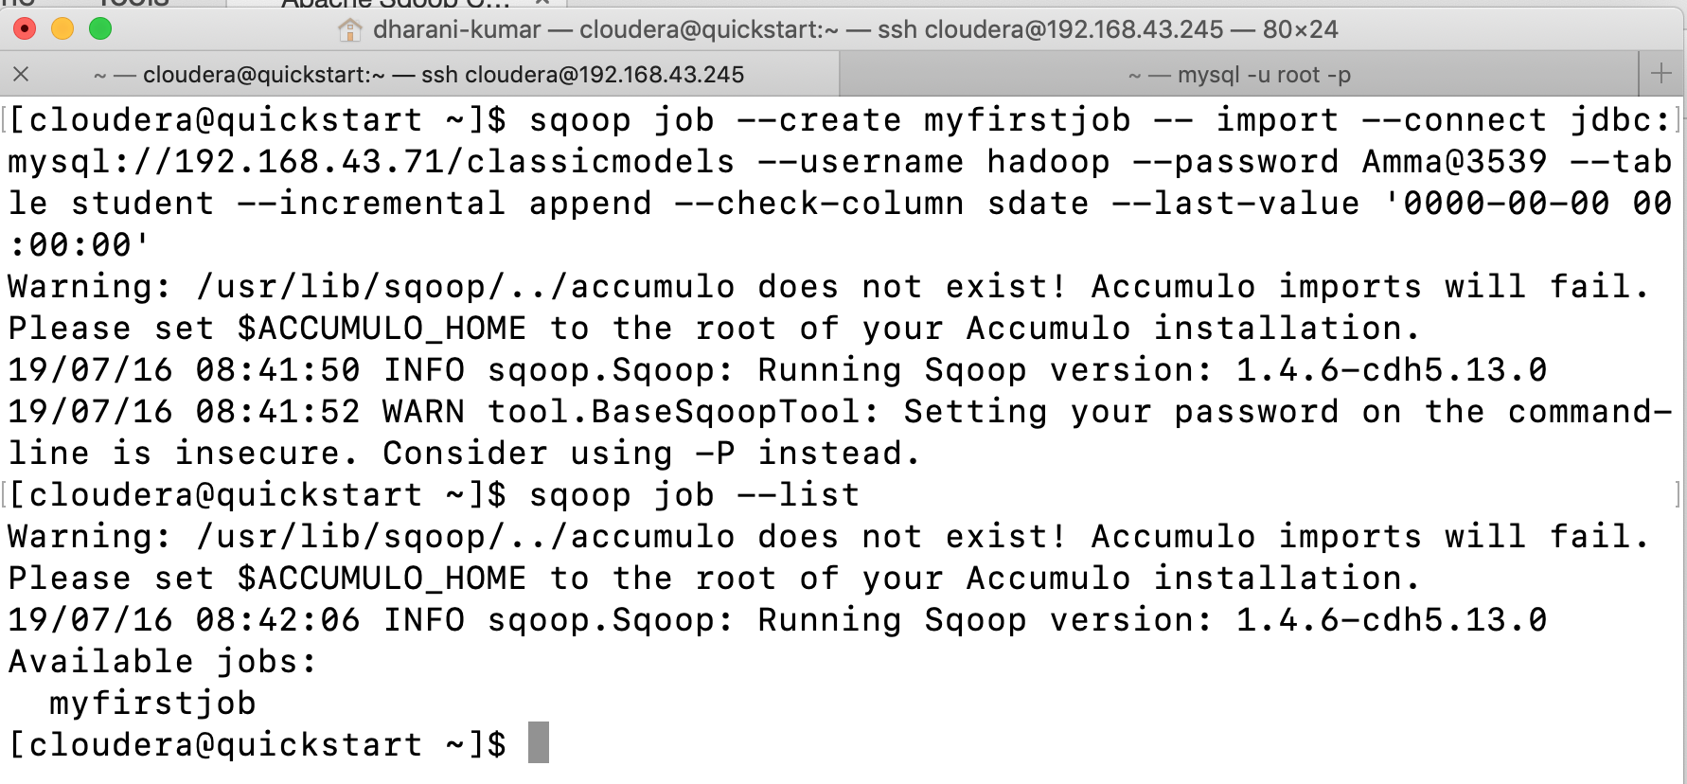

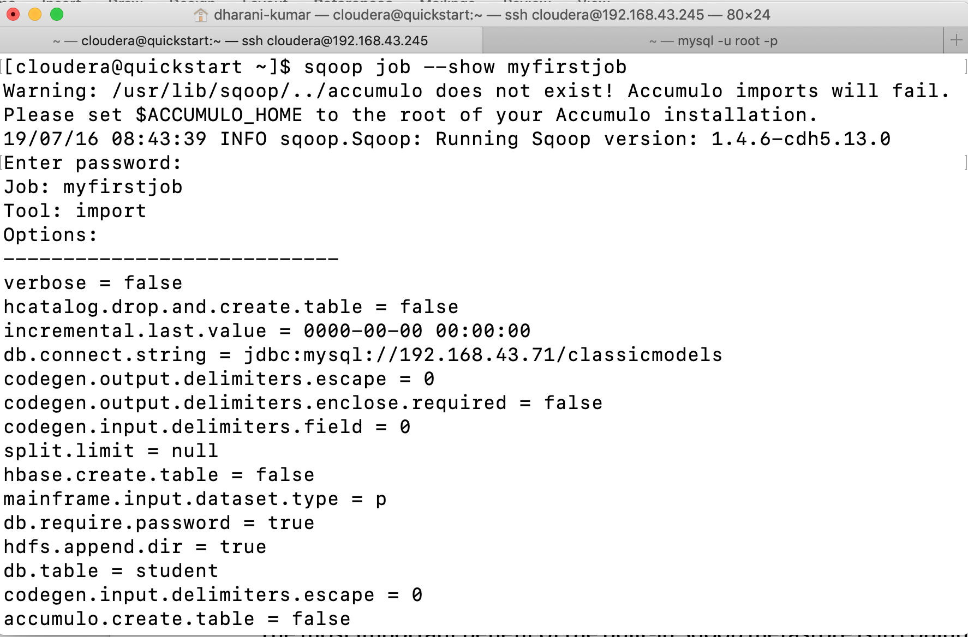

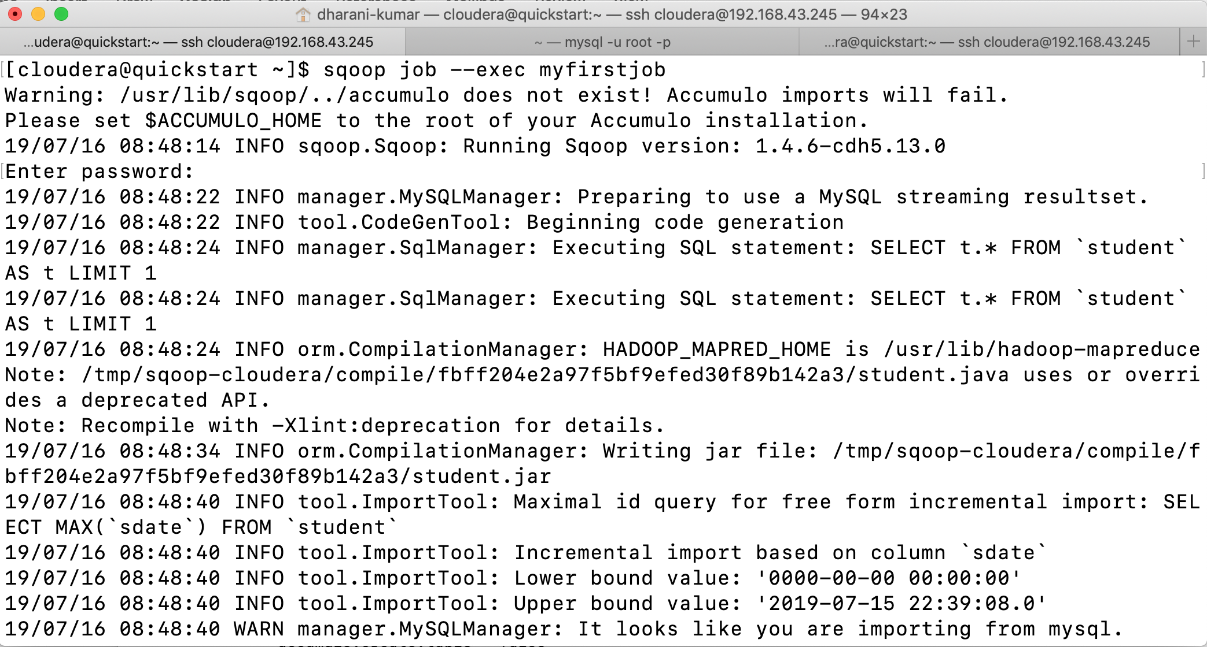

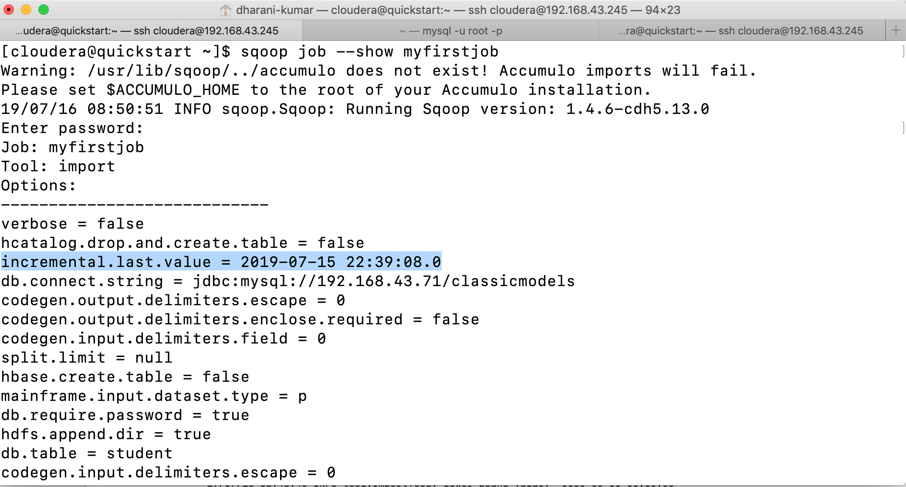

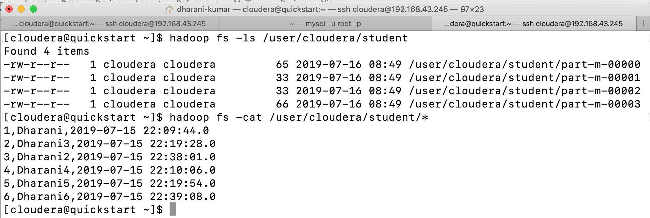

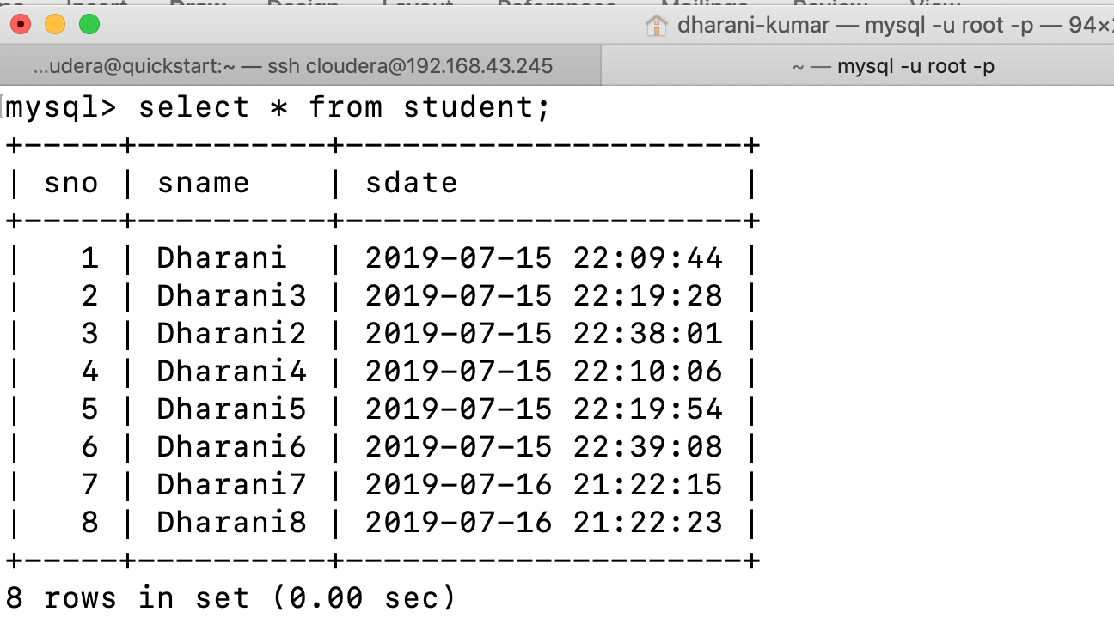

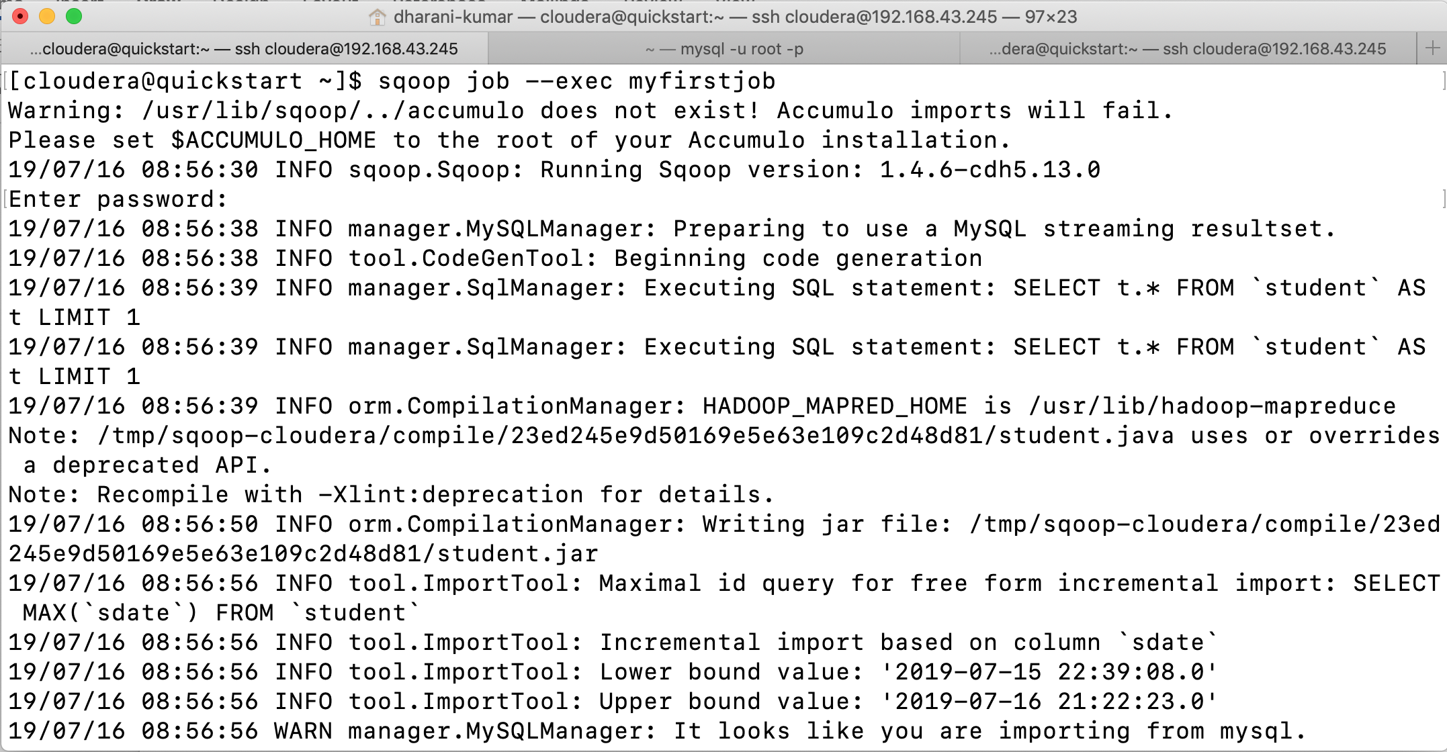

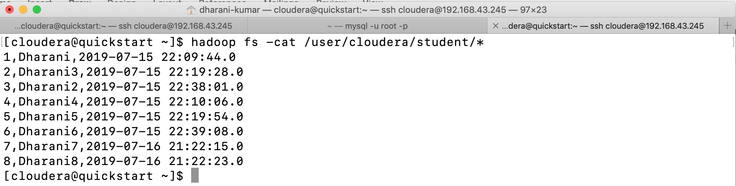

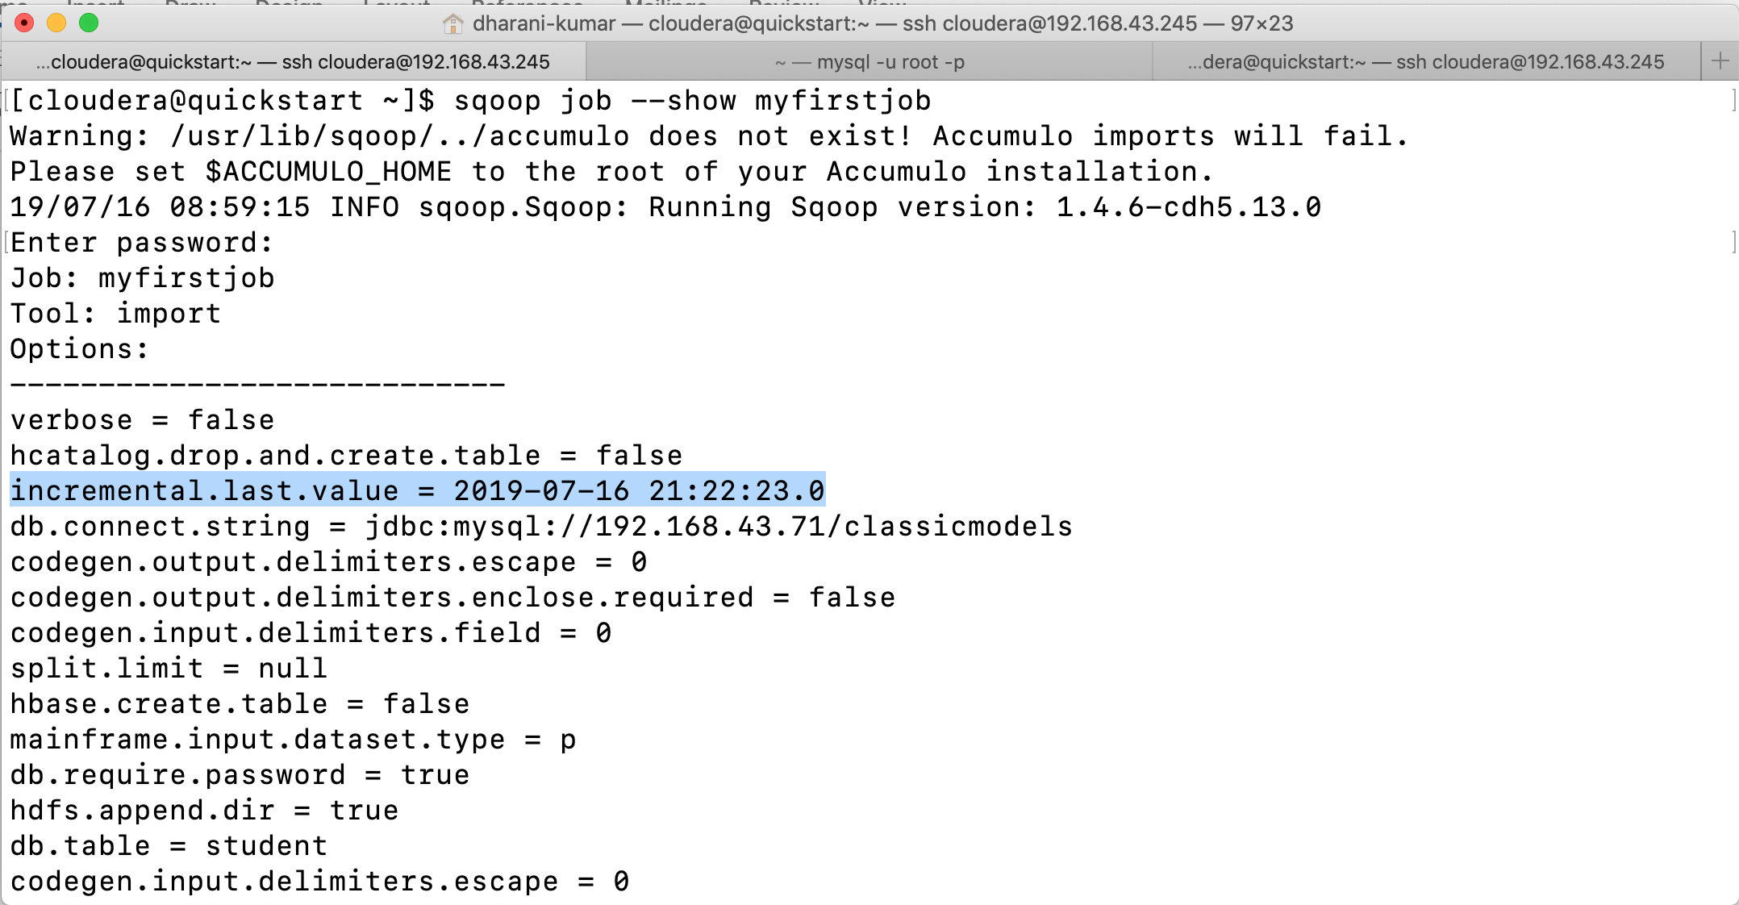

Once you create the job you are not required to give last value separately it will automatically take the last value. Directly we can execute the job without providing the last value.

To execute a job sqoop job --exec jobname.

You can list all retained jobs using the --list parameter.

sqoop job --list

You can remove the old job definitions that are no longer needed with the --delete parameter.

Finally, you can also view content of saved job definition using the --show parameter.

Output of the show command will be in the form of properties. Unfortunately, sqoop currently can’t rebuild the command line that you used to create the saved job.

The most important benefit of the built-in Sqoop metastore is in conjunction with incremental import. Sqoop will automatically serialize the last imported value back into the metastore after each successful incremental job. This way, users do not need to remember the last imported value after each execution; everything is handled automatically.

Storing Passwords in Metastore: -

You like the built-in Sqoop metastore for its ability to store jobs and the option to elegantly run them at your convenience. As a next step, you would like to automate the process and start the jobs automatically. Unfortunately, each execution requires you to enter a password, which is not easily automated by a script.

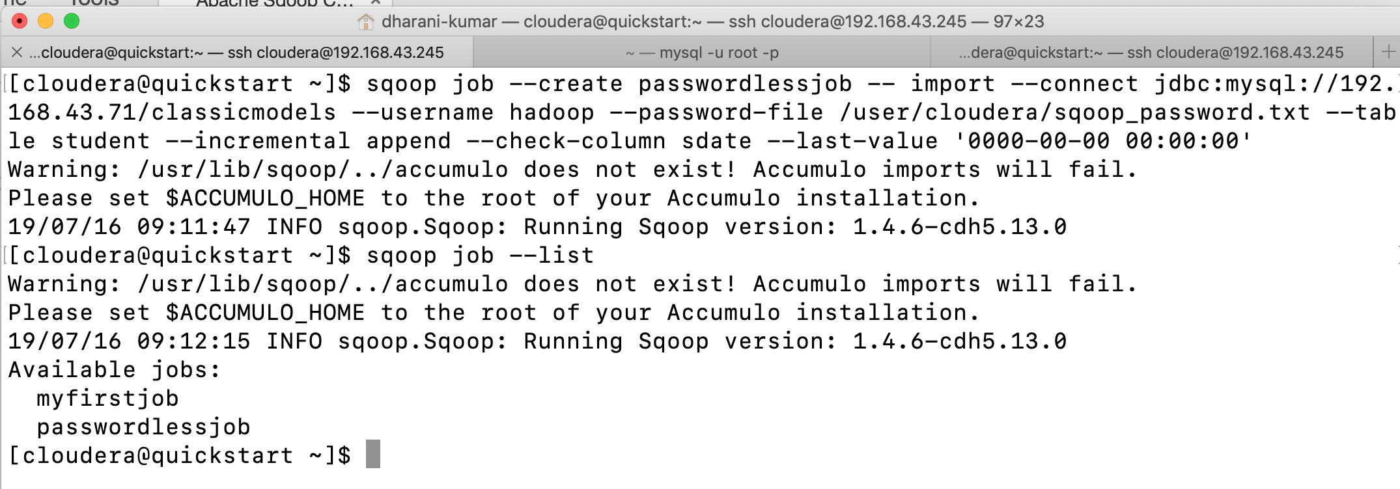

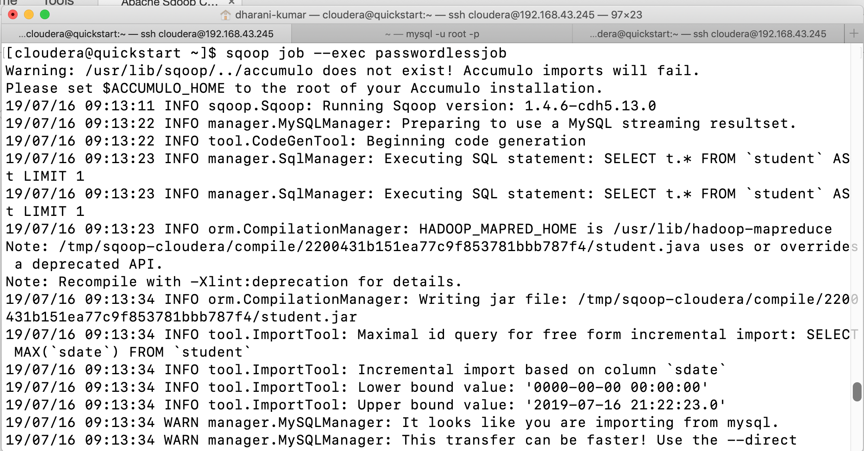

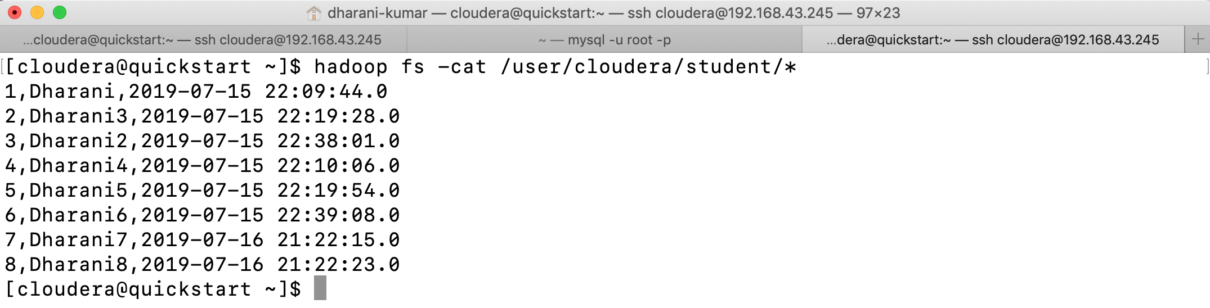

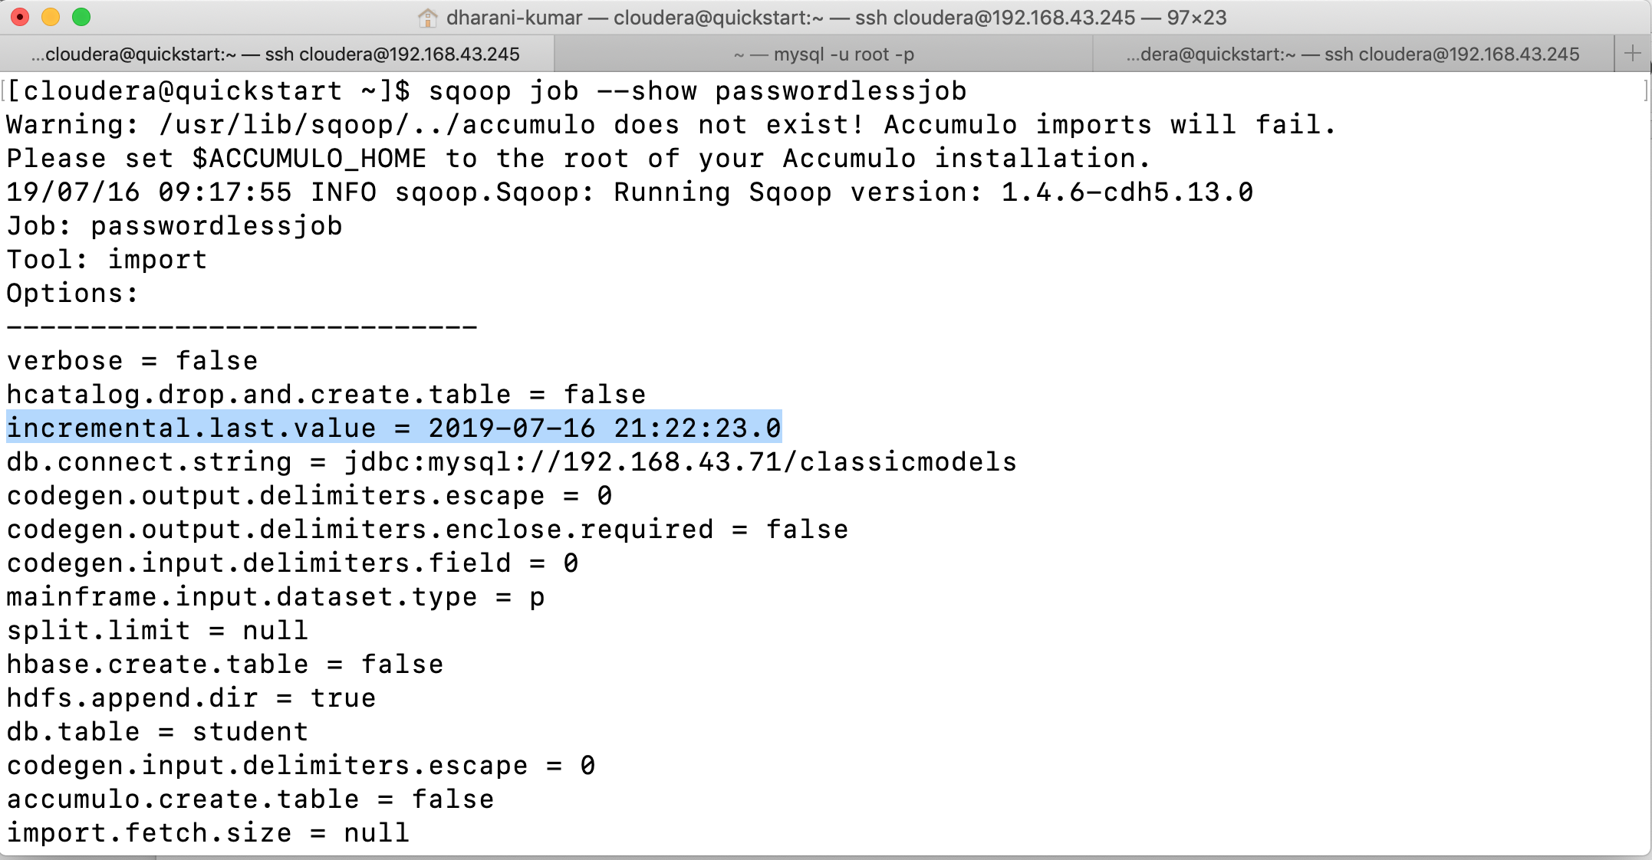

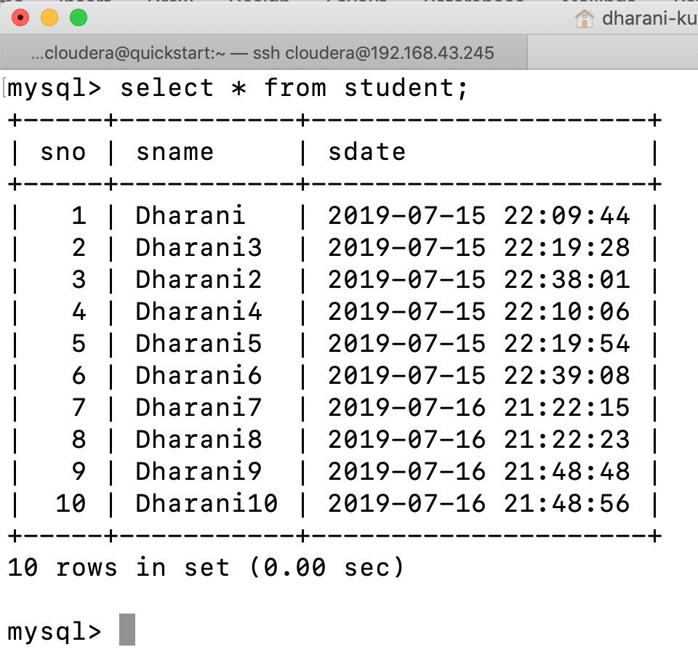

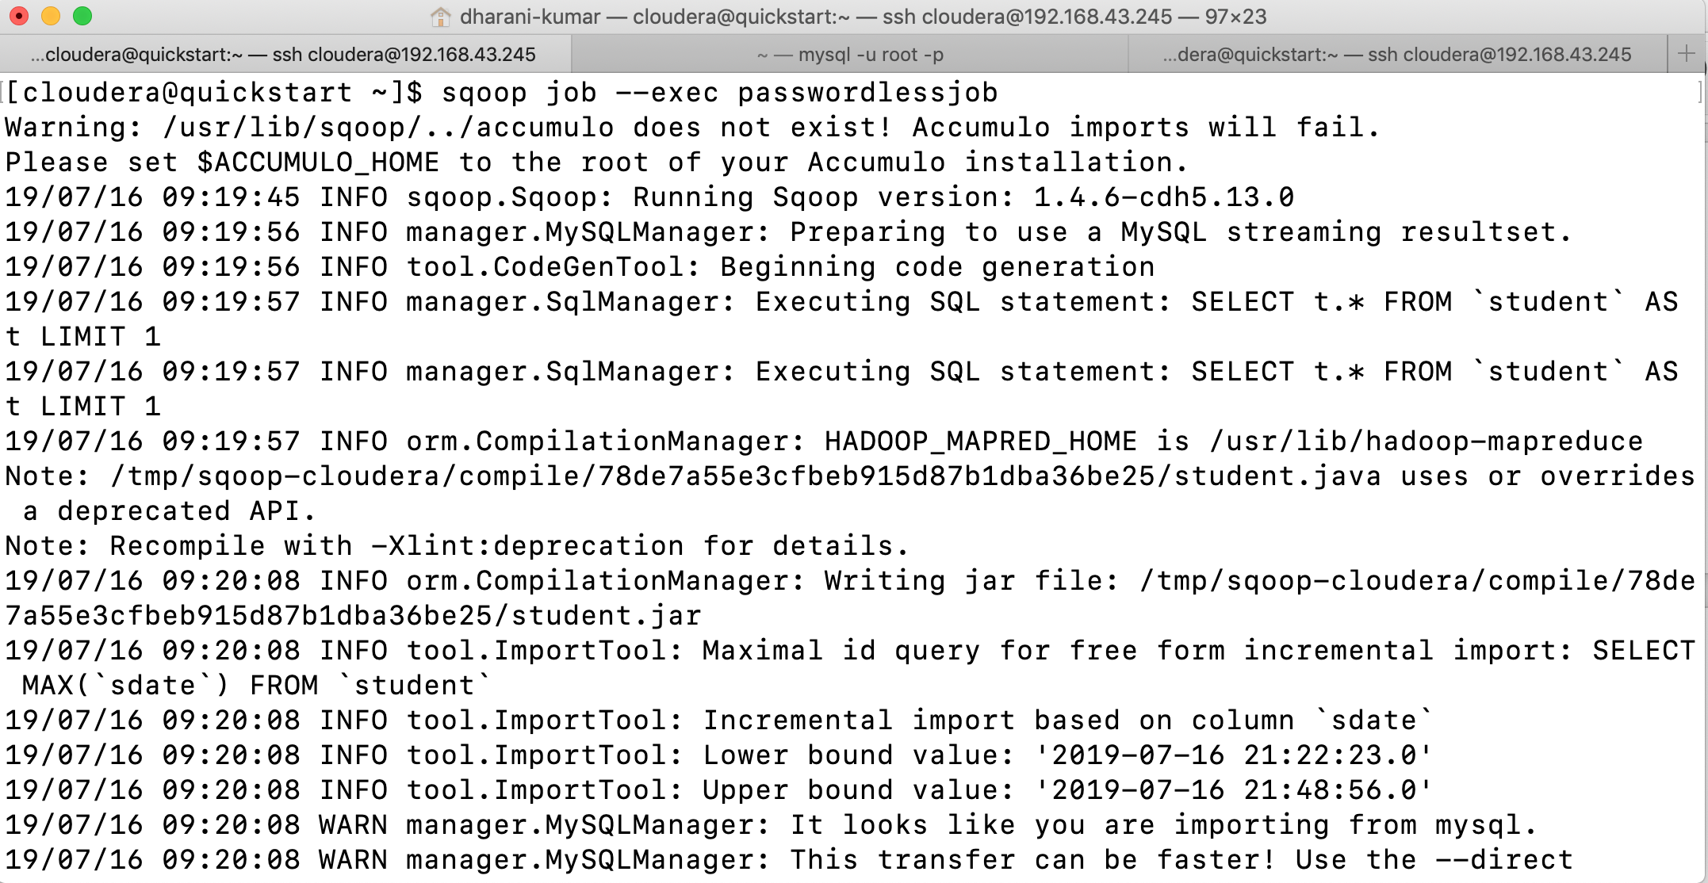

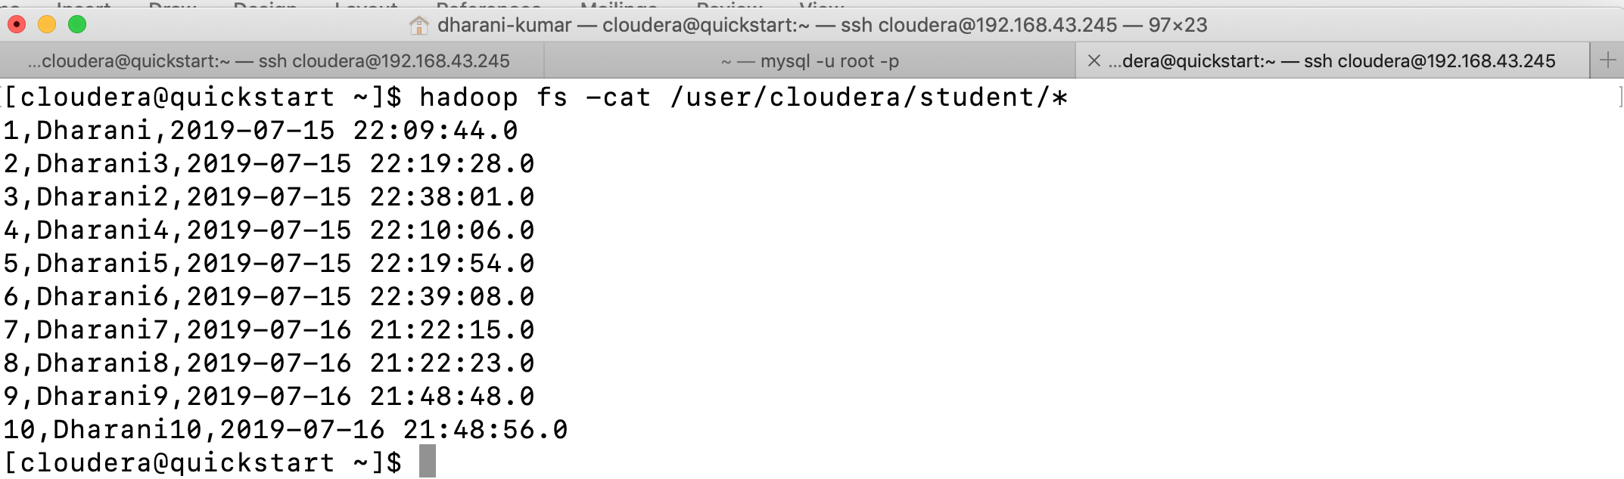

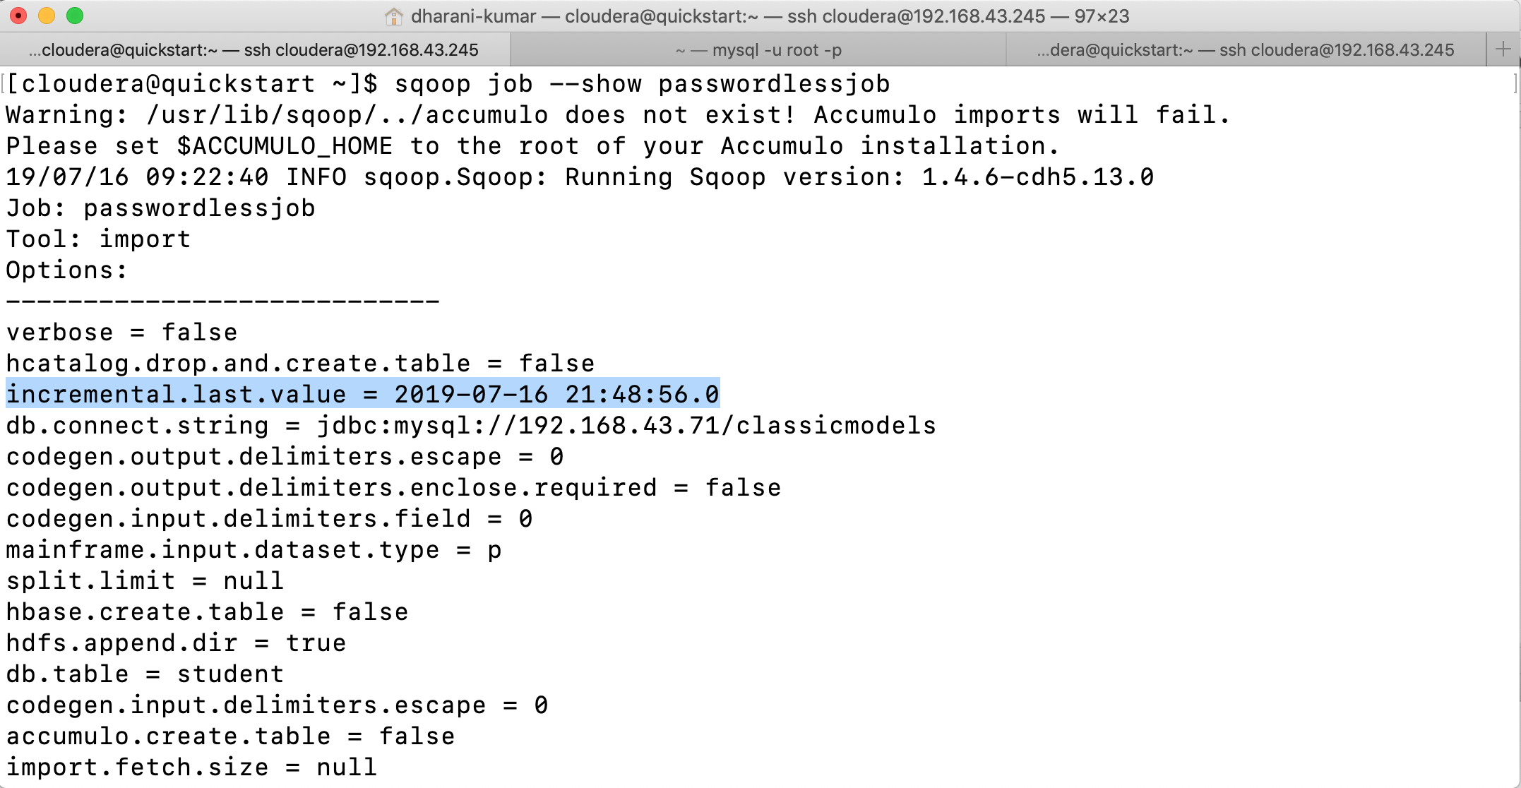

Every time when we execute a sqoop job it will ask for password. To avoid this, we can use the --password-file option while creating the sqoop job.

Sqoop offers two ways to run jobs from within the metastore without requiring any user input. The first and more secure method is by using the parameter --password-file to pass in the file containing the password. The second, less secure method is to set the property sqoop.metastore.client.record.password in the sqoop-site.xml to true:

Both available methods have their advantages and disadvantages. While using the password file is considered safer, in order to secure it, you need to restrict access to the password file. The Sqoop job will be executed with the permissions of the user running the --exec operation rather than the user who created the saved job. You might need to share the file between the two users. The second method of storing the password inside the metastore is less secure. The metastore is unencrypted, and thus anyone can easily retrieve your saved password. This method might be feasible if you have a dedicated machine with very restricted user access.

Overriding the arguments to a saved job: -

You can add or override any parameters of the saved job when executing it. All you need to do is add an extra -- after the --exec command, followed by any additional parameters you would like to add.

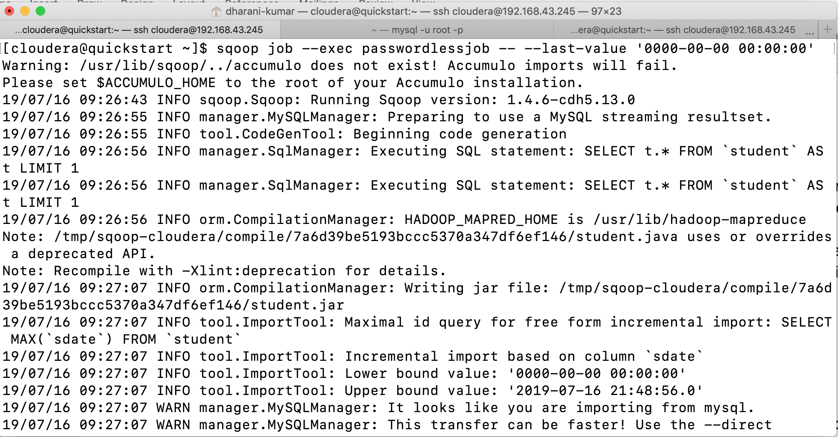

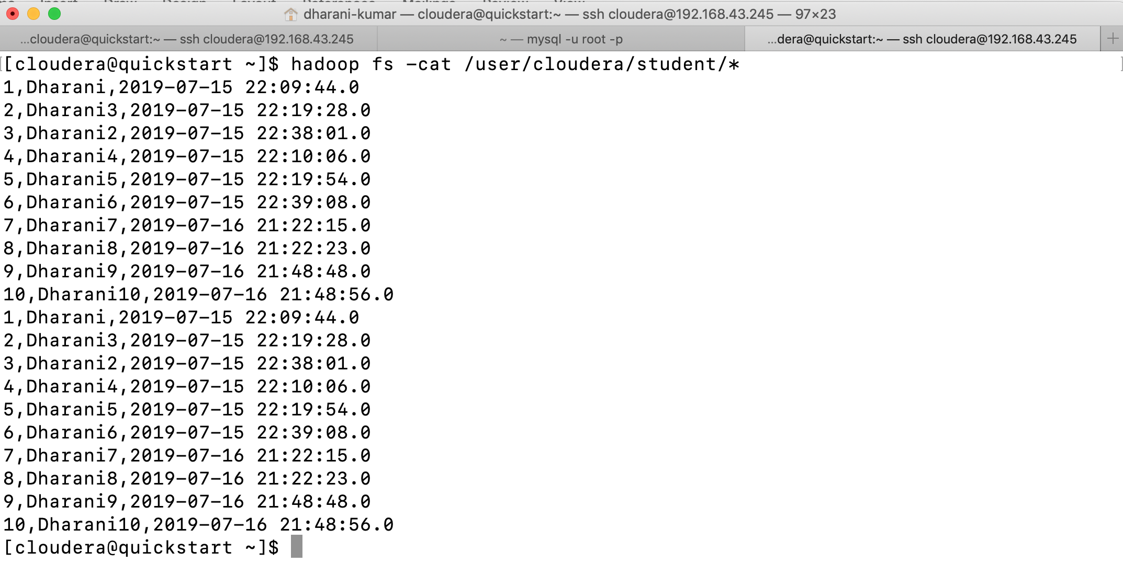

Any number of parameters can be changed while customizing the job.

Saved jobs can be customized at execution time. You can override any arbitrary parameter to check how the job with the new settings will behave without modifying the saved job itself. Another handy use case is to temporarily change the destination in HDFS or in the Hive table if you need an extra import of data to do some unscheduled investigation or

analysis.

You need to be careful about changing the parameters of saved incremental jobs. Sqoop will always retain the value of the last imported row into the metastore regardless of whether you are customizing the execution or not. Using the saved job to just temporarily dump the

data somewhere else might lead to data loss in the main destination.

Free-From Query Import: -

The previous chapters covered the use cases where you had an input table on the source

database system and you needed to transfer the table as a whole or one part at a time into the Hadoop ecosystem. This chapter, on the other hand, will focus on more advanced use cases where you need to import data from more than one table or where you need to customize the transferred data by calling various database functions.

In this mode, Sqoop will allow you to specify any query for importing data. Instead of the parameter --table, use the parameter --query with the entire query for obtaining the data you would like to transfer.

The free form query import is one of the advanced features of sqoop. As with all advanced software features, it gives you great power. With great power comes significant responsibility.

There is lot to be aware when using free-form query imports. By using query imports, Sqoop can’t use the database catalog to fetch the metadata. This is one of the reasons why using table import might be faster than the equivalent free-form query import. Also, you have to manually specify some additional parameters that would otherwise be populated automatically. In addition to the --query parameter, you need to specify the --split-by parameter with the column that should be used for slicing your data into multiple parallel tasks. This parameter usually automatically defaults to the primary key of the main table. The third required parameter is --target-dir, which specifies the directory on HDFS where your data should be stored. We can’t use --warehouse-dir for free form query.

Sqoop performs highly efficient data transfers by inheriting Hadoop’s parallelism. To help Sqoop split your query into multiple chunks that can be transferred in parallel, you need to include the $CONDITIONS placeholder in the where clause of your query. Sqoop will automatically substitute this placeholder with the generated conditions specifying which slice of data should be transferred by each individual task. While you could skip $CONDITIONS by forcing Sqoop to run only one job using the --num-mappers 1 parameter,

such a limitation would have a severe performance impact.

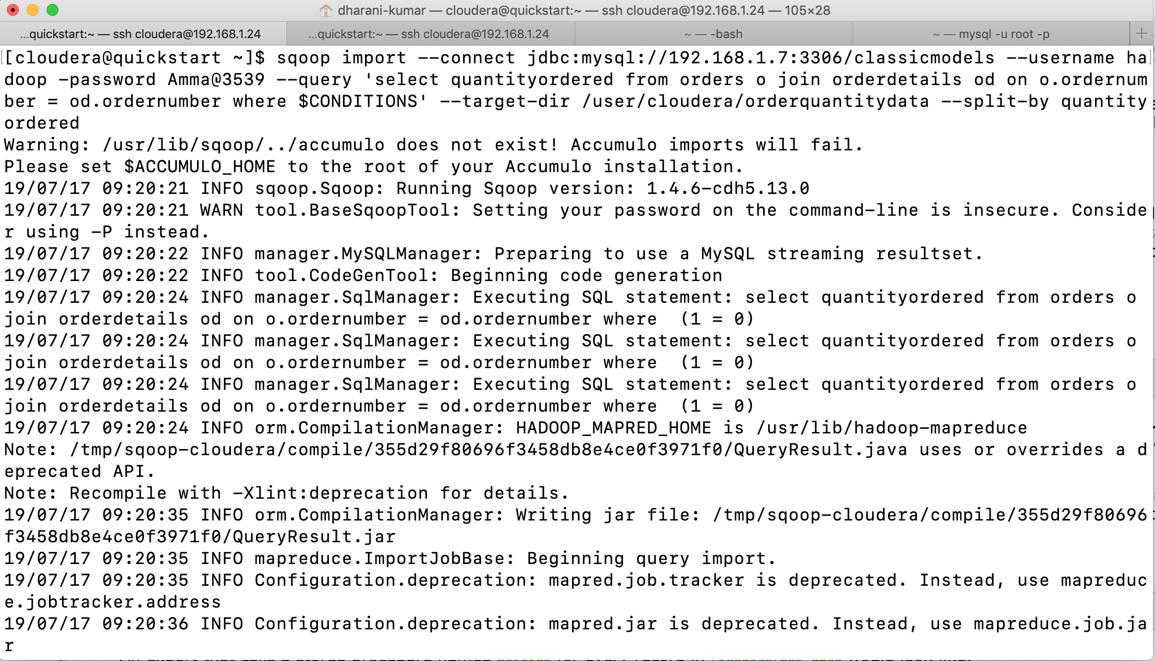

If your query needs more than a few seconds in order to start sending data, it might not be suitable for the free-form query import. If this is the case, you can always run the expensive query once prior to Sqoop import and save its output in a temporary table. Then you can use table import to transfer the data into Hadoop.

Using Custom Boundary Queries: -

You found free-form query import to be very useful for your use case. Unfortunately, prior to starting any data transfer in MapReduce, Sqoop takes a long time to retrieve the minimum and maximum values of the column specified in the --split-by parameter that are needed for breaking the data into multiple independent tasks.

You can specify any valid query to fetch minimum and maximum values of the --split-by

column using the --boundary-query parameter.

In order to partition data into multiple independent slices that will be transferred in a parallel manner, Sqoop needs to find the minimum and maximum value of the column specified in the --split-by parameter. In a table-based import, Sqoop uses the table’s primary key by default and generates the query select min(col), max(col) from table. In the case of the free-form query import, there is no table that Sqoop can use for fetching those values; instead, it will use the entire query specified on the command line as a subquery in place of the table name, resulting in a query select min(col), max(col) from ($YOUR_QUERY). Such a query is highly inefficient, as it requires materialization of the output result set prior to moving any data just for the purpose of getting the import boundaries.

Without understanding your query and the underlying data, there aren’t many optimizations that Sqoop can automatically apply. Sqoop does offer the parameter --boundary-query, with which a custom query can override the generated query. The only requirement for this query is to return exactly one row with exactly two columns. The first column will be considered the lower bound, while the second column will be the upper bound. Both values are inclusive and will be imported. The type of both columns must be the same as the type of the column used in the --split-by parameter. Knowing your data and the purpose of your query allows you to easily identify the main table, if there is one, and select the boundaries from this table without any additional join or data transformations.

The query used for fetching boundaries can indeed be arbitrary. Let’s walk through a few examples. If you happen to know the boundaries prior to running Sqoop, you can select them directly without opening a single table using a constant boundary query like SELECT 1, 500. If you’re storing the minimum and maximum values in different tables for accounting purposes, you can fetch the data from there as well. There is no requirement to reference any table used in the --query parameter inside the --boundary-query parameter. As the output of the boundary query serves as the basis for importing data, it is imperative that the return value not skew the import process.

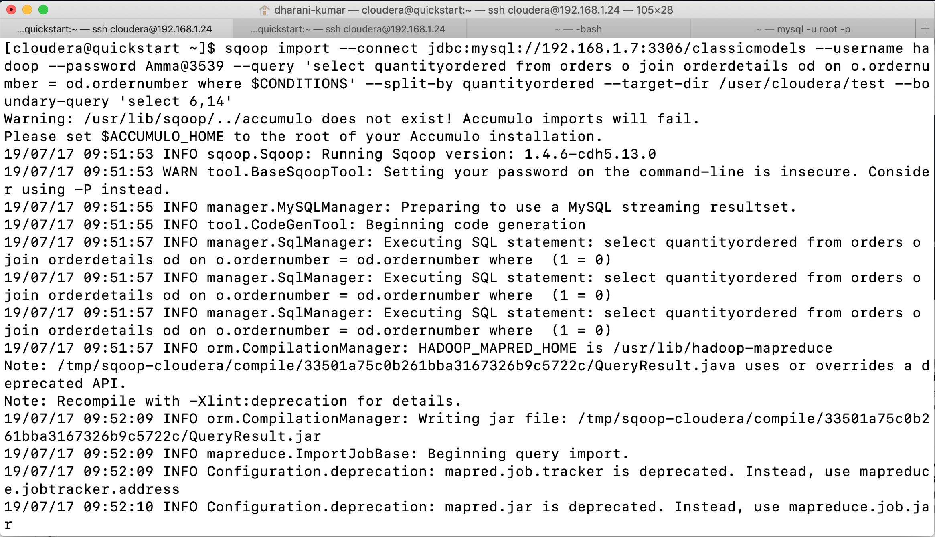

Renaming Sqoop job instances: -

You run several concurrent free-form query imports from various databases at the same time on your Hadoop cluster. All MapReduce jobs are named QueryResult.jar, so it’s very hard to see which MapReduce job belongs to which imported query.

You can use the command-line parameter --mapreduce-job-name to specify the name of the generated MapReduce job. This name will then show up in the JobTracker web UI.

Sqoop follows the default behavior of Hadoop in using the submitted JAR name for the MapReduce job name. In a table import, the JAR is named after the table name, resulting in unique JAR and therefore also MapReduce job names. In the free-form query import case, with no single table involved, Sqoop will use QueryResult as the base name for the JAR. All query imports will look exactly the same on the JobTracker web UI. You can use the --mapreduce-job-name parameter to choose a name for your job.

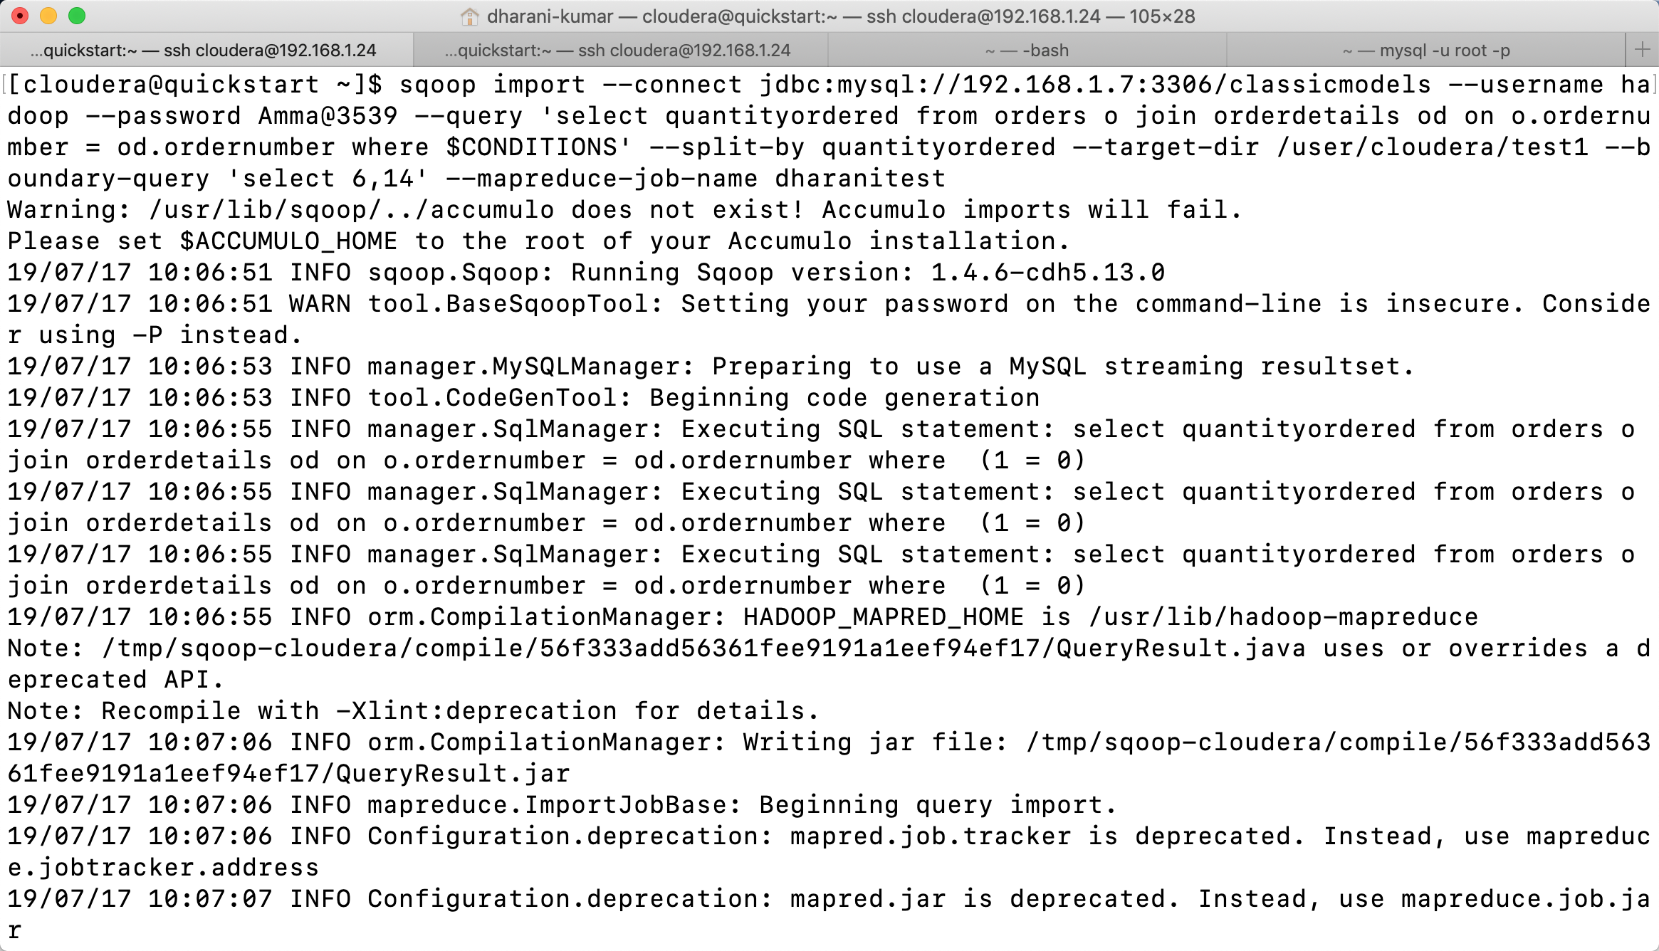

Importing Queries with duplicate columns: -

You have more than one table that you’re joining in your free-form query. Your Sqoop import is failing with an error message about duplicate columns, similar to the following one:

Imported Failed: Duplicate Column identifier specified: 'id'

You might need to use SQL projection to rename columns in the query so that each column in the output result set has a unique name. You can do that using the AS syntax.

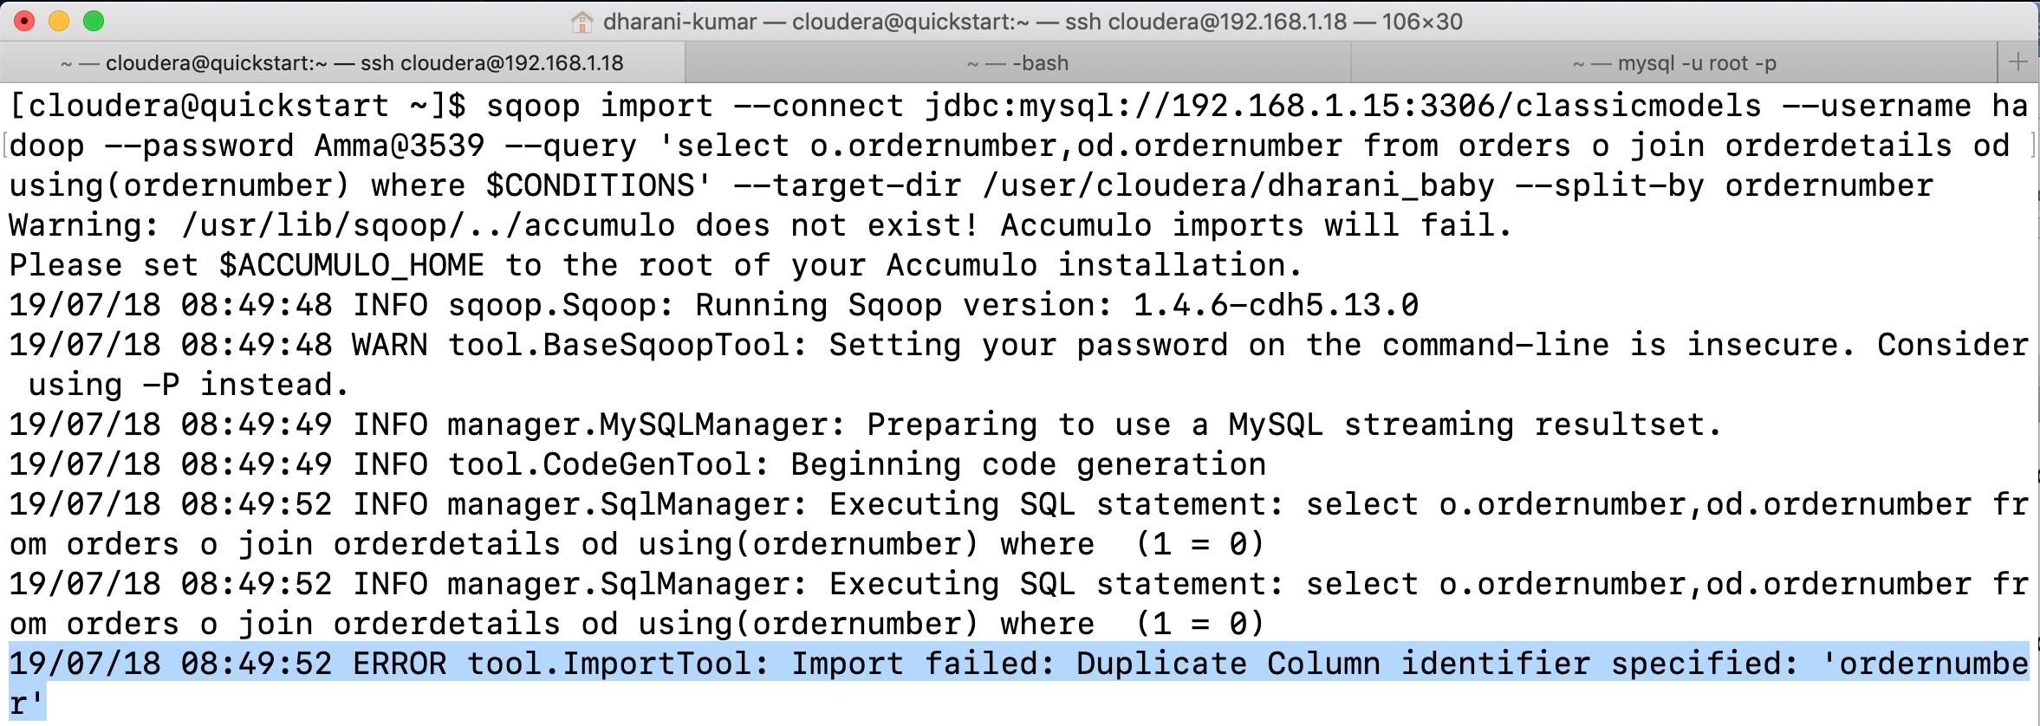

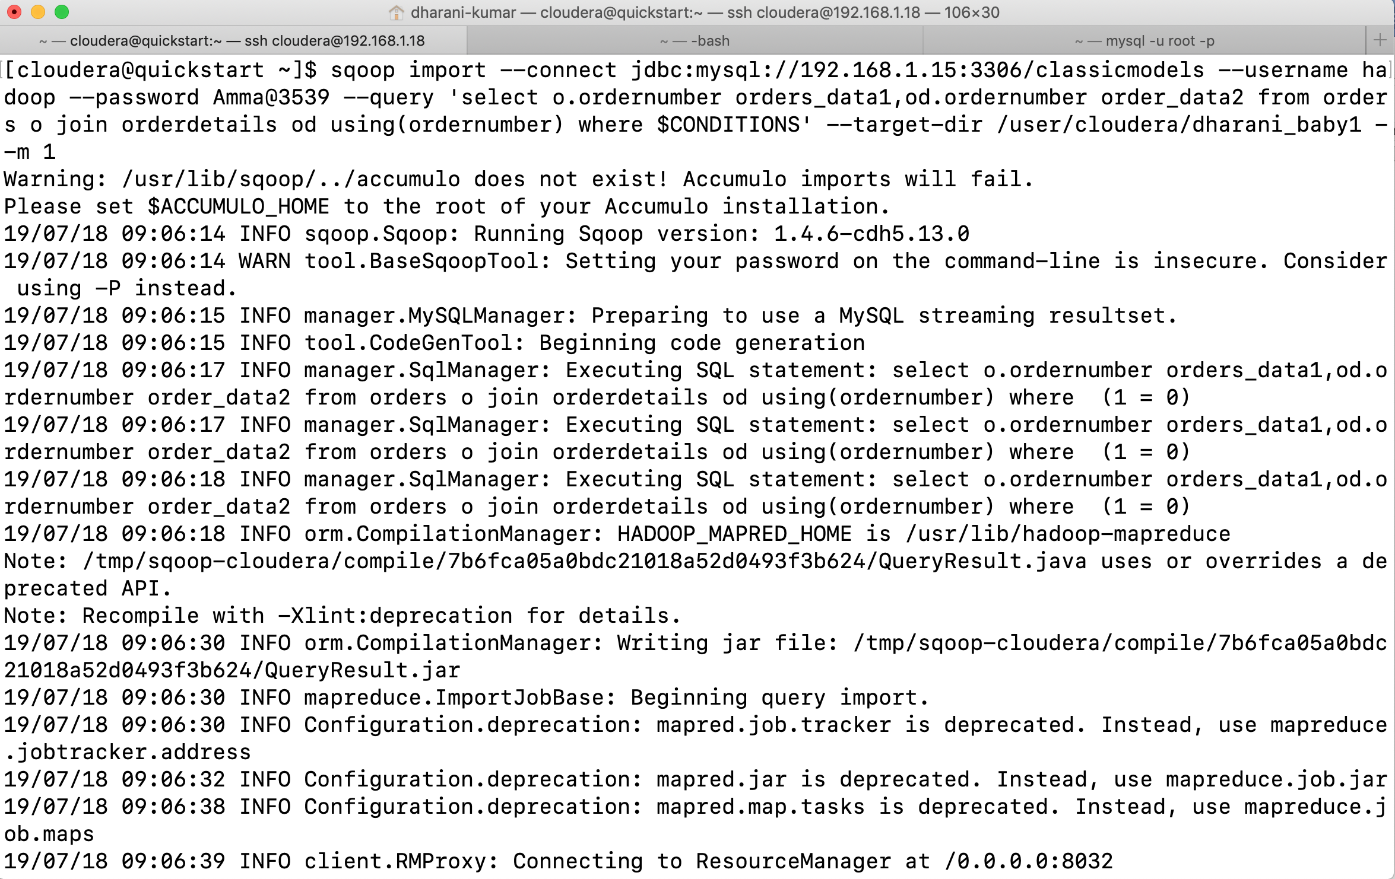

During initial preparation and before submitting the MapReduce job, Sqoop performs several actions. One such action is to fetch metadata about the transferred columns and their associated types. During this step, Sqoop will generate a Java class that contains one attribute for each column that will be named as the column itself. Java attributes must be unique; therefore, all columns in your query must have unique names. While databases generally enforce unique column names in tables, it is a likely scenario that during a join operation two columns from different tables will have the same name. The output result set then contains two columns with the same name. This is especially problematic if your query selects all columns from all join tables using fragments like select table1. *, table2. *. In this case, you must break the general statement down, name each column separately, and use the AS clause to rename the duplicate columns so that the query will not have duplicate names.

Export: -

The previous three chapters had one thing in common: they described various use cases of transferring data from a database server to the Hadoop ecosystem. What if you have the opposite scenario and need to transfer generated, processed, or backed-up data from Hadoop to your database? Sqoop also provides facilities for this use case, and the following

recipes in this chapter will help you understand how to take advantage of this feature.

You can use Sqoop’s export feature that allows you to transfer data from the Hadoop ecosystem to relational databases.

Export works similarly to import, except export transfers data in the other direction. Instead of transferring data from the relational database using SELECT queries, Sqoop will transfer the data to the relational database using INSERT statements. Sqoop’s export workflow matches the import case with slight differences. After you execute the Sqoop command, Sqoop will connect to your database to fetch various metadata about your table, including the list of all columns with their appropriate types. Using this metadata, Sqoop will generate and compile the Java class. The generated class will be used in the submitted MapReduce job that will export your data. Similar to the import mode, no data is being transferred through the Sqoop client itself. All transfers are done in the MapReduce job, with Sqoop overseeing the process from your machine.

Sqoop fetches the table’s metadata in the export: the destination table (specified with the --table parameter) must exist prior to running Sqoop. The table does not have to be empty, and you can even export new data from Hadoop to your database on an iterative basis. The only requirement is that there not be any constraint violations when performing the INSERT statements (for example, you can twice export the same value for any primary or unique key).

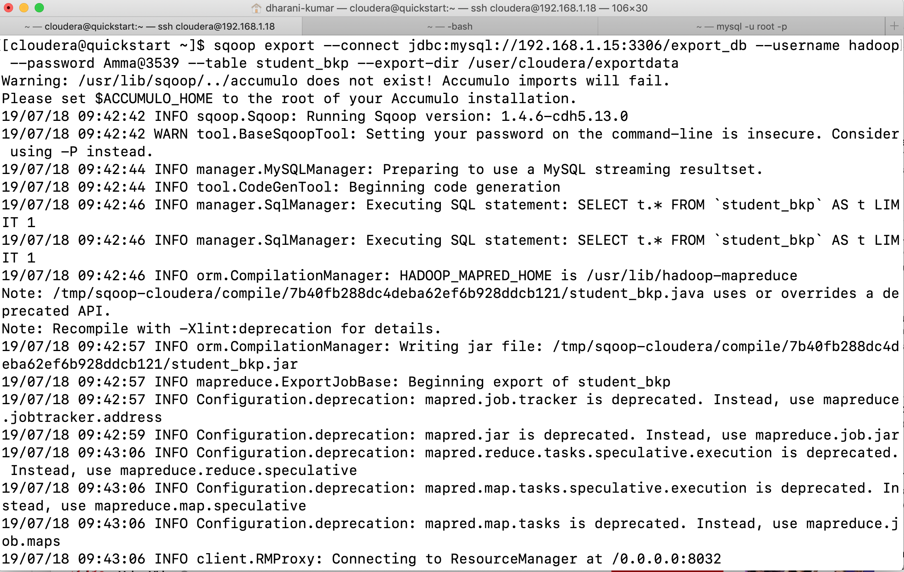

Inserting data in batches: -

Tailored for various databases and use cases, Sqoop offers multiple options for inserting more than one row at a time.

First, you can enable JDBC batching using the --batch parameter:

The second option is to use the property sqoop.export.records.per.statement to specify the number of records that will be used in each insert statement: